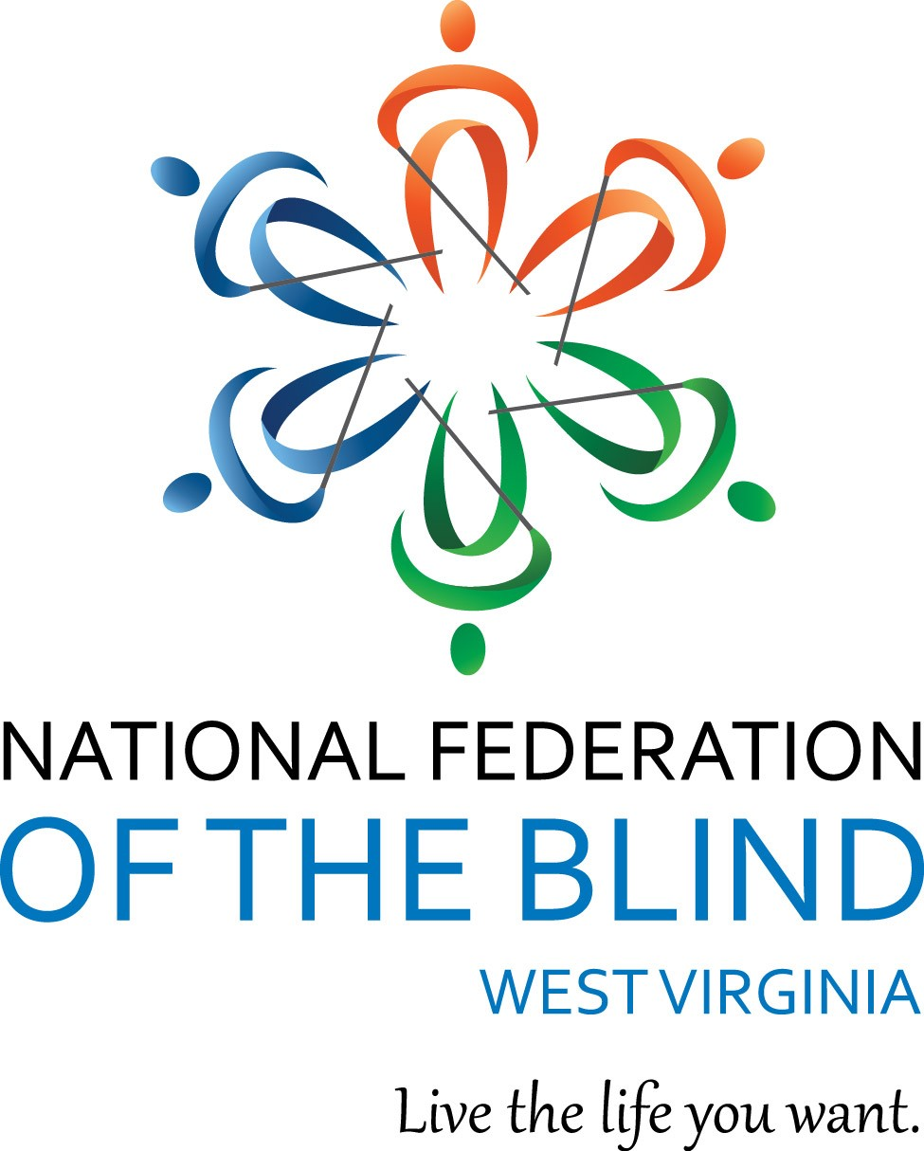
2019 BELL Academy!!!
The National Federation of the Blind of West Virginia (NFBWV) BELL Academy is a summer program which provides children ages 6-15 with intense Braille instruction through fun, hands-on learning activities. NFB's BELL Academy targets blind and low-vision children who do not receive enough Braille and nonvisual skill instruction in school or who could benefit from Braille enrichment over the summer. The National Federation of the Blind has developed an extensive curriculum along with additional planning aids and guidelines.
The National Federation of the Blind of West Virginia (NFBWV) will conduct our second BELL Academy which will take place in Charleston the weeks of July 22nd through July 26th, 2019 at the Elizabeth Memorial United Methodist Church, located at 108 Oakwood Rd., Charleston, WV. The program will be open to as many as 7 to 8 blind and low-vision children from Kanawha county. At least three members of our NFBWV affiliate have volunteered to participate as mentors (adult blind role models) to work with the children. Additionally, we will provide a certified teacher of the blind and visually impaired who will serve as the lead teacher. The church offers a variety of facilities—open meeting space, classrooms, kitchen, playground, etc.—which will provide an ideal environment for a BELL Academy. Pastor Jim McCune will also provide transportation for both student and staff participants who live within a 35-mile radius.
In addition to Braille, crafts, games, and other engaging projects, children will learn vital independent living skills from a nonvisual perspective. They will also benefit from peer learning and mentoring from blind adults, and the daily schedule includes opportunities for play and recreation. Planning is already underway for an exciting and informative field trip to the West Virginia State Museum at the Culture Center.

The National Federation of the Blind of West Virginia has established a BELL Academy fund, and several individuals as well as local Federation chapters have already made generous contributions. Additional financial support is still needed. All checks should be made payable to National Federation of the Blind of West Virginia and earmarked for “BELL Academy.” The National Federation of the Blind of West Virginia is a 501(c)(3) “not-for-profit” organization, registered with the state of West Virginia.

It is our hope that this will be yet another successful BELL Academies which will greatly impact the lives of blind West Virginia children!! We want to reach out to these children to make a real difference, and we sincerely appreciate your interest in this project.
For additional information, please contact Sheri Koch, NFBWV BELL Academy State Coordinator at (304) 993-5103 or at skochnfbwv@gmail.com

