Social Security and OIG Launch Public Service Announcement Campaign

Agency Alerts Public about Telephone Impersonation Scheme

The Social Security Administration (SSA) and its Office of the Inspector General (OIG) launched a joint Public Service Announcement (PSA) campaign addressing a nationwide telephone impersonation scheme. Social Security and the OIG continue to receive reports from across the country about fraudulent phone calls from people falsely claiming to be Social Security employees. Calls can even “spoof” Social Security’s local customer service number as the incoming number on the caller ID. PSAs are airing on TV and radio stations across the country to alert the public to remain vigilant against potential fraud.
Social Security employees do occasionally contact people--generally those who have ongoing business with the agency--by telephone for business purposes. However, Social Security employees will never threaten a person or promise a Social Security benefit approval, or increase, in exchange for information. In those cases, the call is fraudulent and people should not engage with the caller. If a person receives these calls, he or she should report the information to the OIG Fraud Hotline at 1-800-269-0271 or online at https://oig.ssa.gov/report.
“These calls appear to be happening across the country, so we appreciate SSA’s partnership in this national public outreach effort,” said Gail S. Ennis, the Inspector General for the Social Security Administration. “Our message to the public is simply this: If you or someone you know receives a questionable call claiming to be from SSA or the OIG, just hang up.”
The new PSA addressing the telephone impersonation scheme is available online at www.youtube.com/socialsecurity and below:

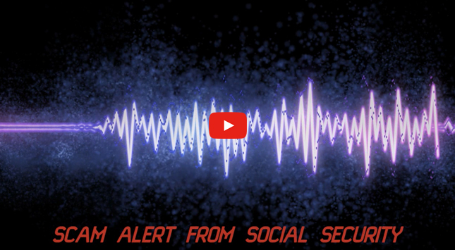

# # #

To get more Social Security news, follow the Press Office on Twitter @SSAPress.

