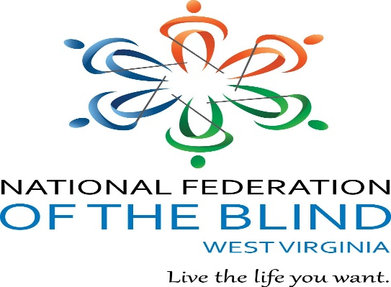
To
Sandy Streets
JACOBUS TENBROEK AWARD
FEDERATIONIST OF THE YEAR
For Demonstrating Outstanding Commitment to the Philosophy, Purpose, Goals, and Objectives of the NATIONAL FEDERATION OF THE BLIND OF WEST VIRGINIA.
1018

