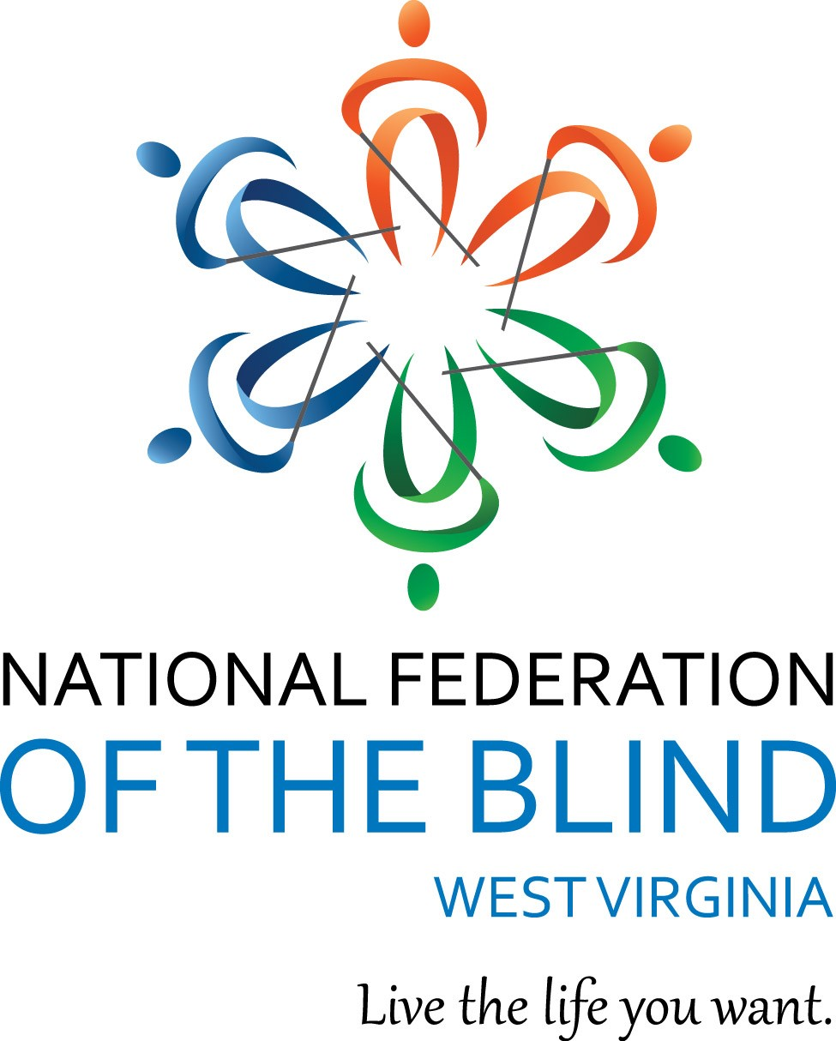
NATIONAL FEDERATION OF THE BLIND
OF WEST VIRGINIA

CONVENTION AGENDA

September 18 - 22, 2019

HOLIDAY INN Express
1188 Pineview Drive
Morgantown, WV 26505
(304) 241-6649
"Living Blind in West Virginia
Challenges and Choices"
Welcome one and all to the sixty-sixth Annual Convention of the National Federation of the Blind of West Virginia.
Our 2019 NATIONAL REPRESENTATIVE:
Anil Lewis, Executive Director, Blindness Initiatives, National Federation of the Blind, 200 E Wells St., Baltimore, MD 21230
Special Thanks:
Special Thanks go out to the 2019 Convention Planning Committee, as well as all members who have contributed their time and energy to this convention. Thanks also to the staff of the Holiday Inn Express, for their help with convention arrangements.
An extra special expression of appreciation goes out to John Jackson and his company, Master Conversions, for the Braille production of this agenda. Based in Weirton, WV, Master Conversions is a private company offering high-quality Braille and large print transcription services for more than a decade to state and federal agencies, schools and individuals. For more information, contact:

John R. Jackson
Master Conversions
PHONE: (304) 748-1963
E-MAIL: j.r.jackson@comcast.net
Once again, John and Sheri Koch are pleased to contribute standard and
large print agendas.
Thank you also to others, whose names may have been inadvertently
omitted, for their hard work.
When and where activities will take place:
WEDNESDAY, September 18, 2019
5:00 – 7:00 PM Dinner for the board and anyone else who would like to join us will take place in the Situation Room. This offers a quiet place for a good meal from the menu and stimulating conversation with one another. This dinner will be at your own expense.
7:00 PM NFBWV BOARD OF DIRECTORS MEETING—Sheri Koch, President, National Federation of the Blind of West Virginia; Situation Room. (This meeting is open to all convention attendees)
9:00 - 10:00 PM REGISTRATION—John Koch, Members at Large Chapter, and Sandy Streets, Treasurer, National Federation of the Blind of West Virginia; Presidential Suite 300
Registration Information:
Those who pre-registered at least 7 days in advance will have already paid the convention registration fee of $45.00 per person, which covers admission to all convention sessions including the Friday night reception. The advance convention banquet fee is $30.00 per person. The onsite convention registration fee is $50.00 per person and the convention banquet fee is $35.00 per person.
THURSDAY, September 19, 2019
9:00 – 11:30 AM Nuts and Bolts of Rehabilitation Services—Anil Lewis, Executive Director, Blindness Initiatives, National Federation of the Blind; Situation Room

11:30 AM – 1:00 PM Lunch (on your own) Atria’s Restaurant open

1:00 – 5:00 PM: Nuts & Bolts of Rehabilitation Services Continued--Anil Lewis, Executive Director, Blindness Initiatives, National Federation of the Blind; Situation Room

5:00 – 7:00 PM Dinner (on your own); Atria’s Restaurant opened
7:00 – 9:00 PM Strategic Planning Committee Meeting: Identifying and setting our affiliate goals for the upcoming year—Sheri Koch, Chairperson; Situation Room (all who wish to attend are welcome)
FRIDAY, September 20, 2019
9:00 – 11:30 AM Self-Advocacy; Getting what you need from Rehabilitation Services—Anil Lewis, Executive Director, Blindness Initiatives, National Federation of the Blind; Siempre Room #2 / Liberi Room #3
11:30 AM – 1:00 PM Lunch on your own (Atria’s Restaurant open)

1:00 PM GENERAL SESSION; Siempre Room #2 / Liberi Room #3
* CALL TO ORDER—Sheri Koch, President, National Federation of the Blind of West Virginia
* INVOCATION—Trish Walker, Members at Large Chapter
* PLEDGE OF ALLEGIANCE—John Koch, Vietnam Veteran and Members at Large Chapter
* NFB PLEDGE—Karen McDonald, Secretary, National Federation of the Blind of West Virginia
I pledge to participate actively in the effort of the National Federation of the Blind to achieve equality, opportunity, and security for the blind; to support the policies and programs of the Federation; and to abide by its constitution.

1:10 – 2:00 PM National Federation of the Blind Report—Anil Lewis, Executive Director, Blindness Initiatives, National Federation of the Blind

2:00 – 2:30 PM Disability Rights of West Virginia Report—Jeremiah Underhill, Legal Director, Disability Rights of West Virginia

2:30 – 3:00 PM National Library Services Report —Donna Calvert, Director, West Virginia Library Commission, Special Services Division
3:00 – 3:30 PM West Virginia School for the Blind Report—Mark Gandolfi, Superintendent, West Virginia Schools for the Deaf and the Blind

3:30 – 4:00 PM West Virginia Assistive Technology System (WVATS)—Jennifer Ham, Assistive Technology Specialist
4:00 – 4:30 PM American Foundation for the Blind--Aaron Preece, National Technology Associate, Huntington West Virginia
4:30 – 5:00 PM West Virginia 211—Janette Lewis, Community Impact Director, Monongalia and Preston Counties and Vincent Marroquin, Information and Referral Coordinator
SPLIT THE POT
5:00 Adjourn
6:00 - 7:30 PM: RECEPTION: This includes a tasty dinner of Chicken parmesan with penne pasta, salad, broccoli florets, roll, tea, coffee, and ice water and a special dessert for all; Liberi Room #3 / Siempre Room #2
7:30 - 11:00 PM: MEMBERS AUCTION--Trish Walker, Members at Large, and Marcus Soulsby, Second Vice-President, will serve as your Auctioneers; Liberi Room #3 / Siempre Room #2
SATURDAY, September 21, 2019
GENERAL SESSION; Liberi Room #3 / Siempre Room #2
9:00 – 9:05 AM Poem; Together we are, A poem written and read by Keryl Rustin, President, Eastern Panhandle Chapter
9:05 – 9:30 AM Celebration of our membership—Sheri Koch, President, National Federation of the Blind of West Virginia

9:30 – 10:15 AM It’s as close as your own front door; using shopping services and delivery services—Charlene Smyth, President, Harrison County Chapter, National Federation of the Blind of West Virginia

10:15 – 11:15 AM Can I get there from here? A close look at transportation services in West Virginia. Panel members: Jennifer Woodall, Assistant General Manager, Tri State-Transit Authority, WV Public Transit Association President Huntington, WV; Elaine Bartoldson, Director, Eastern Panhandle Transit Authority WV Public Transit Association Secretary Martinsburg, WV; Janie Lou White, Executive Director, Buckwheat Express, Kingwood, WV; and Lisa Weisher, Executive Director, Ohio Valley Regional Transit Authority, Wheeling, WV. Panel discussion moderated by John Jackson, Member at Large
SPLIT THE POT
11:30 AM – 1:00 PM Lunch on your own (Atria’s restaurant is open)
1:00 – 1:45 PM Federal Accessibility Standards for Hospital and Health Care Facilities—Mark Derry, President, Eastlake Derry & Associates, LLC, ADA Accessible Solutions

1:45 – 2:30 PM President’s Report; a year in review— Sheri Koch, President, National Federation of the Blind of West Virginia

2:30 – 3:30 PM Looking Back with an Eye to the Future: Fifty Years in Radio, Music, and the National Federation of the Blind—Ed McDonald, First Vice-president, National Federation of the Blind of West Virginia
3:30 – 4:10 PM Strategic Planning Committee Report, A glimpse into our future—Ed McDonald, First Vice-president, National Federation of the Blind of West Virginia
4:10 – 4:20 PM PAC Plan Report—Marcus Soulsby, Second Vice-president, National Federation of the Blind of West Virginia

4:20 – 4:30 PM Agency Partnership report—Ed McDonald, Chairperson

4:30 - 4:40 PM BRIEF FINANCIAL SUMMARY—Sandy Streets, Treasurer, National Federation of the Blind of West Virginia
4:40 – 4:50 PM OLD BUSINESS
4:50 – 5:00 PM NEW BUSINESS
SPLIT THE POT
5:00 PM Adjourn
6:30 PM BANQUET--Ed McDonald, Master of Ceremonies; Montani Room #1
* INVOCATION—Trish Walker, Members at Large Chapter

* INTRODUCTION OF GUESTS--Ed McDonald, First Vice-president, National Federation of the Blind of West Virginia
* PRESENTATION OF AWARDS--Karen McDonald, Secretary, National Federation of the Blind of West Virginia
* KEYNOTE ADDRESS—Anil Lewis, Executive Director, Blindness Initiatives, National Federation of the Blind

* SPLIT THE POT

SUNDAY, September 22, 2019
9:00 – 10:00 AM: MEMORIAL SERVICE--Charlene Smyth, President, Harrison County Chapter; Liberi Room #3 / Siempre Room #2
10:00 – 11:30 AM Members at Large chapter meeting; Banquet Room B Siempre Room #2 & Liberi Room #3
11:30 AM Adjourn
HOLIDAY INN EXPRESS
Restaurant Information & Hotel Description

Registration: Registration as well as dropping off door prizes and auction items will take place in Presidential Suite 300.
Atria’s Restaurant

Atria’s on-site restaurant is open for breakfast, lunch and dinner that offers a wide variety of menu options. To view the menus, go to www.atrias.com.

RESTAURANT HOURS

Monday – Thursday:
Breakfast 6:30am to 10:30am
Kitchen open to 9 pm
Tavern open to 10 pm

Friday:
Breakfast 6:30am to 10:30am
Kitchen open to 10 pm
Tavern open to 11pm

Saturday:
Breakfast 7am to 10:30am
Kitchen open to 10 pm
Tavern open to 11pm
Sunday:
Breakfast 7am to 10:30am
Kitchen and Tavern open to 8 pm

Convention attendees may enjoy a self-serve breakfast buffet or they may ask for a plated breakfast, making specific selections from buffet choices.

HOTEL DESCRIPTION
Below is a description of the hotel which we hope will be helpful mas you navigate your surroundings. If you have any issues, there are hotel staff members and NFBWV members who can answer your questions.
Passing through the sliding glass doors of the hotel will take you into the lobby. The check-in desk is straight ahead. There is good signage in both print and Braille throughout the hotel.
DIRECTIONS TO ELEVATORS/OTHER THINGS: Walk to the front desk and then skirt around it to your left. Just past the counter and to your right is a short hallway. The first doorway on the right is the Sundry Shop that contains assorted items such as snacks, Tide-Pods, and a cooler with soda. Pay for items at the front desk. The Next door on the right is Sales and Marketing. At the very end of the hallway is an emergency exit.
If you bypass this short hallway, you will find a padded table. After this and slightly recessed, are two elevators side-by-side. There is a narrow wall between the elevators with call buttons on each side of it for each elevator.
LOBBY LAYOUT: Turning left after passing through the sliding glass doors to the lobby brings you to a doorway to a storage area. Just after this is a hallway which we will come back to later.
Bypassing the hallway on the left, you will start into the lobby. The first thing on the left is an Argo ATM machine that seems to be accessible. Traveling down the left wall, you will encounter an artificial tree, a waterfall built into the wall, and another artificial tree. You will then come to a small alcove with a table containing brochures and other information followed by a sign for Atria’s Restaurant and then a padded table with newspapers on it. You will then come to a counter area containing a coffee machine and water. Just past the counter is another padded table followed by Shelves with knickknacks.
Turning right, you will find another set of shelves followed by a Window, a Chair, and a table with an ottoman in front of the chair. Just past this and slightly set back in is a fireplace followed by another chair with an ottoman and then another table.
RESTROOMS: Turning left, you will come to a rug and sliding glass doors. After passing through these doors, there is another set of sliding glass doors to your left that will take you outside. If you keep going straight across the rug, you will come to a tiled area where two unisex bathrooms are located. One bathroom is directly in front of you and the other is set back in an alcove. Inside the alcove and to the left is a storage closet.
Bypassing the sliding glass doors, you will find another padded table. Set slightly back in are the two elevators we mentioned earlier. This then brings you back around to the Sundry Shop hallway and the check-in desk.
SLEEPING ROOM FLOORS: After exiting the elevator, the room on the right contains the ice machine. Past this is a bench. Turning left after exiting the elevator brings you to a carpeted hallway that runs left to right. Rooms 200 to 214 are on the left and 215 to 246 are on the right. Straight ahead is a glass wall that overlooks the lobby. This is the general layout for all the upper floors.
RIGHT SIDE OF THE HOTEL LAYOUT: After passing through the sliding glass doors that bring you into the hotel, there is a storage area to the right. Past this is a hallway that will take you to rooms 145 to 154 and the Business Center. Just before you start down this hall, there is a carpeted area that takes you behind the check-in desk.
Starting down the hall, there is a sign in print and Braille on the left wall that says “Office”. There are windows along the right side of the hallway. Continuing past the Office on the left is the Business Center that is open 24-hours a day. This is a recessed area containing two computers and a printer. Continuing down the hall you will pass through two double doors that are usually left open.
The hallway then turns to the left. As soon as you turn left, there is a staircase on the right that goes down.
Continuing down the hall on your left are two doors to the Manager’s Office. Past the Managers Office is a small alcove. After the alcove is Room 154. With 154 to your left, the enclosed staircase is to your right.
You will then come to a carpeted area with Room 152 on the left side of the hall and Housekeeping on the right side of the hall. The rooms in this hall end with 145.
Take a right to another hallway with Room 146 on your right and the last door on the left leads to the stairs.
LEFT SIDE OF THE HOTEL LAYOUT: After passing through the sliding glass doors that bring you into the hotel is a storage room to your left.
Just past this is a hallway with windows on your left. The first set of double doors down this hall on your right is the Liberi Conference Room. The signs for the conference rooms are in print and Braille but are located about 5 and a half feet up the wall. Walking forward after exiting the Liberi Room will take you to a little alcove area with a bench.
After exiting the Liberi Room, turn right to start down another hall. Again, there are windows and benches on your left.
The next set of double doors take you into the Semper Conference Room. Just past the Semper Room is a little alcove on the right with a table that juts out a little. Across from this table are doors leading to the outside.
Proceeding past the table is a set of double doors to your right that lead to the Montani Conference Room. This is followed by the Women’s Restroom on your right, then a water fountain, followed by the Men’s Room.
ATRIAS RESTAURANT: After the Men’s Room are double doors that lead into the Atria’s Restaurant. The Hostess Desk is on your right and doors leading outside are to your left. There is a carpeted area in front of the Hostess Stand. Past the Hostess Stand on your right and forward about 15 feet is a huge octagon shaped bar. Tables and booths are situated throughout the restaurant.
SITUATION ROOM: You must go through the restaurant to get to the Situation Room where some convention meetings will take place.

