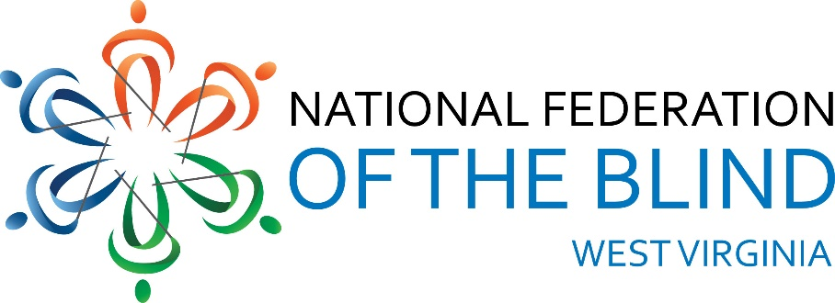
National Federation of the Blind of West Virginia 2024 State Convention
Holiday Inn-University Area, 1188 Pineview Dr.
Morgantown, WV 26505
AGENDA
Thursday, October 31, 2024
3:00 PM Hotel Check-in
3:30 PM Drop off auction items and door prizes
presidential suite #215
5:00 PM Dinner on your own (Bourbon Room)
7:30 PM NFBWV Board of Directors Meeting
(Bourbon Room): Sheri Koch, Chair
Friday, November 1, 2024
BLIND COMMUNITY UNITY DAY:
8:000 AM Vendor Booths Setup (Liberi Section)
-2-
8:30 AM Welcome (Montani Semper Section): Sheri
Koch, NFBWV President
A Moment of Silence for those we’ve lost
Vendor mini presentations: 10 minutes
each
WV Library Commission: Donna
Calvert
WV Assistive Technology System
(WVATS): Doug Cumpston
Jehovah’s Witness (JW.org) Robert &
Geraldine Johnson, Ron & Diane Barnett
VISIONS: Amanda Udell
American Printing House for the Blind
(APH): Lee Huffman
Jim Sullivan Monarch)
LiveAbility Center for Independent
Living: Annetta Johnson
-3-
This & That Gadgets Table: Sheri Koch
Demonstrations provided by blind
equipment owners: NFBWV members,
other interested gadget users
10:00 AM BREAK
10:15 AM Vendor booths (Liberi Section)
11:30 PM BOX LUNCH (Montani Semper Section)
12:30 PM GENERAL SESSION ORGANIZATION &
AGENCY REPORTS: (Montani Semper
Section)
National Federation of the Blind, A
National Rverview of our Mission and
Impact: Jesse Sherik, National
Representative
12:50 PM National Federation of the Blind of West
Virginia, A State and Grassroots
Perspective on our Mission and Impact:
Sheri Koch, NFBWV President
1:00 PM WV School for the Deaf and the Blind:
Melanie Hesse, WVSDB Dean of Students
-4-
1:20 PM Cabell-Wayne Association of the Blind:
Toni Walls, Executive Director
1:40 PM Seeing Hand Association for the Blind:
Karen Haught, Executive Director
2:00 PM LiveAbility Center for Independent Living,
Morgantown: Annetta Johnson,
Administrative Director
2:20 PM American Foundation for the Blind,
Huntington: Aaron Preece, AccessWorld
Editor in Chief
2:40 PM American Printing House for the Blind,
Huntington: Lee Huffman, Low Vision
Product Manager, Product Development
and Jim Sullivan, Director, Social Enterprise
3:00 PM BREAK
3:15 PM LET’S TALK: West Virginia Division of
Rehabilitation Services (WVDRS); Services
and Policies; a Pannel Discussion: Pisnu
Bus-Iam, Director; (Blind Services
Staff) Candice Ward, Assistant Director,
Rachel Hatfield, Rehabilitation Services
-5-
Manager 1, Gentry Cline, Deputy Director,
Kevin Maynus, Rehabilitation Specialist for
the Blind, Tammy Murdock, VISIONS
Manager, NFBWV members, Jesse Sherik,
NFB National Representative, and other
interested blind sstakeholders
5:00 PM Wrap-up and Adjourn
6:15 PM DINNER (Montani Semper Section)
8:00 PM AUCTION (Montani Semper Section)
All Things West Virginia Auction: Marcus
Soulsby, Auctioneer
Saturday, November 2, 2024
8:30 AM GENERAL SESSION: (Montani Semper
Section)
Call to order, remarks, & announcements:
Sheri Koch, NFBWV President
Pledge of Allegiance, Harold Thomas
-6-
NFB Pledge, Lead by Karen McDonald
“I pledge to participate actively in the
efforts of the National Federation of the
Blind; to achieve equality, opportunity,
and security for the blind; to support
the policies and programs of the
Federation; and to abide by its
constitution.”
8:35 AM WHAT’S GOING ON AT THE NATIONAL
LEVEL, NFB Report: Jesse Sherik, National
Representative
9:00 AM WHAT’S GOING ON AT THE STATE LEVEL,
NFBWV Report: Sheri Koch, NFBWV
President
9:15 AM FUNDAMENTALS OF SELF-ADVOCACY:
Jesse Shirek, National Representative
10:15 AM BREAK
10:30 AM TRAINING FOR LIFE AT AN NFB CENTER:
My Experience at the Louisiana Center for
the Blind: Ahmad Shafi, NFBWV Member
Sat Large
-7-
11:00 AM CHALLENGING INACCESSIBILITY AT THE
UNIVERSITY LEVEL: Miranda Lacy &
Harold Rogers, WVU Students and NFBWV
Members at Large, and Sheri Koch
11:45 AM MY EXPERIENCE AS A TEACHER OF
TOMORROW: Wendy Bailey
12:00 PM LUNCH (On your own) hotel restaurant
1:30 PM GENERAL BUSINESS SESSION (Montani
Semper Section)
BUILDING OUR AFFILIATE: A ROADMAP
FOR TODAY AND TOMORROW; Final Report
of the Committee of the Whole on
Membership Building): Review & Progress
Report: Ed McDonald, 1st Vice-president
and President Members at Large
RESOLUTIONS & POLICY STATEMENTS: Ed
McDonald, Sheri Koch
FINANCIAL MATTERS: Garrett Harris,
Interim Treasurer
-8-
ELECTION OF OFFICERS
CHAPTER REPORTS: Sightless Workers Guild
President, Jack Yahnke; and Members at
Large President, Ed McDonald
OEN DISCUSSION: Review of Blind
Community Unity Day; Initiatives &
Priorities for the Coming Year
4:30 PM WRAP-UP AND ADJOURN
6:30 PM BANQUET
Master of Ceremonies: Ed McDonald
Keynote Speaker: Jesse Sherik
Sunday, November 3, 2024
9:00 AM IN MEMORIUM, Remembering those we’ve
loved and lost: Marla Sewell (Montani
Semper Section)
10:00 AM WRAP-UP AND ADJOURN
THANKS YOU FOR SHARING YOUR TIME, SPIRIT, AND GREAT IDEA! THE FELLOWSHIP WAS WONDERFUL. BE SAFE GOING HOME.

