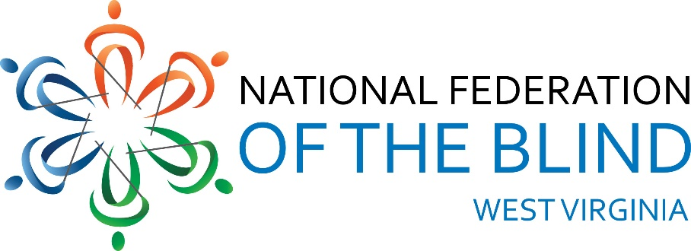
National Federation of the Blind of West Virginia 2024 State Convention
Holiday Inn-University Area, 1188 Pineview Dr.
Morgantown, WV 26505
AGENDA
Thursday, October 31, 2024
3:00 PM Hotel Check-in
3:30 PM Drop off auction items and door prizes
presidential suite #215
5:00 PM Dinner on your own (Bourbon Room)
7:30 PM NFBWV Board of Directors Meeting
(Bourbon Room): Sheri Koch, Chair
-2-
Friday, November 1, 2024
BLIND COMMUNITY UNITY DAY:
8:000 AM Vendor Booths Setup (Liberi Section)
8:30 AM Welcome (Montani Semper Section):
Sheri Koch, NFBWV President
A Moment of Silence for Those We’ve
Lost
Vendor Mini Presentations: 10 Minutes
Each
VISIONS: Amanda Udell
WV Assistive Technology System
(WVATS): Doug Cumpston
Jehovah’s Witness (JW.org) Robert &
Geraldine Johnson, Ron & Diane
Barnett
WV Library Commission: Susan Ward
-3-
American Printing House for the Blind
(APH): Lee Huffman
Jim Sullivan Monarch)
LiveAbility Center for Independent
Living: Annetta Johnson
This & That Gadgets Table: Sheri Koch
Demonstrations provided by blind
equipment owners: NFBWV members,
other interested gadget users
10:00 AM BREAK
10:15 AM Vendor booths (Liberi Section)
11:30 PM BOX LUNCH
(Montani Semper Section)
12:30 PM GENERAL SESSION ORGANIZATION &
AGENCY REPORTS: (Montani Semper
Section)
-4-
National Federation of the Blind, A
National Rerview of our Mission and
Impact: Jesse Sherik, National
Representative
12:50 PM National Federation of the Blind of
West Virginia, A State and Grassroots
Perspective on our Mission and Impact:
Sheri Koch, NFBWV President
1:00 PM WV School for the Deaf and the Blind:
Melanie Hesse, WVSDB Dean of
Students and Wendy Bailey, Statewide
Outreach Specialist for WVDE
1:20 PM Cabell-Wayne Association of the Blind:
Toni Walls, Executive Director
1:40 PM Seeing Hand Association for the Blind:
Karen Haught, Executive Director
2:00 PM LiveAbility Center for Independent
Living, Morgantown: Annetta Johnson,
Administrative Director
-5-
2:20 PM American Foundation for the Blind,
Huntington: Aaron Preece, AccessWorld
Editor in Chief
2:40 PM American Printing House for the Blind,
Huntington: Lee Huffman, Low Vision
Product Manager, Product Development
and Jim Sullivan, Director, Social
Enterprise
3:00 PM BREAK
3:15 PM LET’S TALK: West Virginia Division of
Rehabilitation Services (WVDRS);
Services and Policies; a Pannel
Discussion: Pisnu Bua-Iam, Director;
(Blind Services Staff) Candice Ward,
Assistant Director, Rachel Hatfield,
Rehabilitation Services Manager 1,
Gentry Cline, Deputy Director,
Kevin Maynus, Rehabilitation Specialist
for the Blind, Tammy Murdock,
VISIONS Manager, NFBWV members,
-6-
Jesse Sherik, NFB National
Representative, and other interested
blind stakeholders
5:00 PM Wrap-up and Adjourn
6:15 PM DINNER (Montani Semper Section)
8:00 PM AUCTION (Montani Semper Section)
All Things West Virginia Auction:
Marcus Soulsby, Auctioneer
Saturday, November 2, 2024
8:30 AM GENERAL SESSION: (Montani Semper
Section)
Call to order, remarks, &
announcements: Sheri Koch, NFBWV
President Pledge of Allegiance, Harold
Thomas
-7-
NFB Pledge, Lead by Karen McDonald
“I pledge to participate actively
in the efforts of the National
Federation of the Blind; to
achieve equality, opportunity,
and security for the blind; to
support the policies and programs
of the Federation; and to abide
by its constitution.”
8:35 AM WHAT’S GOING ON AT THE NATIONAL
LEVEL, NFB Report: Jesse Sherik,
National Representative
9:00 AM WHAT’S GOING ON AT THE STATE
LEVEL, NFBWV Report: Sheri Koch,
NFBWV President
9:15 AM FUNDAMENTALS OF SELF-ADVOCACY:
Jesse Shirek, National Representative
-8-
10:15 AM BREAK
10:30 AM TRAINING FOR LIFE AT AN NFB
CENTER: My Experience at the
Louisiana Center for the Blind:
Ahmad Shafi, NFBWV Member
at Large
11:00 AM CHALLENGING INACCESSIBILITY AT
THE UNIVERSITY LEVEL: Miranda Lacy
& Harold Rogers, WVU MSW Students
and NFBWV Members at Large, and
Sheri Koch facilitating
11:30 AM MY EXPERIENCE AS A TEACHER OF
TOMORROW: Wendy Bailey
12:00 PM LUNCH
1:30 PM NFBWV GENERAL SESSION;
Convention Business (Montani Semper
Section)

-9-
BUILDING OUR AFFILIATE: A
ROADMAP FOR TODAY AND
TOMORROW; Final Report of the
Committee of the Whole on
Membership Building: Review &
Progress Report: Ed McDonald, 1st
Vice-president and President Members
at Large Chapter
RESOLUTIONS: Ed McDonald
FINANCIAL MATTERS: Garrett Harris,
Interim Treasurer
ELECTION OF OFFICERS
CHAPTER REPORTS: Sightless Workers
Guild President, Jack Yahnke & Members
at Large President, Ed McDonald
-10-
OPEN DISCUSSION: Review of Blind
Community Unity Day; Initiatives &
Priorities for the Coming Year
4:30 PM WRAP-UP AND ADJOURN
6:30 PM BANQUET
Master of Ceremonies: Ed McDonald
Keynote Speaker: Jesse Sherik
Sunday, November 3, 2024
9:00 AM IN MEMORIUM, Remembering Those
We’ve Loved and Lost: Marla Sewell,
Members at Large (Montani Semper
Section)
10:00 AM WRAP-UP AND ADJOURN
THANKS YOU FOR SHARING YOUR TIME, SPIRIT, AND GREAT IDEA! THE FELLOWSHIP WAS WONDERFUL. BE SAFE GOING HOME.

