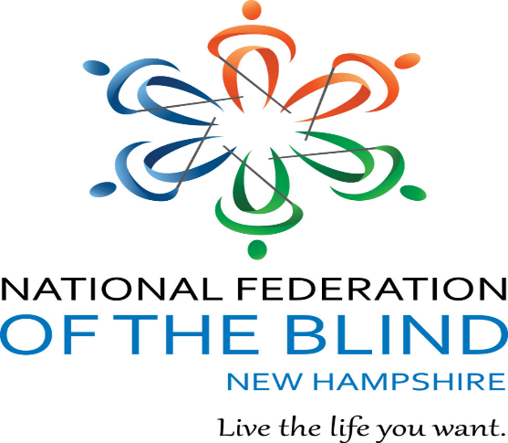

National Federation of the Blind of New Hampshire -
Would you like a chance to win some MONEY and help a great cause in the process?
Well, you can do both by purchasing raffle tickets to win a $300 Visa Gift Card!
Just in time to help the winner with Holiday Shopping, Gas, or Groceries!!!
Tickets are only $5 each or 6 for $20!! That’s right!! Get a bonus ticket for spending $20!
Tickets will be available to purchase until midnight on December 10, 2022.
The Raffle will be drawn on December 17, 2022, during our chapter meeting!
Purchase your tickets from any one of our NFB-NH affiliate members. Make checks payable to “Lakes Region Chapter”
For any questions call the Lakes Region chapter president Deanna O’Brien at 603-864-8847.
The lucky winner will be drawn on December 17^{th,} so act soon as this will make a wonderful holiday present to keep or give away!!!

