**Coalition of Blind and Vision Impaired Voters Logo which includes a graphic of a voting box with the word VOTE on one side and a ballot entering a slit on the top of the box with a large black check mark. The box is red, blue, and purple.

One4all Accessible Voting System**

*"All elections are to be free, and every inhabitant of the state of 18 years and upwards shall have equal right to vote in any election."* -NH State Constitution

New Hampshire citizens have the right to vote independently, privately, and with a secret ballot in federal, state, and local elections**.** The Help Americans Vote Act (HAVA) and Title II of the Americans with Disabilities Act (ADA) establish specific protections for voters with disabilities.

**How the accessible One4All voting machine works**:

In NH, our accessible voting system is called the one4all and it consists of a tablet, keyboard, headphones, and printer. It is not connected to the internet, and it is secure. All registered voters of all abilities can use the system.

**For a demonstration go to:** [**Future In Sight Training Sessions**](https://futureinsight.org/nhaccessiblevoting/)

A blind or vision impaired person can use the system independently. Sighted assistance is not necessary throughout the process, but assistance is available at the polls if needed.

Although not required, it may be helpful to notify your town or city clerk that you intend to use the one4all on election day. This allows for a paper trail in case there is a need to file a complaint. For a template letter visit [drcnh.org/voting-rights/request-to-use-an-accessible-voting-device-during-local-elections](https://drcnh.org/voting-rights/request-to-use-an-accessible-voting-device-during-local-elections/).

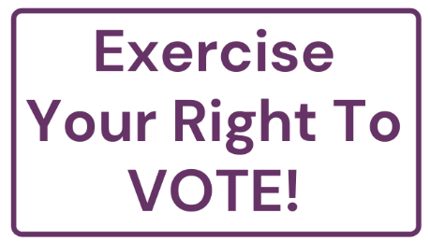**Who to contact if you require assistance:**

* Ask the moderator or poll workers.
* Secretary of State’s Help Desk: (603) 271-8241
* Disability Rights Center – NH: (603) 228-0432

**Need transportation to and from the polls?**

* Democratic Party Volunteers: (603) 225-6899
* Republican Party Volunteers: (603) 225-9341

**Consumer and Individual Partners**Rep. Mark Paige, Fred Fournier, Jean Shiner, Dana Trahan, Andrew Harmon

**Organizational Partners**

