Stuffed Animal Drive 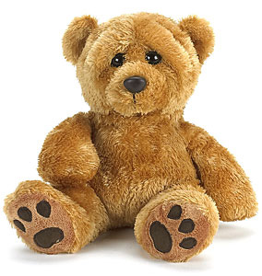

Do you have stuffed animals you don’t want anymore but don’t know where to send them? Donate to the Albuquerque Police and Fire departments. The stuffed animals will go to children and families. The New Mexico Association of Blind Students, a division of the National Federation of the Blind of New Mexico is proud to collect new or gently used stuffed animals to benefit the Albuquerque Police & Fire departments as well as Paramedics.
Beginning September 1, 2011 through December 1, 2011 we will be collecting stuffed animals.
Please bring or mail stuffed animals to:
Tara Chavez
4209 San Pedro DR. NE.
APT 331
Albuquerque NM 87109
If you have questions or need directions, please contact Tara by phone: (505) 328-3349 or by email at: nmabs.president@gmail.com
We appreciate your generous donations.
Thank you,
The New Mexico Association of Blind Students

