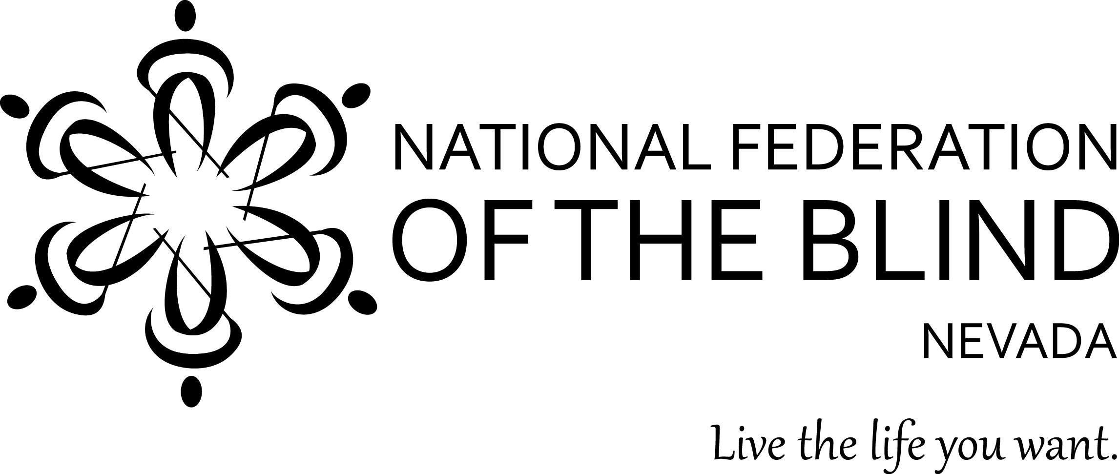

**Explore and Embrace a Piece of Your Story Through Collaboration, Imagination, and Innovation**

The National Federation of the Blind of Nevada

invites you and your family to join us and our family

for the

2017 NFB of Nevada State Convention

Friday, November 10, through Sunday, November 12, 2017

at the

Embassy Suites by Hilton Las Vegas

4315 East Swenson Street

Las Vegas, NV 89119

(702) 765-6759

Get your hotel reservation and convention preregistration in before October 11 to ensure you take advantage of the discounted prices. Book your room by calling 702-765-6759, or directly by visiting our group link at https://secure3.hilton.com/en_US/es/reservation/book.htm?execution=e1s1

Preregistration before October 11 is: $10.00

Braille Ball and Awards Banquet Ticket before October 11 is: $40.00

Onsite registration is: $20.00

Onsite Braille Ball and Awards Banquet Ticket is: $50.00

**\*\*\*SPECIAL FIRST TIME ATTENDEE DISCOUNT\*\*\***

All first timers attending an NFBNV State Convention will receive a $5.00 discount whether preregistering or registering on site.

How to Preregister:

1. Fill out the following registration form, and turn it into your chapter president with a check before October 11.

2. Fill out the following form and send it along with a check to NFB of Nevada Treasurer before October 11.

Chun (Alan) Chao

P.O. Box 20041

Reno, NV 89515

We are excited to announce that we will be providing childcare for those attending with children. For more information or to register your child/children, contact Terri Rupp at 702-524-0835 or [terri.rupp@gmail.com](mailto:terri.rupp@gmail.com).

**SCHEDULE OF EVENTS**

Friday, November 10 Prologue

5:30 PM - 7:00 PM NFB of Nevada Board of Directors Meeting

7:30 PM - 10:30 PM Welcome Mixer and Venders Fair

Kick off the weekend with food, a cash bar, entertainment, raffles, a photo booth, and much more, all while mixing and mingling with vendors, NFB leaders, special guests, and your Federation family.

Saturday, November 11 Explore and Embrace Our Story

9:00 AM - 12:00 PM Morning Convention Session

12:00 PM - 2:00 PM Lunch (on your own)

2:00 PM - 2:50 PM Concurrent Workshops

Nevada’s Organization of Parents of Blind Children

Nevada’s Association of Blind Students

3:00 PM - 3:50 PM Concurrent Workshops

Accessible Technology from Low Tech to High Tech

Advocacy, From the Classroom to Capitol Hill

4:00 PM - 5:00 PM Business Session

Treasurer’s Report, and Affiliate Board Elections

7:00 PM - 10:00 PM Braille Ball and Awards Banquet

Come dressed to impress as we celebrate our numerous awards and scholarships. The evening’s highlight will be our National Federation of the Blind First Vice President, Pamela Allen, as our keynote speaker.

Sunday, November 12 Epilogue

White Cane Walking Tour on Las Vegas Boulevard

Meet in the Lobby at 9:30AM

**2017 NFB OF NEVADA CONVENTION PREREGISTRATION**

Please type your responses in the spaces marked with an “X”.

Name: X

Address: X

City, State, Zip: X

Phone Number: X

Please check the following items that apply to you by placing an “X” in between the brackets.

Are you a NFB Member?

[] YES

[] NO

In what format would you prefer your convention agenda?

[] Print

[] Large Print

[] Braille

[] Email

Is this your first NFB of Nevada convention?

[] YES

[] NO