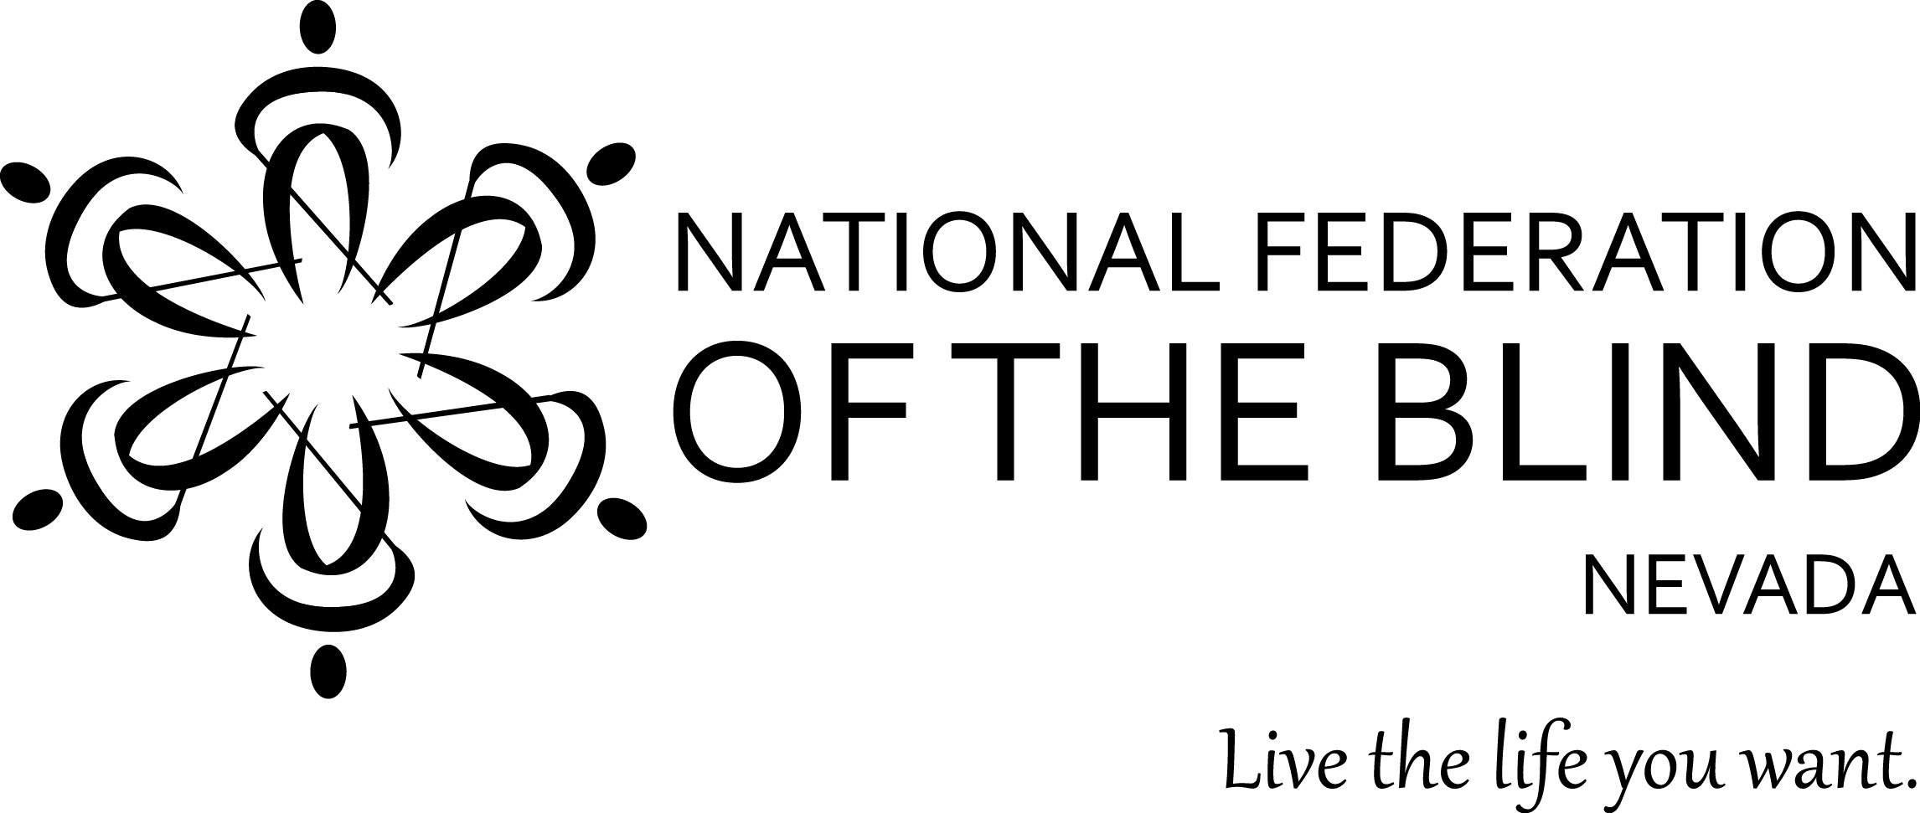

National Federation of the Blind of Nevada

2017 Annual State Convention

November 10 - November 12, 2017

Embassy Suites by Hilton Las Vegas

4315 East Swenson Street

Las Vegas, NV 89119

National Representative; Gary Wunder,

Editor, the Braille Monitor Magazine, President emeritus, National Federation of the Blind of Missouri. and former NFB National Board Member.

National Federation of the Blind of Nevada Board of Directors

President; Terri Rupp

Vice President; Michael Ausbun

Secretary; Frida Aizenman

Treasurer;Chun Chao

Board Member I; Mark Tadder

Board Member II; Thomas Kearns

Board Member III; vacant

2017 CONVENTION COMMITTEE

Terri Rupp, Michael Ausbun, Chun Chao, Frida Aizenman, Amanda Bolton, Thomas Kearns, Mark Tadder, Jason Alamillo, and Ryan Hernandez

The National Federation of the Blind knows that blindness is not the characteristic that defines you or your future. Every day we raise the expectations of blind people, because low expectations create obstacles between blind people and our dreams. You can live the life you want; blindness is not what holds you back.

Prologue

Friday, November 10

5:30 PM - 7:00 PM; Riviera Room

NFB of Nevada Board of Directors Meeting

Introduction of 2017 NFBNV Unity Scholarship Winners

NFB Pledge,

I pledge to participate actively in the effort of the National Federation of the Blind, to achieve equality, opportunity, and security for the blind, to support the programs and policies of the Federation, and to abide by it's constitution.

7:30 PM - 10:30 PM; Flamingo Room

Welcome Mixer and Vender Fair; kick off the weekend with food, a cash bar, entertainment, raffles, a photo booth, and much more, all while mixing and mingling with vendors, NFB leaders, special guests, and your Federation family.

Convention Registration and Preregistration Packet Pick Up

Registration; $20.00

Braille Ball and Awards Banquet Ticket; $50.00

SPECIAL FIRST TIME ATTENDEE DISCOUNT

All first timers attending an NFBNV State Convention will receive a $5.00 discount whether preregistering or registering on site.

Childcare

The Childcare suite will be open on Saturday, November 11th from 9:00AM to 12:00PM, 2:00PM to 5:00PM, and 7:00PM to 10:00PM. The cost of childcare is $15/child, or free if the child is registered for the convention. Please contact Aaron Rupp at 702-526-2271 for the suite number.

Explore and Embrace a Piece of Your Story

Through Collaboration, Imagination, and Innovation

Saturday, November 11

8:00AM - 9:00AM; Outside Flamingo Room Doors

Convention Registration and Preregistration Packet Pick Up

9:00AM - 9:20AM

Welcome Ceremony by NFBNV Southern Nevada Chapter and Friends

9:20AM - 9:40AM

Helen McCoy and BELL Academy staff and students present, “What BELL Means to Me.”

9:40AM - 10:00AM

National Report byGary Wunder, Braille Monitor Magazine Editor, President emeritus, National Federation of the Blind of Missouri. and former NFB National Board Member.

10:00AM - 10:20AM

Bret Silver and Colin Miller; Nevada Talking Books Library

10:20AM - 10:40AM

Becky Andrews; LCMHC, FT, Individual, Marriage and Family Therapist, author of:”Look Up, Move Forward.”

10:40AM - 11:00AM

A Story of Angela's House, by Ryan O'Neil

11:00AM - 11:20AM

Collaboration, Imagination, and Innovation by

Nancy McRight; NCM Consulting for the Bureau of Vo Rehab, state of NV

Laurie Clemens; Director LV PETA

11:20AM - 11:40AM

Winning an NFB National Scholarship and the Federation Family, by Regina Mitchal

11:40AM - 12:00PM

Vendor Highlight

Amanda Tolson, Director of Sales, Envision America

Hari Prasath Palani, PhD Candidate Spacial Informatics School of Computing and Information Science University of Maine

NFB Newsline, Mark Tadder, NFBNV Board Member

12:00 PM - 2:00 PM

Lunch (on your own)

2:00 PM - 2:50 PM; Riviera Room

Nevada’s Organization of Parents of Blind Children

Helen McCoy; NVPOBC President

Carlton Walker; NOPBC National Board Member

Leslie Jones; Nevada Blind Children Foundation

2:00PM - 2:50PM; Flamingo Room

Nevada’'s Association of Blind Students

Michael Ausbun; NABS First Vice President

Congressman Ruben Kihuen

3:00PM - 3:50PM; Riviera Room

Accessible Technology, the Past, the Present, the Future

Karl Smith; Axis Technology, NFB of Utah Board Member

Amanda Tolson; Envision America

Hari Prasath Palani; Spacial Informatics School of Computing and Information Science University of Maine

3:00PM - 3:50PM; Flamingo Room

Advocacy, From the Classroom to Capitol Hill

Congressman Ruben Kihuen

Carlton Walker, NOPBC National Board Member

Michael Ausbon; NFBNV Vice President, NABS First Vice President

4:00 PM - 5:00 PM; Flamingo Room

Presidents Report; Terri Rup

Treasurer's Report, Alan Chun Chou

NFB of Nevada Board Elections

7:00 PM - 10:00 PM; Flamingo Room

Braille Ball and Awards Banquet

Come dressed to impress as we celebrate our numerous awards and scholarships. The evening's highlight will be keynote speaker Gary Wunder.

Epilogue

Sunday, November 12

White Cane Walking Tour on Las Vegas Boulevard

Meet in the Lobby at 9:00AM.