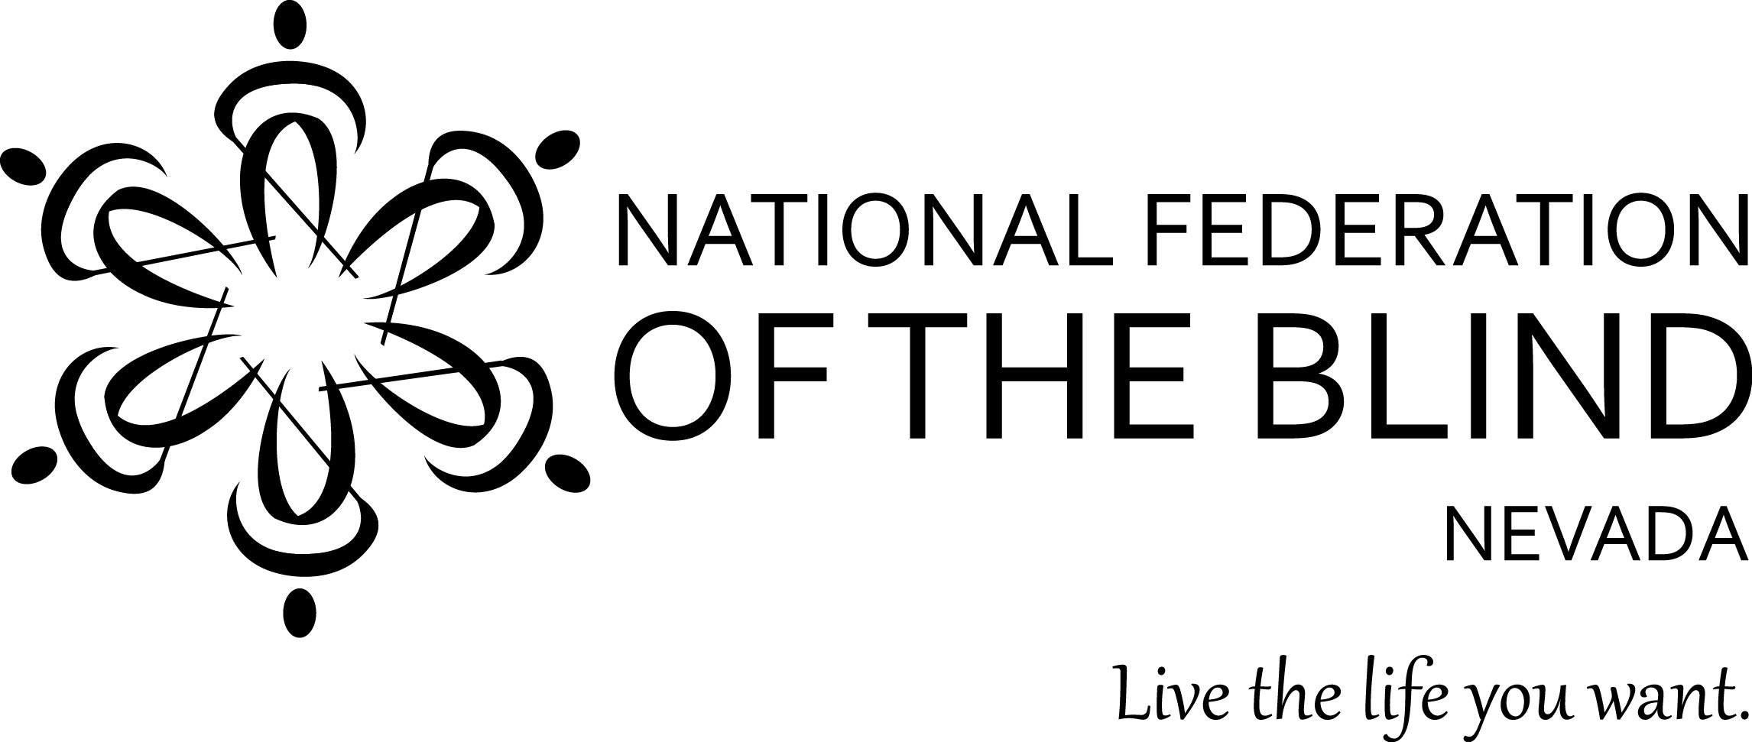
The Silver State Federation Family First Timer Convention Scholarship
presented by
The National Federation of the Blind of Nevada

Are you a new member of the National Federation of the Blind of Nevada interested in attending your first NFB of Nevada State Convention?

Have you been involved with the NFB of Nevada for some time, but haven’t had the opportunity to attend a state convention due to financial restraints?

Are you a parent of a blind child in Nevada seeking support in advocacy and positive blind role models for yourself and your child?

We have great news for you!

The National Federation of the Blind of Nevada will be supporting five first timers in attending our 2018 State Convention, which is to be held October 5 - 6 at the Nugget in Reno. Through our Silver State Federation Family First Time Convention Scholarship, we will provide five qualified applicants stipends in the amount of $250.00 each.

How to apply: Send an essay of no more than 1,000 words on why you would like to attend our state convention. Send your essay to our NFB of Nevada secretary, Frida Aizenman, at nfbfrida@gmail.com. Entries must be received by no later than August 31.

The National Federation of the Blind knows that blindness is not the characteristic that defines you or your future. Every day we raise the expectations of blind people, because low expectations create obstacles between blind people and our dreams. You can live the life you want; blindness is not what holds you back.

