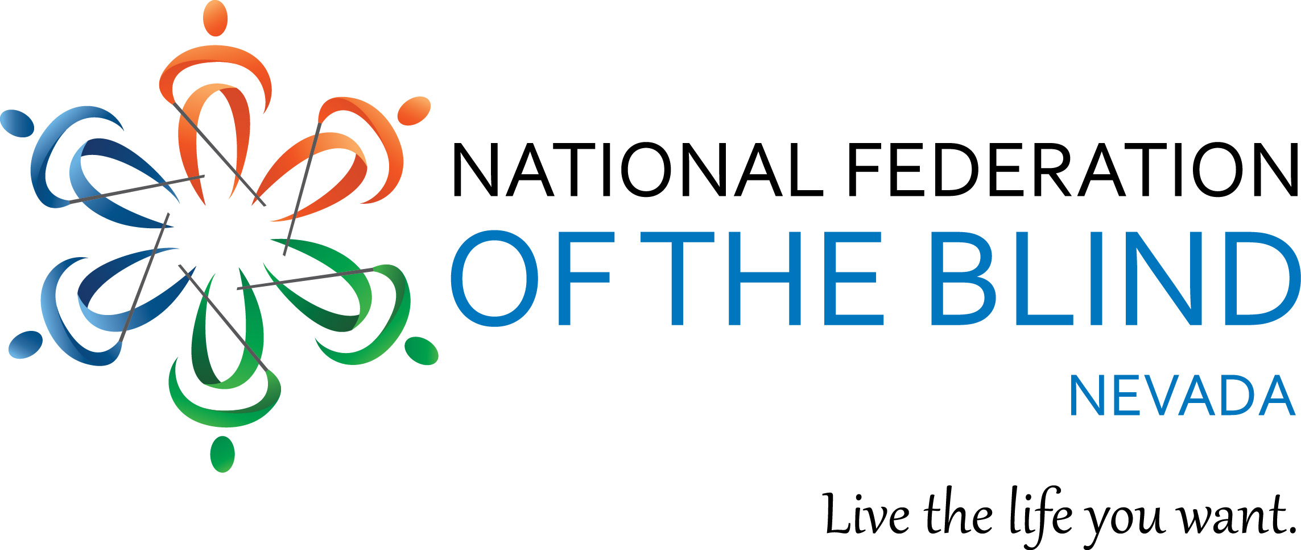

2018 NFBNV UNITY SCHOLARSHIP INFORMATION

The National Federation of the Blind of Nevada has broadened its commitment to blind college students and would like to recognize their achievements by awarding three students merit-based scholarships ranging from $500 to $1,500. All scholarships awarded are based on academic excellence, community service, and leadership.

ELIGIBILITY: To be eligible, applicants must be 1) legally blind in both eyes, 2) must have either been taking college courses or is graduating from a high school in Nevada, 3) must be pursuing or planning to pursue a full-time, postsecondary course of study in a degree program at a Nevada institution of higher education in the 2018-2019 scholastic year (one scholarship will be allowed for an individual employed full-time while attending school part-time), and 4) must participate in the entire 2018 NFB of Nevada state convention including all of its scheduled scholarship program activities. In addition to the scholarship, each winner will receive financial assistance to attend the 2018 NFB of Nevada state convention that will be taking place from October 5 and 6, 2018, in Reno, Nevada.

TO APPLY: Complete the application provided below by August 31, 2018; the application may also be obtained by emailing either the NFB of Nevada President, Terri Rupp at terri.rupp@gmail.com or by requesting a copy from the Southern Nevada Chapter, or Northern Nevada Chapter,. Please submit all documents listed on the application via e-mail to Frida Aizenman, Secretary, at nfbfrida@gmail.com.

DEADLINE: August 31, 2018.

Disbursement of Scholarship: Scholarship finalists will be contacted by the affiliate president one week after the scholarship deadline. At that time, finalists may request financial assistance to attend the 2018 NFB of Nevada state convention. All scholarship awards will be announced during the convention banquet.

2018 NFBN UNITY SCHOLARSHIP APPLICATION

Please type your responses in the spaces marked by an “X”.

PERSONAL INFORMATION
Name: X
Date of Birth: X
Home Street Address: X
Home City, State, ZIP: X
Phone Number (please indicate Home or Cell): X
Email address: X

EDUCATION
College or university you will attend in the fall: X
Class standing, i.e. freshman, sophomore, etc.: X
Cumulative GPA: X

MISCELLANEOUS
Please check the following items that apply to you by placing an “X” in between the brackets.

[] I am legally blind.
[] I am a current NFB member.
[] I will attend college full time in the fall of 2017.
[] I am a resident of the State of Nevada.
[] I am attending school in the state of Nevada.
[] I commit to attend the entire NFB of Nevada state convention (financial assistance may be provided upon request to scholarship winners).

If none of the items apply to you, you are ineligible for a scholarship at this time.

REQUIRED ATTACHMENTS

In addition to the information above, please attach the following documents to your completed application:
1. Personal Essay briefly introducing yourself to the committee. Consider the essay an opportunity to tell the committee who you are. Describe your strengths, achievements, and aspirations. What is important to you? Who do you hope to become? Has a particular person or experience changed your life? How has your blindness affected you? How do you handle it at school, on the job, and in interpersonal relationships? Include information about your goals for this award. Keep in mind that scholarships are not awarded based on financial need. Your personal essay should be no more than 750 words.
2. Two current letters of recommendation.
3. Current unofficial transcripts from the institution you are currently attending. If you have not completed study at an institution of higher learning, please provide your recent high school transcript.

