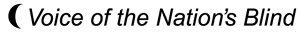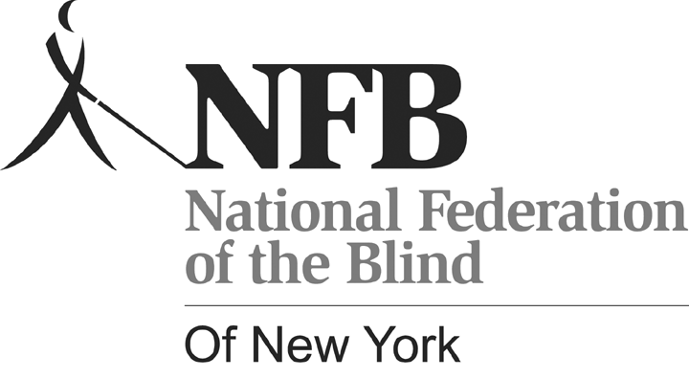REGISTRATION FORM
Carl Jacobsen, President
P.O. Box 205666 Sunset Station
Brooklyn, NY 11220
Telephone (718) 567-7821
Email: office@nfbny.org

National Federation of the Blind of New York State, Inc. 54th Annual Convention

Guest Name ________________________________________________________

Address____________________________________________________________

City / State ___________________________ Zip Code _____________________

Home Phone_________________________ Cell Phone _______________

Additional Names____________________________________________________

Description | How Many? | Amount Enclosed
Convention Registration | ________@ $15.00 | $______________
Box lunch Friday 10/22 | ________@ $12.00 | $______________
Box lunch Saturday 10/23 | _________@ $12.00 | $______________
Banquet Dinner Sat. 10/23  Salmon or chicken (CIRCLE ONE) | ________@ $28.00 | $______________
Hotel stay (check nights)  Oct. 21___ Oct. 22____ Oct.23 ____ | __________@ $95.00 | $______________
Deduct 5 % before October 8 |  | $-______________
TOTAL ENCLOSED: |  | $______________

Register on line at www.nfbny.org or send this registration form with a check or money order payable to NFB of NYS to: NFB of NYS Convention Committee
P.O. Box 205666 Sunset Station Brooklyn, NY 11220

