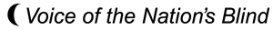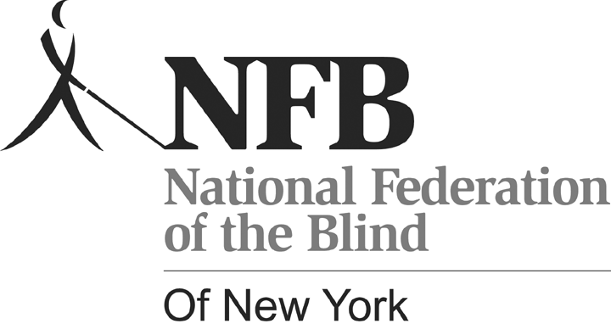
Carl Jacobsen, President
PO Box 205666 Sunset Station
Brooklyn, New York 11220
Telephone: 718-567-7821
E-mail: office@nfbny.org

ANNOUNCING! OUR 54th ANNUAL STATE CONVENTION

If you are a blind person, related to a blind person, a professional in the field of work with the blind, or simply interested in the future of blind people in New York and the world read on. The National Federation of the Blind of New York State will hold its 54th annual convention over the weekend of October 22-24 at the Adams Mark Hotel, 120 Church Street, Buffalo, NY 14202.

The convention will begin on Friday with a seminar for parents and their blind children. This seminar will include literacy, technology, social adjustment, issues surrounding blind children with other disabilities in addition to their blindness, and much more. Childcare will be available all weekend, so PLEASE BRING YOUR CHILDREN. This is an educational event not only for parents but for children as well. It will be a very beneficial weekend for all. For more information about the Parents of Blind Children Division, contact President Maria Garcia at
Mtg129@verizon.net

All day Friday there will be exhibits of technology and products for blind people of all ages. A meeting of the Board of Directors of the affiliate, to which all are invited, will follow. In addition, the
Commission for the Blind will be holding a Town Meeting from 1-3 pm. Come and share your experiences with officials from the Commission.

Saturday will see us engaged in discussing all aspects of life for blind people in our society. Government officials, professionals in the field, vendors of technology and many others will present on topics reaching every member of the audience.

We are delighted to welcome Patti Chang, President of our Illinois Affiliate, member of our National Board, and a practicing attorney as our National Representative. Patti is a multi-faceted woman who will interact with us throughout the weekend and keynote our Saturday evening banquet. On Sunday we will hold our annual business meeting and it is there that we will chart our course for the coming year.

Room rates this year are $95, banquet tickets are $28 and a box lunch for $12 will be available on Friday and Saturday in order to save time in a full convention schedule. The registration fee is $15. Please see the attached form or visit our website to use your credit card at www.nfbny.org. All charges including the hotel room should be made through the NFB of New York. A 5% discount will be given to anyone who registers before October 8, 2010. Please call the office at 718-567-7821 for any questions regarding this year’s convention.

