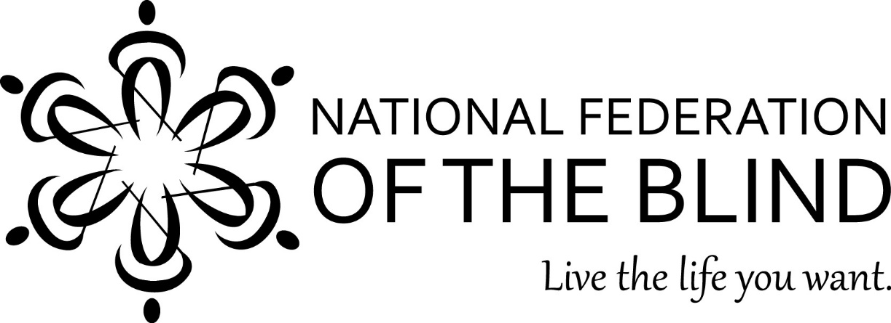

NATIONAL FEDERATION OF THE BLIND
2021 SCHOLARSHIP PROGRAM
for blind high school seniors through grad school students

Program Begins: November 1, 2020
Deadline: Midnight, EST, March 31, 2021

$12,000 Scholarship
“The Kenneth Jernigan Scholarship”
and
1 scholarship for $10,000
2 scholarships for $8,000 each
4 scholarships for $5,000 each
22 scholarships for $3,000 each

PLUS other gifts to our thirty scholarship finalists!

ARE YOU A LEGALLY BLIND HIGH SCHOOL SENIOR OR COLLEGE STUDENT?
Go to: www.nfb.org/scholarships

To apply: During the five-month open period, read the rules and the Submission Checklist, complete the official 2021 Scholarship Application Form (online or in print), supply all required documents, and request and complete an interview with an NFB affiliate president. Read the Frequently Asked Questions (FAQ) page for more information.

Questions? Contact the NFB Scholarship Program; Chairperson Cayte Mendez
E-mail: Scholarships@nfb.org
Office: (410) 659 -9314, ext. 2415, (8 a.m. - 5 p.m. EST)

