Exams got you stressed? Rover to the rescue

http://www.usatoday.com/story/news/nation/2013/12/10/dogs-final-exams/3960567/

Matthew Daneman, USA TODAY 4:08 p.m. EST December 10, 2013

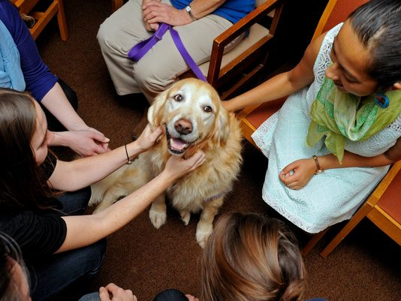

Hannah, a 9-year-old Golden Retriever, is petted by University of Buffalo students at the Health Sciences Library on Dec. 5, 2013.(Photo: Don Heupel for USA TODAY)

AMHERST, N.Y. — The dogs stepped into the University at Buffalo's Health Sciences Library building and instantly were stars, mobbed by a phalanx of cooing and ooing college students.

"You're so nice," said Heidi Moy, 20 and an occupational therapy major from Stony Point, N.Y., as she patted one of the therapy dogs brought to campus last week as a stress reliever for students readying for final exams this week.

While students crammed upstairs, the university had a room set up in the building's basement with a masseuse, soft music, snacks and a small group of trained therapy dogs happy to receive pats, hugs and dog treats.

On college campuses across the USA, therapy dogs are becoming increasingly common sights as slobbering, tail-wagging stress alleviators.

Kathi Piekarski, a staff member at Indiana University South Bend's sociology and anthropology department, said her daily dog walks were frequently a student magnet: "Students at exam time would say 'we need to borrow your dog, we need some stress relief.'"

The result was more than 130 students over two days in October petting her standard poodle, Paris, for Depression Awareness Week. And the university plans to have the dog back next week for a final exam-related session.

"I know when I get stressed out, I just call my dog and start petting him and before you know it the anxiety just kind of leaves and I feel calmer," Piekarski said. "I had a couple students say (after the October event) 'Now we think we can go back and do my academics.'"

Monty, a border terrier mix, is actually part of Yale Law School's Lillian Goldman Law Library catalog system, available for checkout during such times as final exams and bar finals, said Julian Aiken, library head of access services and Monty's owner.

When Monty is coming to campus, an e-mail goes out to students telling them the dates and times, and students then sign up individually or in small groups for blocks of 20 to 30 minutes. They then interact with Monty in Aiken's office.

"It's been very popular," Aiken said. "We always sell out within the hour or two of the e-mail going out. We always create waiting lists."

The dog has been an occasional visitor to law students since 2011. But with Monty now 14, Aiken said, "He's now approaching retirement. I've been working on the succession. I'm thinking about bringing a younger dog in, who happens to be Monty's son."

Therapy dogs — trained to provide comfort to people — frequently are used in such settings as nursing homes and hospitals and at disasters.

"We're doing the airport now, too," said Deborah Williams of Colden, N.Y., as University of Buffalo students fawned over her Labrador retriever, Sam. Buffalo Niagara International Airport is one of a handful around the country making therapy animals available to travelers and airport workers

"I get e-mails every day from all over the country, 'I want to start this at my university,'" said Kathleen Adamle, a faculty member at the Kent State University College of Nursing and founder of its 7-year-old Dogs on Campus Pet Therapy Program.

There is a growing body of scientific literature pointing to the medicinal benefits of pets.

"Dogs have been used in mental health for a long long long time," Adamle said. "Florence Nightingale used animals in her nursing career. There's something about the attachment between a human and an animal. There are volumes written about the human-animal bond. All of a sudden a 20-year-old turns into a 2-year-old — 'Omigod, here's a dog.' It's the most happy I've seen college students."

Moy didn't sleep the night before running into the therapy dogs at UB, as she was up studying for finals and for a pair of other important tests.

"I've been so stressed out," she said. "(The dogs) really did help. It made me happy to see them. They're so innocent and adorable and loving."

Daneman also reports for the Rochester (N.Y.) Democrat and Chronicle

