“Happy Thanksgiving, Everybody!”

God Bless Each of You This Holiday,

~ Everett ~
☺

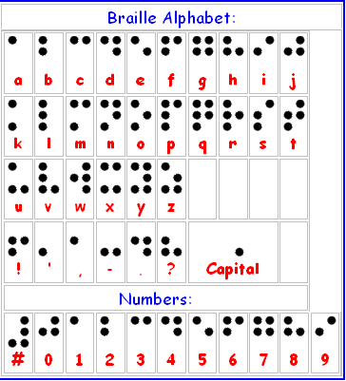

Remember, if you know anyone who is losing sight for any reason, tell them about the NFB. It’s helped many people turn their lives around (me included). ☺

National Federation of the Blind
www.nfb.org / 1-800-396-NFBO (6326)

