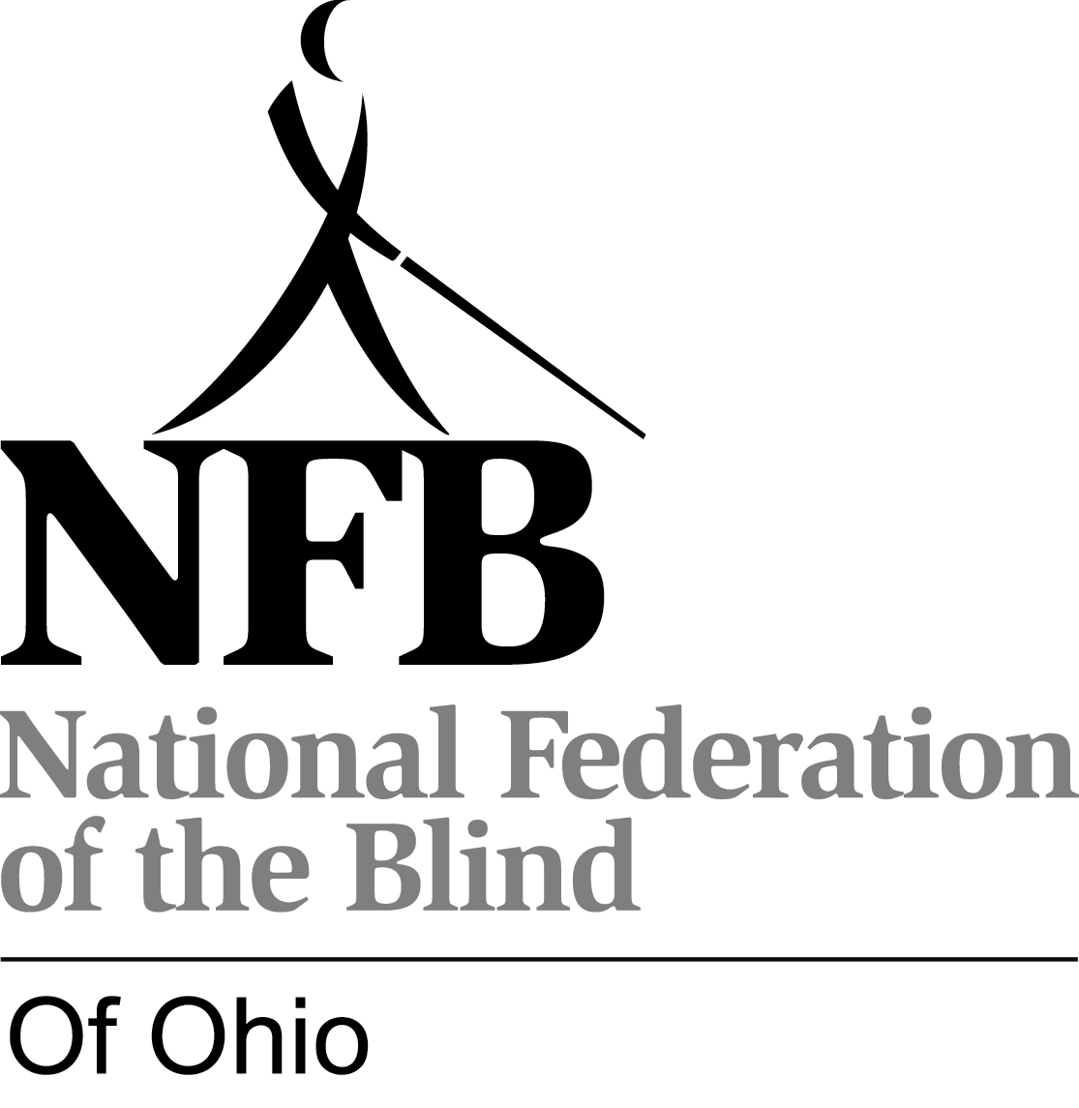

NATIONAL FEDERATION OF THE BLIND OF OHIO
2009 SCHOLARSHIP PROGRAM

In 2009 at its convention, October 30, to November 1, at the Ramada Plaza Hotel in Columbus, the National Federation of the Blind of Ohio will present the Jennica Ferguson Memorial Scholarship of $1,500 and the National Federation of the Blind of Ohio Scholarship of $1,000, to recognize achievement by a blind post-secondary scholar. All applicants for this award must be (1) legally blind and (2) pursuing or planning to pursue a full-time post-secondary course of study during the 2009-2010 academic year.

Criteria: The scholarships are awarded on the basis of academic excellence, service to the community, and financial need.

Membership: The National Federation of the Blind of Ohio is an organization dedicated to creating opportunity for all blind people. Recipients of Federation scholarships need not be members of the National Federation of the Blind.

Making Application: To apply for the National Federation of the Blind of Ohio scholarship, complete and return the application accompanying this page to be received by May 1, 2009. Please provide all the applicable information requested at the bottom of this page, and attach to your application all the additional documents requested.

Winners: The Scholarship Committee reviews all applications and selects the scholarship winners. They will be notified of selection by June 1 and will be brought to the state convention October 30 to November 1 at Federation expense. This trip is in addition to the scholarship grant.
The National Federation of the Blind of Ohio convention will be the largest gathering of blind people to occur anywhere in the state this year. You will meet other blind students and exchange information and ideas. You will also meet and talk with blind people who are successfully working in their chosen professions or occupations. State officials, legislators, and the makers and distributors of new technology attend Federation conventions. Above all, a broad cross section of the most active segment of the blind population of Ohio will be present to discuss common problems and plan for concerted action. It will be an interesting and exciting weekend.

Awards: The scholarship awards to the winners, who must participate throughout the convention in order to receive their awards, will be made during the banquet on Saturday evening, October 31.

The Jennica Ferguson Memorial Scholarship is presented by the NFB of Ohio in loving memory of an extraordinary young woman who died at the age of eighteen but who grew up to embody the best the Federation has to offer the world.

Attach the following documents to your completed application:

1. Send us a letter: we want to get to know you. What information on your application needs or deserves further explanation? How have you dealt with your blindness? What are your hopes and dreams?

2. Send or have sent two letters of recommendation.

3. Provide transcripts through December 2008 from the institution now being attended and from all other post-secondary institutions attended. If you have not yet attended a post-secondary institution or are not about to complete at least one term of study, send your high school transcript.

4. Send or have sent a letter from a state officer or chapter president of the National Federation of the Blind of Ohio showing that you have discussed your scholarship application with that officer. The state president, Dr. J. Webster Smith, (740) 592-6326, will provide contact information for a state officer or chapter president upon request.

NATIONAL FEDERATION OF THE BLIND OF OHIO SCHOLARSHIP APPLICATION FORM

Read cover sheet for instructions and explanation. This form may be photocopied, but only if the cover sheet is also included.
To apply for a scholarship, complete this application form and mail completed application and attachments to Barbara Pierce, chair, National Federation of the Blind of Ohio Scholarship Committee,237 Oak Street, Oberlin, OH 44074; phone, 440-775-2216, email, <bpierce@nfb.org>. Applications must be received by May 1, 2009.

Name (please include any student or other names by which you have been known):

Date of birth:

Spring '09 school address:

Personal phone number while at school:

Home (summer) address:

Home phone number:

Cell phone number: ___________________ Email address:

Institution being attended in spring semester, 2009, with class standing (freshman, senior, etc.):

Cumulative grade point at this institution:

Institution to be attended in fall of 2009, with class standing:

List all post-secondary institutions attended with highest class standing attained and cumulative grade point averages:

High school attended and cumulative grade point:

Vocational goal:

State your major or proposed major:

Awards and honors (attach list if necessary):

Community service (attach list if necessary):

Name of state officer or chapter president who has interviewed you and promised to send a letter:

How did you learn about this scholarship program?

(See cover sheet for list of required attachments.)

