National Association of Blind Students (NABS) Midwest Student Seminar

Marching Towards your Authenticity

March 19-20, 2021

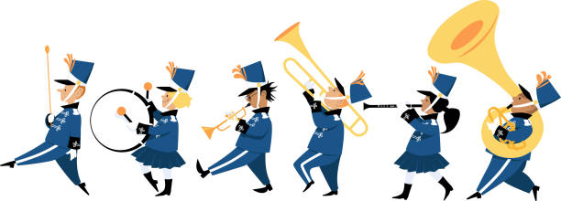

This virtual program is dedicated to equip students with the knowledge and expertise to emulate their authentic selves in all facets of life, including academic settings, the workplace, and social environments. We know that the year 2020 has taken a tole on the mental health of our members, many of whom have experienced difficulties maintaining their academic successes, social groups or environments, and even parts of their identities. Our program, rife with interactive activities, guest speakers, and opportunities to grow, aims to help each and every attendee reaffirm the elements of their authentic self. After all, we wouldn’t be a division full of diversity without the unparalleled qualities of our members. We hope you'll join us for a weekend filled with opportunities to grow, learn, and have fun!

Please make sure to register here by March 1, 2021 by 11:59 CST.

Please direct all registration questions to NABS First Vice President, Kenia Flores at kflores@keniaflores.com.

