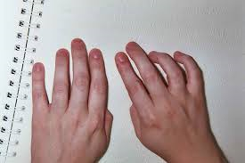
Braille Readers are Leaders

Date: April 1-30, 2016

General Information: The National Federation of the Blind of Ohio is proud to sponsor the first annual Braille Readers are Leaders contest for students in grades K-12.

Contact Information: For registration and answers to specific questions about the contest, contact either of the two names listed below.

Marianne Denning: mailto:Marianne@denningweb.com (513) 607-6053
Debra Baker: mailto:bakerdebra53@gmail.com (937) 206-2935
Categories:
Student participation will be grouped into four grade level categories:
- Students in grades K-2
- Students grades 3-5
- Students grades 6-8
- Students grades 9-12
Prizes: We will award both a first and second place prize in each of the four grade level categories.
Awards: Each participant in the Braille Readers are Leaders contest will receive a Braille magnet from National Braille Press. Magnets and first/second prizes will be distributed at a pizza party for all participants and their parents or guardians to be held in Columbus, Ohio on a later date after the contest.

