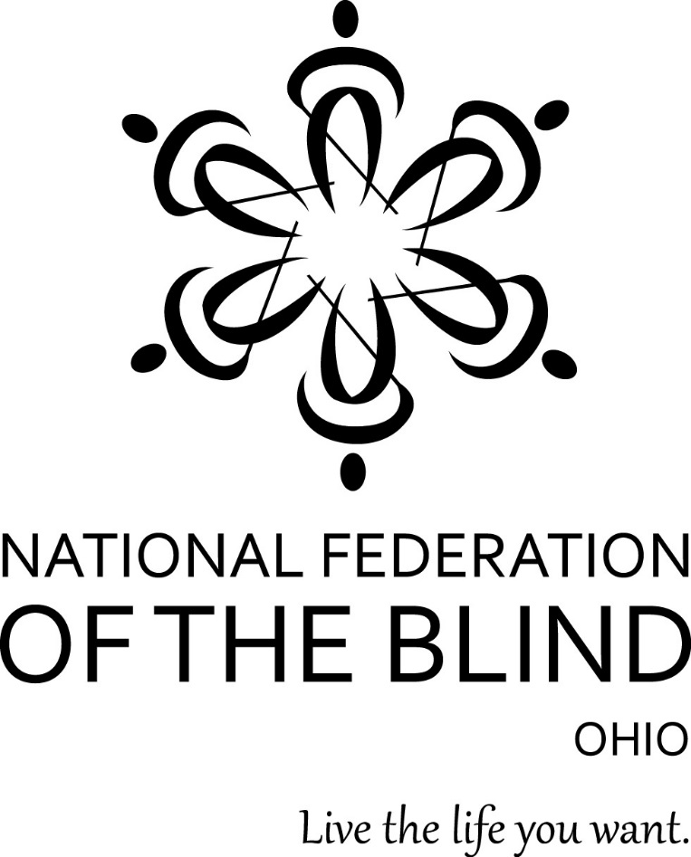
70th Annual Convention
“Marching for Independence”
Independence, Ohio
November 11-13, 2016

National Federation of the Blind of Ohio
70th Annual Convention
“Marching for Independence”
November 11-13, 2016

Richard Payne, President

Sheri Albers, Vice President & Convention Coordinator

Host Chapters
Cleveland Chapter: William Turner, President
Cuyahoga County Chapter: Shawn Martin, President

DoubleTree by Hilton Hotel
6200 Quarry Ln., Independence, Ohio 44131
216-447-1300

Welcome by Richard Payne, President
Thank you for traveling to Independence, Ohio to take part in our 70th annual state convention. We are truly happy that you are here. This year’s agenda is filled with information designed to help you live the life you want. As you take the time to get familiar with the hotel, listen to guest speakers, participate in breakout sessions, join division and chapter meetings, shop in Exhibit Hall, and enjoy a meal with your Federation family during our annual Banquet, please take a moment to reflect on the historic significance that 70 years of blind people marching together toward independence has had on our lives.

Dozens of people all across our affiliate worked tirelessly to make this convention possible. I am sincerely grateful to all those who gave hours and hours of their time and energy to make this convention special. As an all-volunteer organization, we are blessed to have a wide range of dedicated members ready to lend a hand. I hope that you enjoy the fruits of our collective efforts and let’s go build the Federation.

About the NFBO
The National Federation of the Blind of Ohio (NFBO) is a 501c3 non-profit organization and a founding affiliate of the National Federation of the Blind (NFB). We are proud to be an integral part of the oldest and largest blindness organization in the United States. We are a diverse group of people dedicated to changing what it means to be blind. Our members work tirelessly to break down the legal, social, and personal barriers to living the lives we want.

The National Federation of the Blind knows that blindness is not the characteristic that defines you or your future. Every day we raise the expectations of blind people, because low expectations create obstacles between blind people and our dreams. You can live the life you want; blindness is not what holds you back.

NFB Pledge
I pledge to participate actively in the effort of the National Federation of the Blind to achieve equality, opportunity, and security for the blind; to support the policies and programs of the Federation; and to abide by its constitution.

Navigating the DoubleTree by Barbara Pierce
This is a lovely facility with delicious food. The entrance is on the north side of the hotel, which means that you are facing south as you enter. If you step forward a few feet, the registration desk will be on the right (west) side of the lobby. Seating groups of furniture are in the center of the lobby, and Shula's Restaurant and Bar is located on the east wall. You pass through the bar before reaching restaurant seating. Wait in the bar to be seated.

After checking in, continue walking south. You will notice a corridor turning west (right). This leads to the sleeping rooms and the elevators to the upper floors. As you walk down this hall, west, you will first pass the Directors Room on your right and then the Boardroom. These are small meeting rooms, and they are close to the lobby end of the hall. This corridor dead ends into an exit with grass outside it. This is the dog relief area, and a trash receptacle will be located outside the door for your convenience. Back in the hallway turn left at that door (south) to reach sleeping rooms and the elevator; both of these are found on the left side of the hallway only. At the south end of the hall you can turn right to find Room 121, our hospitality room, or left (east) to walk along a hall that connects with the south end of the foyer area outside the ballrooms, which are also our principal breakout rooms.

Returning to the lobby just before the right turn to pass the Directors Room and Boardroom. If you angle yourself forty-five degrees to the left, you’ll find a corridor with access to the indoor and outdoor swimming pools, and the business center on the right. This hall opens into the ballroom area. There are two ballrooms, both on the left side. The first is the Grand Ballroom with division rooms 1, 2, and 3 going south. Next is a carpeted hall to the left (east) which gives access on the right side to Petit Ballrooms A and B. Rooms C, D, and E lie to the south of these two smaller rooms. Note that the only access to rooms A and B is from the cross hall. There are restrooms in the foyer on the east side before the ballrooms and also around the hallways near the elevators.

That's it. Read through this article several times, pausing after reading each new element to build a map in your head. If you take time to do this, you will sail through the convention with no problems. All rooms are marked in Braille and raised print in the standard locations. Happy travels.

Convention Arrangements
If you have any questions about convention arrangements, contact Sheri Albers, Convention Coordinator at 513-886-8697.

Registration and Literature
NFB literature will be available throughout the convention in the registration area. Pre-Registration packet pick-up and convention registration will take place in the foyer outside of the Grand Ballrooms. Those who have completed their registration prior to convention will form a line at the Pre-Registration Table for a speedy process. Visit the Registration Table to register for convention or to purchase additional tickets to events. Both tables will be open for two shifts on Friday, Nov. 11, from 9:00 AM to 10:45 AM and 12:15 PM to 1:45 PM and then again on Saturday, Nov. 12 from 8:00 AM to 8:45 AM. The Cuyahoga County Chapter has volunteered to staff both tables at convention. Please contact Shawn Martin with any questions or concerns at 216-288-1243.

Door Prizes
Door prizes should be labeled clearly in print and Braille with the donor's name and the amount of cash or type of gift. Suzanne Turner is in charge of door prizes. They may be brought to her directly or left at Convention Registration with Rachel Kuntz Call or text Suzanne Turner at 216-990-6199 if you have questions or concerns.

Guide Dogs
There are two relief areas for your convenience. The first is located outside the west doors, off the hall that runs past the Directors Room. The second, is on the south side, at the end of the hall, past the meeting rooms. A trash receptacle will be provided. Please note you will need your room key after 10:00 PM to get back into the hotel from those exits. If you have questions or need assistance, contact Deanna Lewis, President of the Ohio Guide Dog Users Division at 513-328-7976.

Exhibit Hall
Whether you are an information seeker or a new gadget shopper, you will find everything that you need to help you live the life you want at this year’s Exhibit Hall. Visit Exhibit Hall in Grand Ballroom 1 on Saturday, Nov. 12 from noon to 5 PM to explore the latest technology and to get answers to the questions that race through your mind about employment, healthcare, services for the blind, and so much more. All visitors will be entered to win a door prize.

Convention Agenda

Friday, November 11, 2016

9:00 AM to 10:45 AM: Pre-Registration Packet Pick-up and Convention Registration –
Grand Ballroom Foyer

9:00 AM to 10:30 AM: The Art of Structured Discovery: Cane Travel the Federation
Way led by Shelbi Hindel, Secretary, NFBO. Participants should meet in the main lobby near the front desk and will take a walking tour of the hotel.

11:00 AM to Noon: Board of Directors Meeting - Petit A and B Open to all convention attendees.

12:15 PM to 1:45 PM: Pre-Registration Packet Pick-up and Convention Registration Grand Ballroom Foyer

12:15 PM to 1:45 PM: NFBO Meet and Greet – Petit A and B Stop by to enjoy light
refreshments and network with other convention attendees.

General Session – Grand Ballroom 1

2:00 PM: Call to Order by Richard Payne, President, NFBO

2:02 PM: Invocation

2:05 PM: Welcome to Independence by Frank G. Jackson, Mayor, Cleveland, Ohio; Shawn Martin, President, Cuyahoga Chapter; and
William H. Turner, President, Cleveland Chapter.

2:20 PM: Convention Arrangements by Sheri Albers, Vice President, NFBO

2:30 PM: Traveling with Another Tool in the Toolbox by Jerrod Witt CEO and Founder, AudiblEye, LLC.

3:00 PM: Three Benefits of Friendship by Dr. Carolyn Peters, Theologian, Spiritual Counselor at College Hill Community Church in Dayton, Ohio, Board Member of Disability Rights Ohio, and Board Member of the Miami Valley Chapter.

3:25 PM: The Characteristics of an NFB Training Center by Dick Davis, Associate Director of BLIND, Inc. in Minneapolis, MN.

3:50 PM: Building Student Leaders with Sound NFB Philosophy by Bryan Duarte, QwikEyes CEO, National Association of Blind Students Board Member, ASU Computer Science Ph.D. candidate.

4:15 PM: My Experience as a Blind Licensed Massage Therapist by Deanna Lewis,President, Ohio Association of Guide Dog Users and Board Member, NFBO.

4:35 PM: My Involvement in the Emerging Leaders Program and Working as a Blind Vendor by Annette Lutz, President, Ohio Association of Blind Merchants.

4:50 PM: Announcements and Door Prizes

5:00 PM: Adjourn – General Session resumes at 9:00 AM tomorrow.

5:00 PM to 6:00 PM: Ohio Association of Blind Merchants Meeting, Annette Lutz, President - Petit A and B

5:30 PM to 8:30 PM: Hospitality and Game Night - Parlor 121
The Cleveland Chapter, with help from the Cuyahoga Chapter, welcomes you to Cleveland with food and activities for all ages. The evening will begin in the hospitality suite, Parlor 121, then moves to the Amphitheater later in the evening for interactive games.

6:30 PM to 8:30 PM: Sports and Recreation, Maryann Denning, President, OAPUB - Grand Ballroom 3

7:00 PM to 8:00 PM: At Large Chapter Meeting, Colleen Roth, President - Petit A and B

8:00 PM to 8:30 PM: Resolutions Committee Meeting, Debbie Baker, Chair - Petit A and B

8:30 PM: Nominating Committee Meeting, Dr. Carolyn Peters, Chair - Petit C
This is a closed meeting.

10:00 PM to 10:45 PM: “Erma Wants Extra Money for Christmas” Play performance presented by the Ohio Association to Promote the Use of Braille. Tickets are $5.00 and will be sold at the door. – Grand Ballroom 3

Saturday, November 12, 2016

7:00 AM to 8:45 AM: Ohio Association to Promote the Use of Braille Breakfast Meeting, Maryanne Denning, President - Petit A and B

7:00 AM to 8:30 AM: Ohio Diabetes Action Network Breakfast Meeting, Richard Payne, President, NFBO - Shula's Restaurant

8:00 AM to 8:50 AM: Pre-Registration Packet Pick-up and Convention Registration – Grand Ballroom Foyer

General Session – Grand Ballroom 3

9:00 AM: Call to Order by Richard Payne, President, NFBO

9:10 AM: Report from the Talking Book Library by Kenneth Redd, Library Assistant, Outreach, Ohio Library for the Blind and Physically Disabled at the Cleveland Public Library.

9:35 AM: Advocating for your Rights by Gayle Horton, Ohio Disability Rights Law and Policy Center, Inc.
This comprehensive presentation will highlight legal protections against employment discrimination under the ADA, when and how to request reasonable accommodations, when and how to file a complaint with EEOC and/or OCRC, as well as a discussion of your rights and the different resources for transportation available throughout Ohio.

10:10 AM: Report from the Bureau of Services for the Visually Impaired by Robert Nicholson, Assistant Deputy Director of BSVI and Statewide Business Engagement, along with Elizabeth L. Sammons, Program Administrator at Opportunities for Ohioans with Disabilities.

10:45 AM: National Report by Anil Lewis, Executive Director, National Federation of the Blind Jernigan Institute. Baltimore, MD.

11:20 AM: BELL Rings Again in Ohio by Sheri Albers, Vice President, NFBO and special guests.

Noon: Adjourn – General Session resumes at 9:00 AM tomorrow.

Noon: Boxed Lunch Pick-up (tickets required) – Grand Ballroom Foyer

Noon to 5:00 PM: Exhibit Hall – Grand Ballroom 1

12:15 PM to 1:45 PM: Ohio Organization of Blind Seniors Meeting, Barbara Pierce, President - Petit A and B

12:15 PM to 1:45 PM: Ohio Association of Guide Dog Users Meeting, Deanna Lewis, President - Petit C

12:15 PM to 1:45 PM: Real Talk: Repairing and Recovering from the Effects of Financial Abuse, Cheryl Fields, Board Member, NFBO - Grand Ballroom 3
This workshop raises awareness of the real and dangerous impact that financial abuse has on the lives of its victims and discusses ways in which they can recover from it.

12:15 PM to 1:45 PM: Student Luncheon, Bryan Duarte, Board Member, NABS - Director's Room

2:00 PM to 3:30 PM: Establishing the Tone and Setting the Pace: Assuming Leadership in the NFB by Barbara Pierce, Board Member, NFBO and Richard Payne, President, NFBO - Grand Ballroom 3

3:00 PM to 5:00 PM: Technology Workshop by Robert Spangler, Secretary of the Miami Valley Chapter, Jordy Stringer, and Christopher Sabine, Secretary of the Cincinnati Chapter - Amphitheater
Demonstrations and discussions about Windows 10 operating system, Google Apps, Apple products, popular iPhone Apps, KNFB Reader, Tap Tap See, and more are planned for this open forum workshop.

3:30 PM to 5:00 PM: Membership Building 101: Back to Basics by Rachel Kuntz, Board Member, NFBO with special guest Anil Lewis, Executive Director, NFB Jernigan Institute - Grand Ballroom 3

3:30 PM to 5:00 PM: Career Building and Exchange Symposium by Suzanne Turner with Dick Davis, National Representative, Employment Chair/ Associate Director of BLIND, Inc. – Petit A and B
This Exchange will highlight, emphasize, and spark a serious dialogue about the steps that are needed for the blind to become successful interviewers, job seekers, and network builders. Job searching, interviewing and taking assessments are focal points in obtaining a job so it can be depressing, humiliating and scary if one does not have the tools to be productive. Come and engage in a serious and interactive dialogue on the provisions and success in searching, preparing, debriefing, and effectively obtaining competitive employment.

5:30 PM to 6:30 PM: Pre-Banquet Social Hour – Grand Ballroom Foyer
Appetizers and cash bar.

6:30 PM: NFBO Banquet (tickets required) - Grand Ballrooms 2 and 3
Event Highlights:
- Master of Ceremonies - Dr. JW Smith, Professor of Communications, Ohio University
- Keynote Speaker - Anil Lewis, Executive Director, NFB Jernigan Institute
- Gavel Awards - Shelbi Hindel, Chair, Awards Committee and Secretary, NFBO
- Scholarship Awards - Deborah Kendrick, Chair, Scholarship Committee, and President, Cincinnati Chapter
- Not So Silent Auction
- Money for the Movement - Richard Payne, President, NFBO

9:00 PM to 1:00 AM: After Party – Grand Ballrooms 2 and 3
Stick around after the banquet to dance the night away with your federation family. Enjoy live music, cash bar, and fellowship.

Sunday, November 13, 2016

8:00 AM to 8:45 AM: Musical Showcase by Dr. Carolyn Peters - Grand Ballroom 1

General Session – Grand Ballroom 1

9:00 AM: Call to Order by Richard Payne, President, NFBO.

9:05 AM: What is the NFB NEWSLINE and Why it is a Valuable Tool to the Blind Community by Lee Martin, CEO and Host of “See What I’m Sayin” Internet Radio Show, President of the Circle City Chapter, State Coordinator of NFB NEWSLINE Indiana, and Board Member of the NFB of Indiana and by Florence Myers-McSwine, Manager and Co-Host of the “See What I’m Sayin” Internet Radio Show, Vice President of the Circle City Chapter, NFB NEWSLINE of Indiana, Contractor, and Administrative Assistant.

9:35 AM: Why I Am a Federationist by Emily Pennington, Treasurer, Cincinnati Chapter and Law Student at the University of Cincinnati.

9:55 AM: Nominating Committee Report by Dr. Carolyn Peters, Chair

10:00 AM: Affiliate Elections

10:30 AM: The Art of Law by Michael Leiterman

10:50 AM: Financial Report by Sherry Ruth, Treasurer, NFBO

11:00 AM: Resolutions by Debra Baker, Chair

11:15 AM: My First National Convention by Alex Crawford, student at OSSB, Paul Jordan, Board Member of the Cincinnati Chapter, and Heather Leiterman.

11:45 AM: Convention Wrap-up and Other Announcements by Richard Payne, President, NFBO.

Noon: Adjournment

National Federation of the Blind of Ohio
2016 Board of Directors

President - Richard Payne
1019 Wilmington Ave., Apt. 43
Kettering, OH 45420
937-396-5573
rchpay7@gmail.com

Vice President - Sheri Albers
3052 Lischer Ave.
Cincinnati, OH 45211
513-886-8697
Sheri.albers87@gmail.com

Secretary - Shelbi Hindel
185 Crestview Rd.
Columbus, OH 43202
614-558-8059
shelbiah1@gmail.com

Treasurer - Sherry Ruth
6922 Murray Ridge Rd.
Elyria, OH 44035
440-324-4218
babyruth2@windstream.net

At Large Board Members

Macy McClain
701 Stonehollow Pl.
Bellefontaine, OH 43311
937-935-2610
macymcclain0990@gmail.com

Barbara Pierce
198 Kendall Dr.
Oberlin, OH 44074
440-774-8077
barbara.pierce9366@gmail.com

William Turner
1064 E. 167th St.
Cleveland, OH 44110-1523
330-328-9860
william.h.turner@ssa.gov

Rachel Kuntz
7281 Birchwood Dr.
West Chester, OH 45069
937-245-0547
rachelrkuntz@gmail.com

Cheryl Fields
PO Box 202091
Cleveland, OH 44120
216-566-4317
cherylelaine1957@gmail.com

Deanna Lewis
2526 Meyerhill Dr.
Cincinnati, OH 45211
513-328-7976
deannakay03@gmail.com

2016 Convention Sponsor Honor Roll

The NFB of Ohio is truly grateful to the following sponsors for their commitment to helping the blind of Ohio live the life they want.

Gold Sponsor
Medical Mutual of Ohio
2060 East 9th St.
Cleveland, OH 44115-1355
800-822-1152 (TTY/TDD 711
http://www.medmutual.com/

Medical Mutual is proud to support the National Federation of the Blind of Ohio.

Appearing on the right of this message in the large print agenda, is an image of two people smiling while in a friendly embrace above the phrase “Our humanity makes us human” followed by the logo and website of Medical Mutual of Ohio.

Silver Sponsors
Cincinnati Association for the Blind and Visually Impaired
2045 Gilbert Ave.
Cincinnati, OH 45202
513-221-8558 or 888-687-3935
http://www.cincyblind.org/

CABVI offers blind and visually impaired people the opportunity to seek independence.
Disability Rights Ohio
50 W. Broad Street, Suite 1400
Columbus, OH 43215-5923
614-466-7264 or 800-282-9181 (Toll free in Ohio only)
TTY 614-728-2553 or 800-858-3542 (Toll free in Ohio only)
http://www.disabilityrightsohio.org/

Disability Rights Ohio is a non-profit corporation with a mission to advocate for the human, civil, and legal rights of people with disabilities in Ohio.

Bronze Sponsors
Vanda Pharmaceuticals
2200 Pennsylvania Ave NW, Suite 300E
Washington, DC 20037
202-734-3400
http://www.vandapharma.com/index.html

Vanda has worked closely with the National Federation of the Blind to educate the public about non-24 Sleep Wake disorder and to market the drug, Hetlioz, to treat individuals with non-24.

Scholarship Sponsor
Norwalk Ohio Lions Club

Their generous gift in support of blind college students will have a lasting impact on us all.

Media Sponsor
Vivian L. Sharp Productions
Cleveland, Ohio
216.272.5865
http://www.vivianlsharp.com/

