Songwriters: Danny Jones / Carroll Roberson. Carroll Roberson has this on a CD.

From 1558 until 1829, Roman Catholics in England were not permitted to practice their faith openly. Someone during that era wrote this carol as a catechism song for young Catholics.

It has two levels of meaning: the surface meaning plus a hidden meaning known only to members of their church. Each element in the carol has a code word for a religious reality which the children could remember.

The partridge in a pear tree was Jesus Christ.

Two turtle doves were the Old and New Testaments.

Three French hens stood for faith, hope and love.
- 1 Corinthians 13:13

The four calling birds were the four gospels of Matthew, Mark, Luke & John.

The five golden rings recalled the Torah or Law, the 1st 5 books of the Old Testament
- Genesis * Exodus * Leviticus * Numbers * Deuteronomy

The six geese a-laying stood for the six days of creation.
- Genesis 1:3 – 5 Light called Day and Darkness called Night
- Genesis 1:6 - 8—firmament in the midst of the waters (one above called Heaven)
- Genesis 1:9 – 13—firmament under the heavens called Earth and yielded seed after its kind
- Genesis 1:14 – 19—greater light to rule the day and lesser lights to rule the night
- Genesis 1:20 – 23—waters abounded with living creatures and birds to fly above the earth
- Genesis 1:24 – 25—earth bring forth cattle and creeping things according to its kind
- Genesis 1:26 – 31—Let Us make man in Our image and Our likeness (male and female)
Seven swans a-swimming represented the sevenfold gifts of the Holy Spirit:
Prophesy, Serving, Teaching, Exhortation, Contribution, Leadership, and Mercy.
- 1 Corinthians 12:1 – 11 1 Corinthians 13 (gift of love) 1 Corinthians 14 (gift of prophesy)

The eight maids a-milking were the eight be attitudes.
- Matthew 5:3 - 12

Nine ladies dancing were the nine fruits of the Holy Spirit:
Love, Joy, Peace, Patience, Kindness, Goodness, Faithfulness, Gentleness, and Self Control.
- Galatians 5:22 - 23

The ten lords a-leaping were the Ten Commandments.
- Exodus 20:3 – 17 and Luke 18:20

The eleven pipers piping stood for the eleven faithful disciples.
- Matthew 10:2 – 4 (the twelve) and 28:16 (the eleven faithful)

The twelve drummers drumming symbolized the twelve points of belief in the Apostles' Creed.

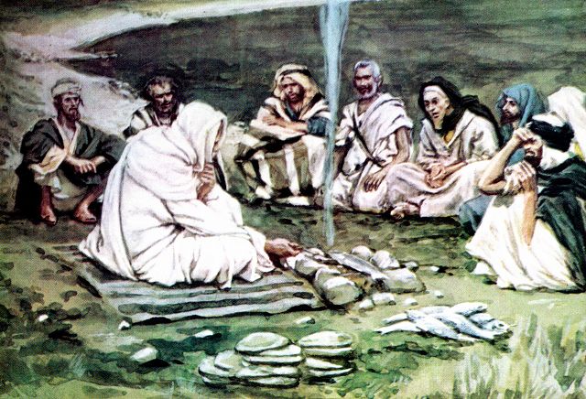

THE APOSTLE’S CREED

The United Methodists commonly include the Apostles' Creed in their worship services. Their version of the Creed is special because it does not have the line "he descended into hell." Except for this, it is very similar to the version in the Book of Common Prayer.

I believe in God the Father Almighty,
Maker of heaven and earth; and in
Jesus Christ His only Son our Lord:
Who was conceived by the Holy Spirit,
Born of the Virgin Mary, suffered under
Pontius Pilate, was crucified, dead, and buried.

The third day He rose from the dead;
He ascended into heaven, and sits at
the right hand of God the Father Almighty.
From there He shall come to judge the quick and the dead.

I believe in the Holy Spirit,
The holy catholic church,
The communion of saints,
The forgiveness of sins,
The resurrection of the body,
And life everlasting. Amen.

On the first day of Christmas
Jesus gave to me Salvation full and free

On the second day of Christmas
Jesus gave to me Everlasting life and salvation full and free

On the third day of Christmas
Jesus gave to me Peace in my heart, Everlasting life, and salvation full and free

On the fourth day of Christmas
Jesus gave to me Love for all men, Peace in my heart, Everlasting life,
and salvation full and free

On the fifth day of Christmas
Jesus gave to me Joy for my soul, Love for all men, Peace in my heart,
Everlasting life, and salvation full and free

On the sixth day of Christmas
Jesus gave to me Power from on high, Joy for my soul, Love for all men,
Peace in my heart, Everlasting life and salvation full and free

On the seventh day of Christmas
Jesus gave to mea body glorified, Power from on high, Joy for my soul,
Love for all men, Peace in my heart, Everlasting life and salvation full and free

On the eighth day of Christmas
Jesus gave to me a robe and a crown, a body glorified, Power from on high,
Joy for my soul, Love for all men, Peace in my heart, Everlasting life,
and salvation full and free

On the ninth day of Christmas
Jesus gave to me Mansions above, a robe and a crown, a body glorified,
Power from on high, Joy for my soul, Love for all men, Peace in my heart,
Everlasting life and salvation full and free

On the tenth day of Christmas
Jesus gave to me Streets of pure gold, Mansions above, a robe and a crown,
a body glorified, Power from on high, Joy for my soul, Love for all men,
Peace in my heart, Everlasting life, and salvation full and free

On the eleventh day of Christmas
Jesus gave to me a thousand songs to sing, Streets of pure gold, Mansions above,
a robe and a crown, a body glorified, Power from on high, Joy for my soul,
Love for all men, Peace in my heart, Everlasting life and salvation full and free

On the twelfth day of Christmas
Jesus gave to me Eternity to praise, a thousand songs to sing, Streets of pure gold,
Mansions above, a robe and a crown, a body glorified, Power from on high,
Joy for my soul, Love for all men, Peace in my heart, Everlasting life,
and salvation full and free

