UPCOMING POPCORN PARTY FUNDRAISER
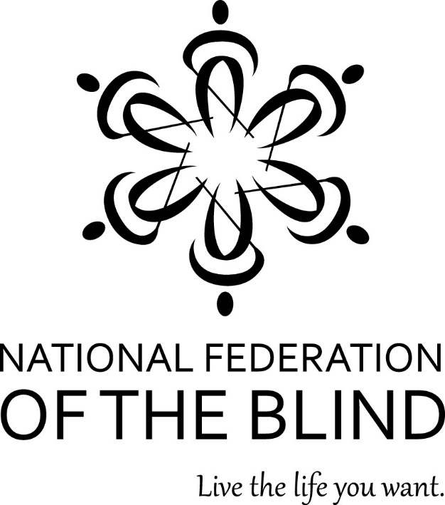
NFB OF ILLINOIS AT LARGE CHAPTER
Fundraiser event: Popcorn Party
Place: NFB of IL AT LARGE CHAPTER’s Pop-Up Store
popup.doublegood.com
When: Coming soon September 2024
Support our efforts and intent,
To get blind people to our programs and events.
Buy the popcorn you love today,
As we teach blind people to live life our own way!

