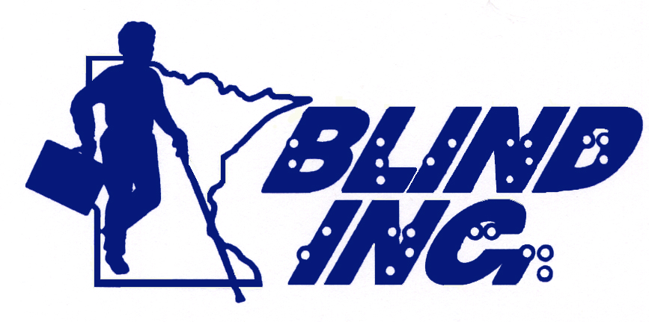
Blindness: Learning In
New Dimensions, Incorporated
100 East 22nd Street.
Minneapolis, Minnesota 55404
Phone: (612) 872-0100 or 800-597-9558
Fax: (612) 872-9358
Email: info@blindinc.org
Web: www.blindinc.org

The Life 101 Summer Program
For High School & College Students

Greetings!

It’s half way through Winter already, and Spring will soon be upon us, but it’s not too early to start thinking about your summer plans. If you are in high school or college, check out the Life 101 Summer Program at BLIND, Incorporated.

In summary, the Life 101 Program is two programs in one; one for transition ages 14 – 17, and the other for those that are in, or about to attend college.

Transition Students ages 14 – 17
This age group will receive similar classes and instruction as the college bound Life 101 students, which will be taught in part, by the blind adult instructors who will be living with them in housing that is separate from our adult students. Please see the descriptions of the program and classes below. This group has specific beginning and ending dates for the program, and is limited to 10 students. The dates for this group this summer is: July 14 through August 8, 2009.

Description of the Life 101 Program
The Life 101 College and Employment Readiness program is an eight-to-ten-week training program to prepare college- and employment-bound high school and college students who are blind with skills and information to promote academic, employment, and social success. Note taking, using readers, ordering books in alternative formats, the role of offices for students with disabilities, time-management, social interaction with fellow students, extensive career exploration, becoming comfortable with blindness, dealing with the misconceptions professors and employers may have about blindness, nutrition and physical fitness as a college student or member of the workforce will be addressed. In addition, core classes in blindness related skills such as Braille reading and writing, independent cane travel, home/dormitory management, including cooking, cleaning, and washing and labeling clothes, daily living skills, industrial arts, and adaptive technology-are all included.

The Life 101 students will participate in seminars where we discuss issues related to blindness and participate in activities such as rock climbing, shopping at the Mall of America, going to amusement parks, canoeing, visiting college campuses, and others. Our curriculum is designed to not only give students the skills they need to be successful in the career fields they choose, but also to give them the confidence and belief in themselves they need to find and keep a job. This program is based on a positive view of blindness, that if blind people are given proper training and opportunity, they can be successful in college, and live full and productive lives.

Life 101 College Bound Students
These students enrolled in our Life 101 Program are integrated into our full-time Adult Comprehensive Program, receiving the same classes and instruction, with a focus on college preparation and success. Classes are Monday through Friday, 8:00 AM to 4:30 PM, and our students compute from an apartment complex to our center daily using our public bus system.

These Life 101 students stay in a two-bedroom apartment. This apartment building contains 48 apartments, some rented by the public, and some are occupied by our other adult students. A BLIND Incorporated staff member lives in this apartment building, and is there to answer questions, and to assist or instruct when necessary.

Living in these apartments is an extension of our Home Management class. Our students are instructed in how to care for the apartments as their own, do their grocery shopping, cooking meals, cleaning, and laundry.

The deadline for applying for the Life 101 Program is April 15, and space is limited. We will continue to accept applications after this deadline, but will only be able to approve them if a vacancy occurs. So don’t hesitate, don’t wait, and don’t procrastinate, fill out the application form and return it to us soon. It’s going to be another great summer!

To have an application for the Life 101 Program mailed or e-mailed to you contact Al Spooner
612-872-0100 Ext. 226
Or Toll Free: 800-597-9558
E-mail: aspooner@blindinc.org
You may also complete the Life 101 application on our web site at: http://www.blindinc.org/lifeapp.htm

Return the completed application by mail or fax to:
Life 101 Program
BLIND, Incorporated
100 East 22nd Street
Minneapolis, MN 55408
Fax: 612-872-9358

For more information, please contact me by e-mail or by calling one of the phone numbers listed above.

Sincerely,

Al Spooner
Assistant Director, Outreach & Marketing
BLIND, Incorporated

