Adventure-In-Fun-Learning!

THE BUDDY PROGRAM
A summer adventure for children ages 9-13.
Dates: Friday, July 17 through Saturday, August 8, 2009
Blindness: Learning In New Dimensions, Incorporated
100 East 22nd Street, Minneapolis, MN 55404
612-872-0100 or 800-597-9558 Fax: 612-872-9358
Web: http://www.blindinc.org E-mail: aspooner@blindinc.org

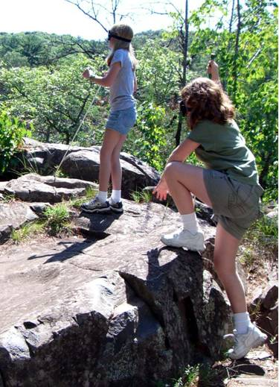
The Buddy Program offers an opportunity for blind children to make friends and have fun in a comfortable and secure setting as well as to learn and practice alternative techniques of blindness.

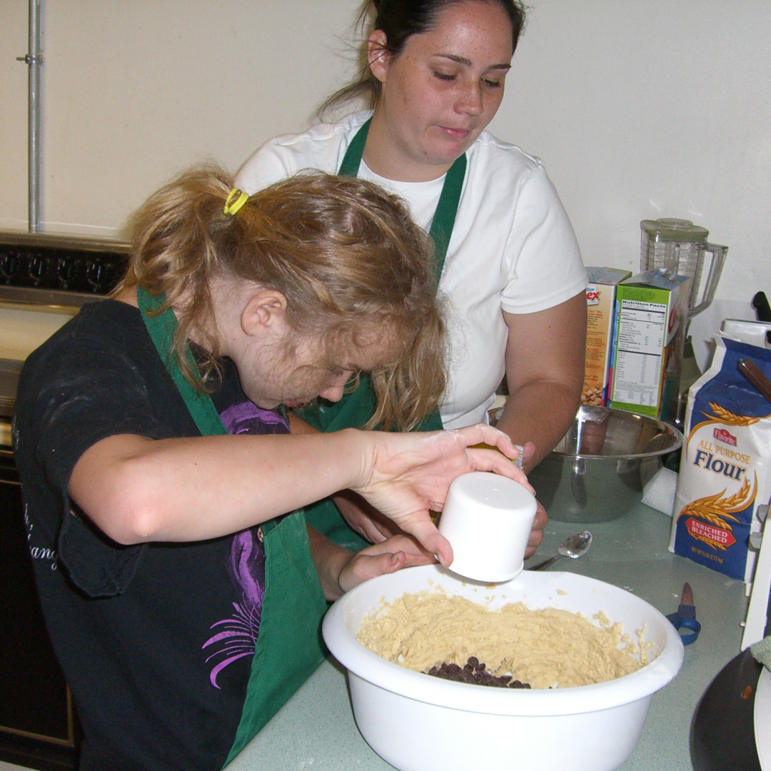
The training in alternative techniques includes: instruction in reading and writing Braille, basic cane travel, cooking skills, and introductions to independent living skills and industrial arts. Students may learn to pour liquids, carry a food tray, do laundry, follow a recipe, and much more. Students have also built and painted their own birdhouses and nightstands. Students also participate in "talk time," where they discuss important issues about blindness with blind peers and instructors. This time gives the students a chance to discuss their feelings about blindness, their frustrations with uncomfortable situations, and suggestions for overcoming problems caused by blindness.

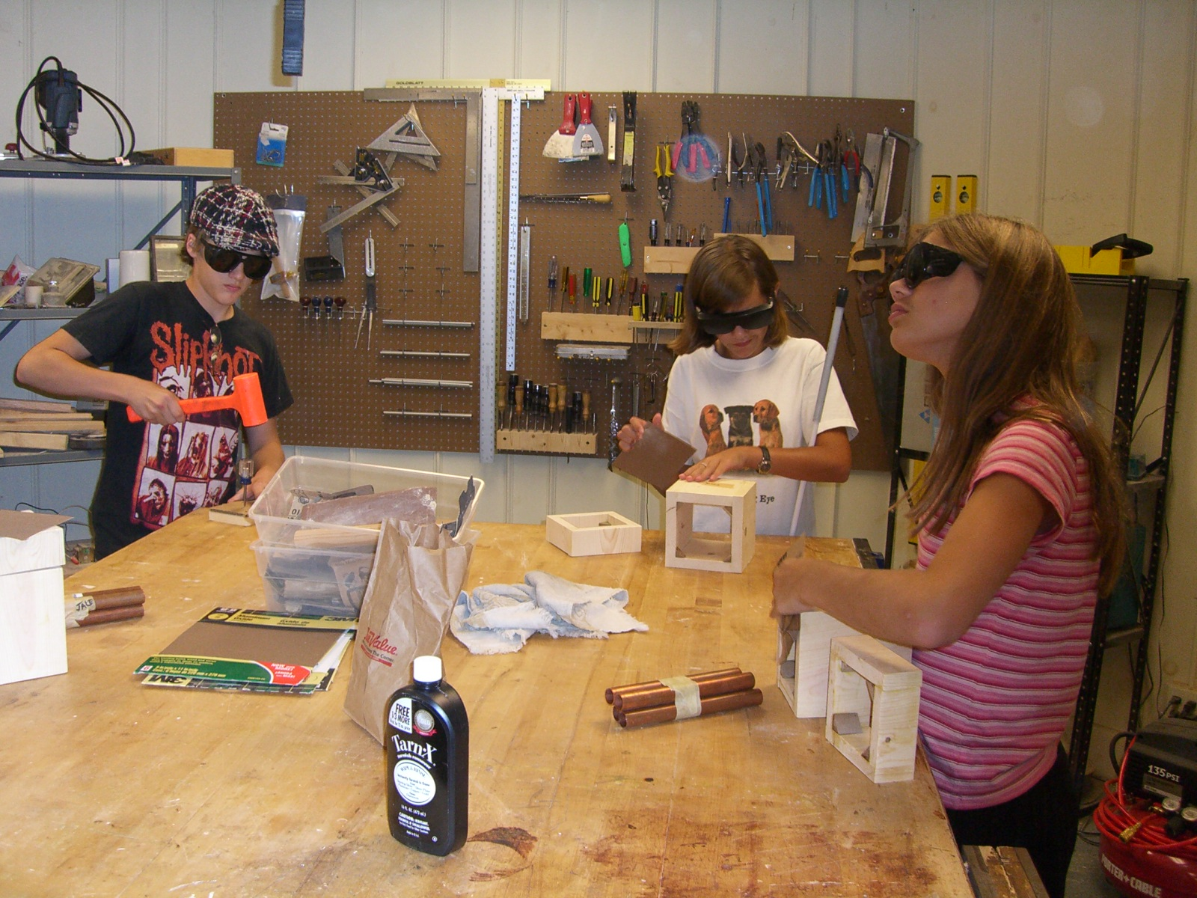
In addition, students participate in many exciting activities in the Twin Cities area, such as visits to the Mall of America, rock climbing, and horseback riding. These activities allow students to develop their socialization skills. Activities are well-supervised and mentoring for the children is provided by active blind role models. Lifelong friendships begin during this brief summer experience.

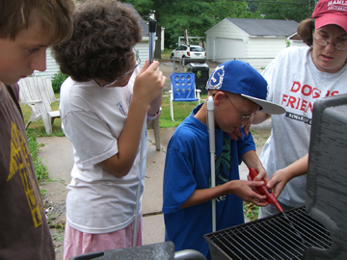
During all of these out-of-the- classroom activities during Buddy Camp, one of our motives is to teach our students the alternative techniques of blindness that would allow them to return home and actively participate in even more fun and activities with their sighted friends.

Activities are excellent opportunities to teach and reinforce a wide variety of alternative techniques, as they apply to real life, and this learning experience is usually most effective when there is a lot of fun involved.

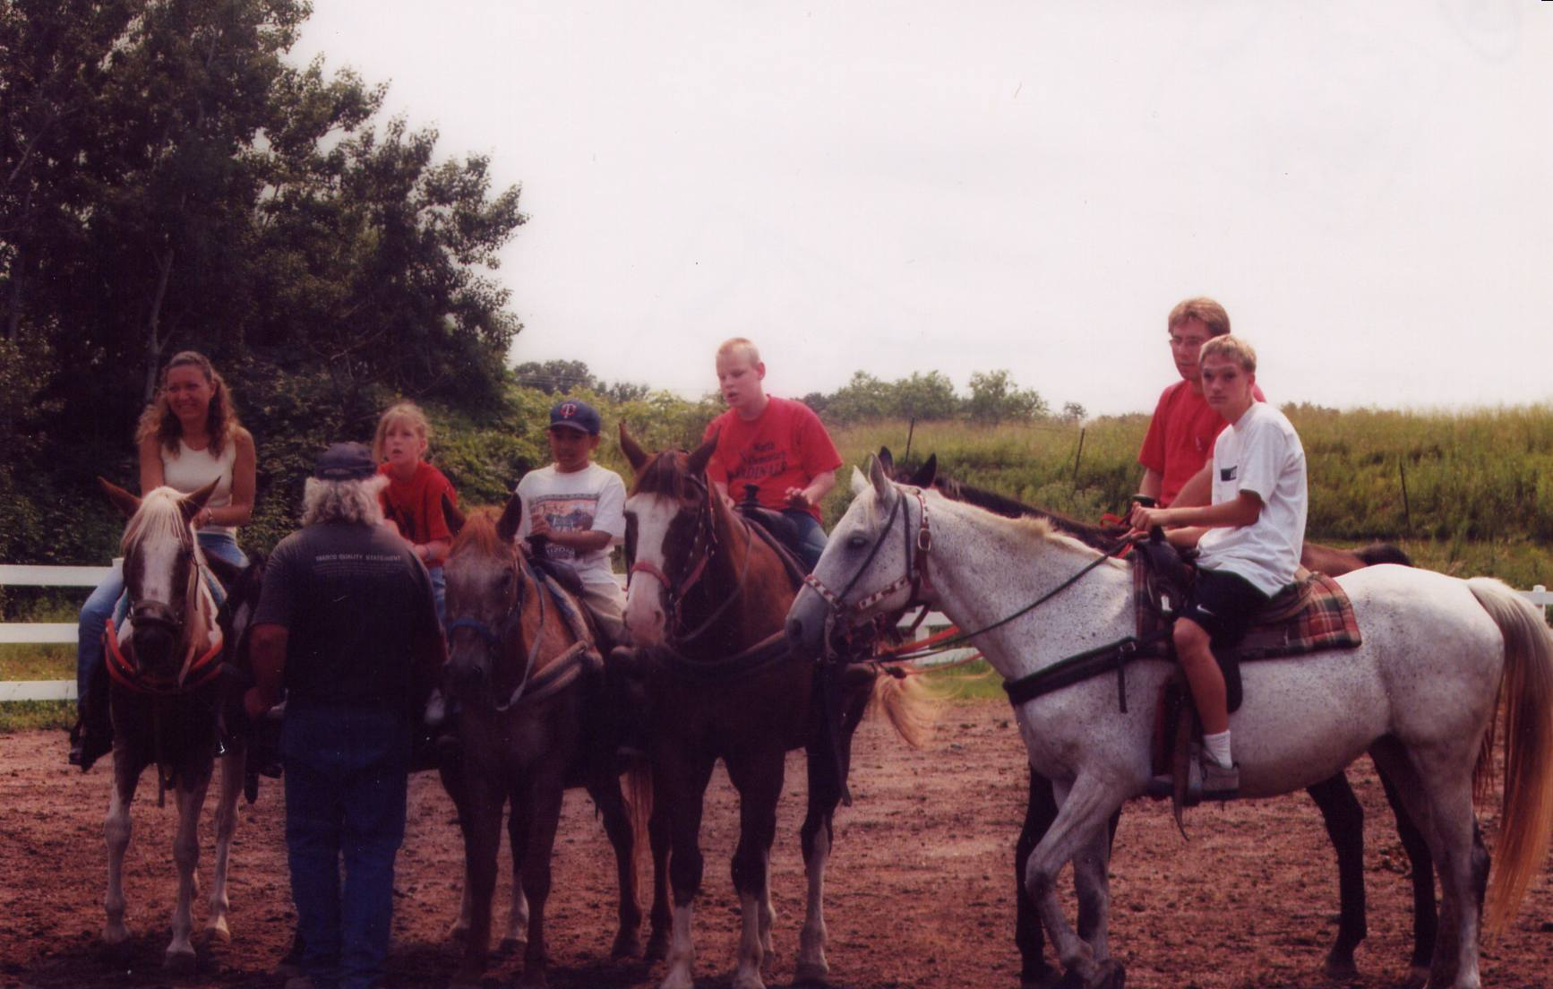
It may be as simple as reinforcing cane techniques by participating in activities such as rock climbing, hiking, and skating, or reinforcing a positive philosophy about blindness through meeting and spending time with positive blind role-models. Below, you will find a description of one of the activities that our Buddies have participated in during some of the previous summers at Buddy Camp.

Wild Mountain Water Park
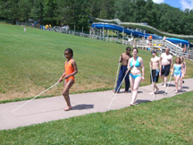
This was a great experience and very rewarding for the Buddies, after their first week of Buddy Camp. The Buddy staff and students joined with the full-time adult and summer Life 101 students, along with the staff of BLIND Incorporated on an all day activity at Wild Mountain Water Park. The school bus that we chartered was filled with noise and excitement during our one-hour trip to the park as everyone on board chattered with anticipation. This was the first of many great opportunities for the Buddies to practice their cane travel skills, navigating the maze of sidewalks and climbing up the many winding stairs to the top of the water slides. Lunchtime presented them with a buffet line, and an opportunity to interact socially with their blind adult peers and exchange the experiences of that morning’s adventure.

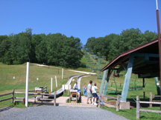
In the afternoon, many of the Buddies rode the Alpine Slide. This slide is a long and curvy concrete trough that extends from the top to the bottom of the mountain. Each rider has his or her own cart to sit on, and each manually controls the rate of descent, which determines how fast he or she goes. Some felt that this was the most exciting ride of all!

While the Buddy Program is supported primarily through grants, this does not cover the entire cost for operating the program. If your child is accepted into the Buddy Program the individual fee will be $200.00. This fee can be paid through your state rehabilitation agency, your child’s school by inclusion in the IEP, individually, or any other source(s). If you would like assistance in working with any of these agencies please let us know. Some scholarships for fee waivers may be available. Please contact us for further information. Up to ten children will be accepted. Unfortunately, we are unable to accept all the individuals applying to the Buddy Program as we receive more applications than space available.
For More an application, or for more information, please contact:
Al Spooner aspooner@blindinc.org
Or call: 800-597-9558 ext. 226

