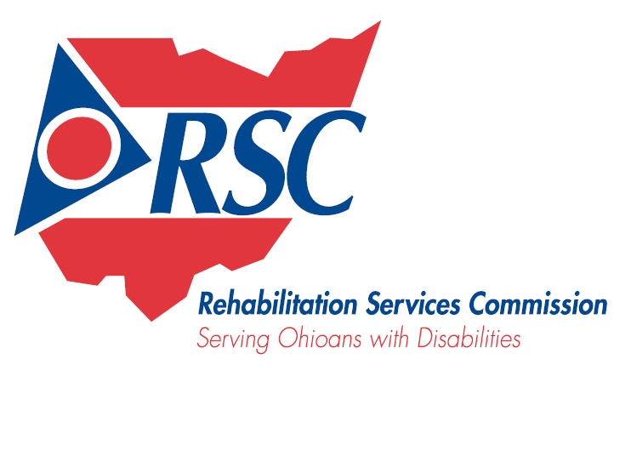
Community Conversation Sponsor
Wrap Up Meeting
Wednesday, May 27, 2009 9:30 to 11:30 a.m.
400 E. Campus View Blvd., Columbus, OH 43235

9:00 a.m. Welcome and Introductions

9:15 a.m. Overview of Community Conversation Report
Common Themes
Feedback of 2009 Process

9:45 a.m. General Discussion
Next Steps

11:00 a.m. Adjourn

