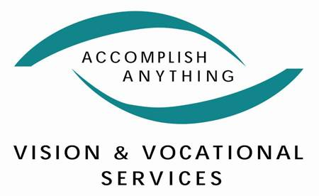

Vision & Vocational Services
1393 N. High Street
Columbus, Ohio 43201
(614) 294-5571

Position: Assistive Technology Specialist

Pay Range: Negotiable

Department: Low Vision Services

Usual working hours (37.5 hours per week): Monday through Friday, between the hours of 8:00am and 4:30pm with a 1 hour (non-paid) lunch.

Position Description:

The Assistive Technology Specialist will provide technology evaluation, consulting, support, and training for persons with disabilities.

Researches, prepares, conducts and evaluates group and/or individual instruction and evaluation in adaptive technology. Clearly writes and composes reports and case notes as required and within expected timeframes on clients seen for services. Provides technical support to clients and/or directs them to appropriate technical resources. Maintains adaptive equipment, software and other resources in good working order. Develops relationships with manufacturers and distributors of assistive technology devices, remains up-to-date on changes occurring within the field and disseminates information to various stakeholders. Provides Closed Circuit Television (CCTV) evaluations for persons with visual impairments.

Travels to and from appointments with employers, stakeholders, and clients. Demonstrates ability to use and input into software applications. Provides direct services to clients and families. Provides excellent communication in writing and orally to clients, families and stakeholders. Must be able to work with agency privacy and confidentiality standards. May perform other duties as assigned to support the organizations programs and activities.

Desired Qualifications:

EDUCATION:
- Bachelor’s degree in area related to rehabilitation, occupational therapy, education, social service, business, or computer science.
- RESNA (Rehabilitation Engineering and Assistive Technology Society of North America) certification or equivalent Assistive Technology certification is required. If applicant does not have the appropriate certification or equivalent at the time of hire, the certification must be obtained as soon as eligible as a condition of continued employment.
- Other licenses or certifications relevant to the position.

EXPERIENCE:
- One (1) to three (3) years of related experience desired.

SKILLS:
- Ability to develop professional and working relationships with clients, staff, and other stakeholders.
- Knowledge and ability to learn various technology applications and adaptive technology.
- Knowledge and ability to implement best practice standards regarding various technological applications, adaptive technology, and adult learning concepts.
- Excellent written and verbal communication skills including group settings.
- Professional appearance.
- Proven ability to produce concise, timely and informative reports.
- Ability to evaluate and instruct others in the use of adaptive technology.
- Ability to create and develop curriculum and use the off-the-shelf curriculum as needed.
- Ability to work with persons with a wide range of disabilities.

PHYSICAL REQUIREMENTS:
- Ability to lift up to 50 pounds as needed and possess the necessary manual and physical dexterity to work with small components.
- Ability to multi-task and work within a schedule with frequent appointments and in a variety of community settings and locations throughout Ohio.
- Ability to stand, sit, bend and type for extended periods of time.
- Ability to interact with clients for extended periods of time while keeping a positive attitude.
- Ability to work independently and manage time efficiently.

Employee Benefits:

- 12 paid holidays
- 3 personal days
- 2 weeks vacation beginning 6 months after continuous employment
- 10 sick days
- Health insurance (currently United Healthcare)
- Limited vision services
- Long term disability coverage
- Life insurance & accidental death & dismemberment insurance
- Supplemental voluntary insurance

Please direct your cover letter and resume to;

Michael Hanes
Chief Operating Officer
Vision & Vocational Services
1393 N. High Street
Columbus, OH 43201
mhanes@vvsohio.org

