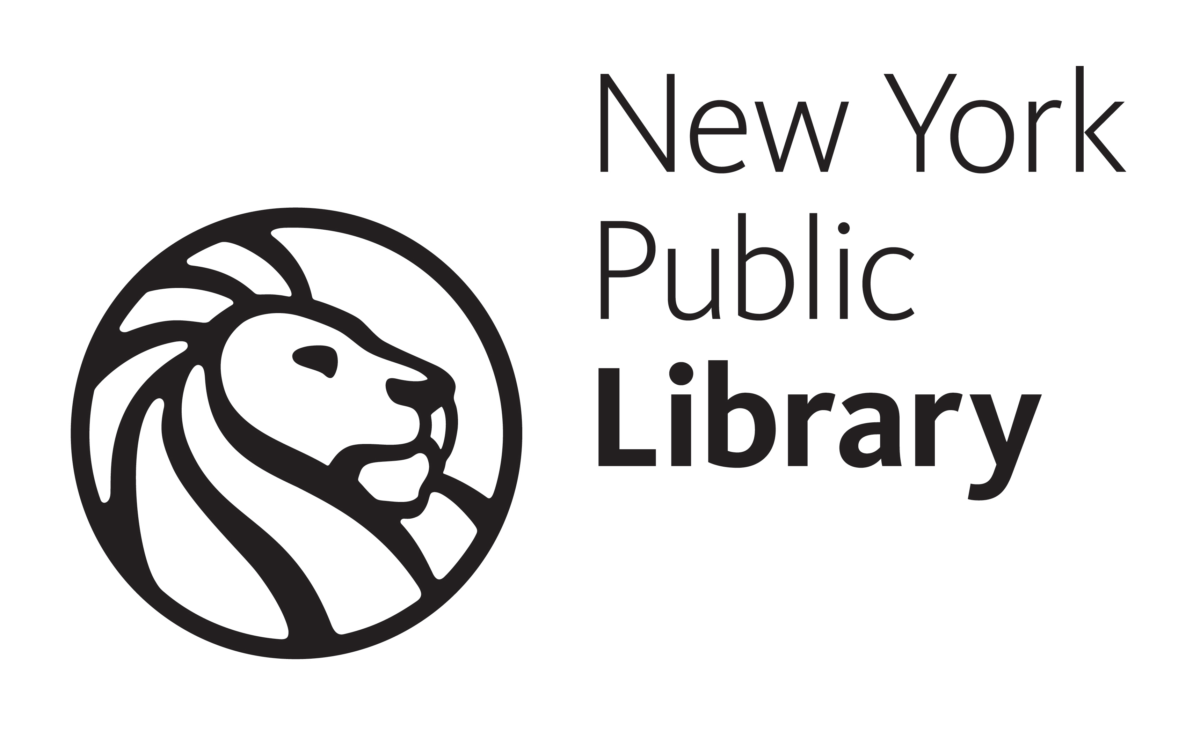
LOW VISION AND BLINDNESS
RESOURCE DAY

Saturday, June 18, 2011
10:00 A.M. - 4:00 P.M.
Mid-Manhattan Library
455 Fifth Avenue (corner E. 40th St.), N.Y., NY 10016

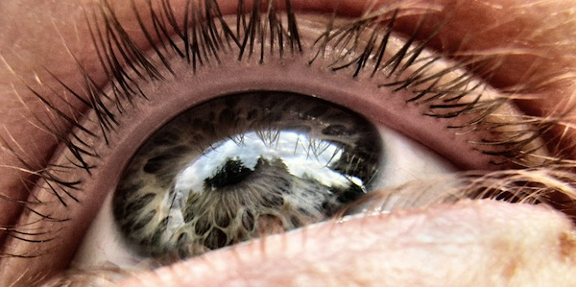

The New York Public Library, in collaboration with Lighthouse International, the Xavier Society for the Blind, and VISIONS Services for the Blind and Visually Impaired, presents a day of resources and information for people with low vision and blindness.

10:05 a.m.-10:35 a.m. | PARENTING A CHILD WITH A VISUAL IMPAIRMENT  Crista Earl, The American Federation for the Blind
10:40 a.m.-11:15 a.m. | ALL ABOUT THE AGING EYE  Rebecca Marinoff, O.D., SUNY/Optometry
11:20 a.m.-11:55 a.m. | FINDING A PATH FOR YOUR LIFE  Deborah Kendrick, award-winning journalist, author and advocate.
12 noon-2:00 p.m. | LUNCH AND EXHIBITS/INFORMATION TABLES
2:10 p.m.-2:45 p.m. | UNDERSTANDING GLAUCOMA: DIAGNOSIS AND TREATMENT  Anna-Maria Demetriades, M.D.
2:50 p.m.-3:25 p.m. | SEEING THE WORLD THROUGH DIFFERENT EYES  Courtney Gross, Staten Island Ctr. for Indep.Living
3:30 p.m.-4:00 p.m. | ART BEYOND SIGHT: ARTISTS DISCUSS MAKING ART WITH VISION LOSS. Fotis Flevotomos, Sandra Padernacht and Dana Simon.
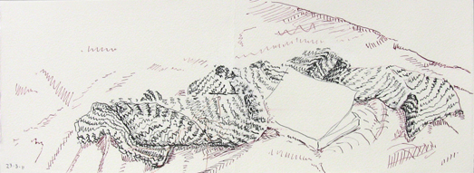

"Scarf and Book," ink and watercolor on paper, by Fotis Flevotomos

