April 24, 2012
RSC Commissioners
Jacqueline Romer-Sensky
Chair, Westerville
Jack Licate, PhD, Vice-chair
Shaker Heights

David Daugherty
Mansfield
Michelle Dillingham
Cincinnati

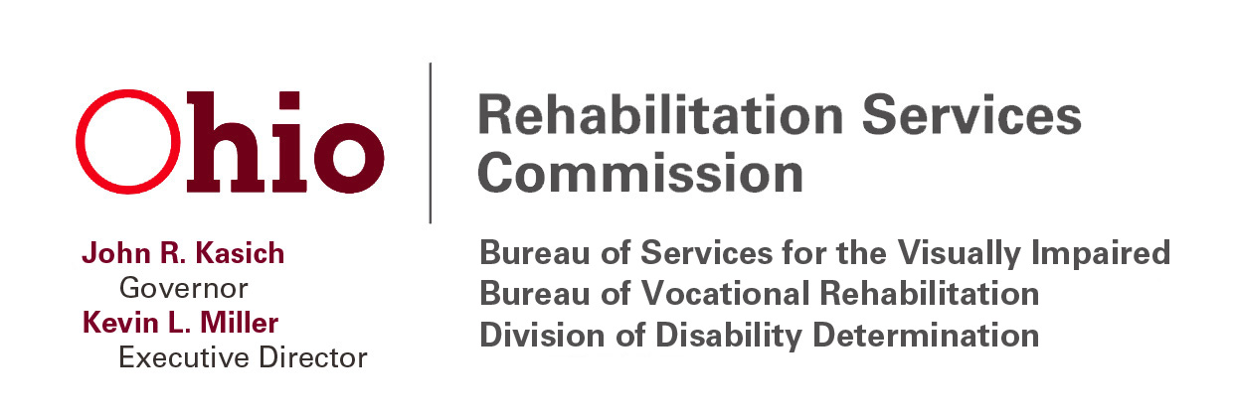

2013 VR STATE PLAN PUBLIC FORUMS

You are invited to attend and provide input into RSC’s 2013 Vocational Rehabilitation (VR) State Plan. The dates, locations and times are listed below.

If you need accommodations, please contact Shirley Marchi no later than 5:00 p.m., Friday, April 27, 2012, via e-mail at Shirley.marchi@rsc.ohio.gov or phone at 614-438-1477. We look forward to your input!

- Date: April 30, 2012
Time: 6:30 p.m. – 8:30 p.m.
Location: RSC, 150 E. Campus View Blvd., 3rd Floor, Ken
Campbell/Trader Sisters Conf. Rooms, Columbus, OH

- Date: May 1, 2012
Time: 3:00 p.m. – 5:00 p.m.
Location: Jewish Vocational Services, 4300 Ross Plain,
Cincinnati, OH

- Date: May 2, 2012
Time: 1:00 p.m. – 3:00 p.m.
Location: Athens Community Center, 701 E. State St., Athens, OH

- Date: May 3, 2012
Time: Noon – 2:00 p.m.
Location: The Ability Center, 5605 Monroe St., Sylvania, OH

- Date: May 4, 2012
Time: 10:30 a.m. – 12:30 p.m.
Location: Center for Families and Children, 4500 Euclid Avenue,
Mandel Community Room, Cleveland, OH

