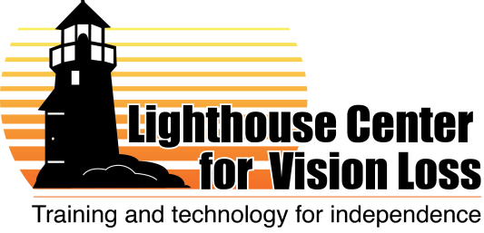

Orientation and Mobility Specialist
Posted April 23, 2012

Note: Job descriptions and duties are subject to change and will depend on the skills and background of the selected candidate, as well as the needs and opportunities of the organization. What is below reflects our best guess of how this position might be structured within our organization.

Location: Duluth, Minnesota
Closing Date: Interviewing to start May 2012
Description: We are a regional agency with 12 current staff, offering both center-based and itinerant services to individuals of all ages. Duluth is a progressive, mid-sized city located on shores of Lake Superior, featuring abundant arts and outdoor recreation opportunities.
This candidate selected for this position will provide O&M services mainly at our center and within nearby communities. This professional may become project director for a new pilot project serving seniors. The person will likely be asked to teach in other areas, such as braille or techniques of daily living, and/or to assist customers in our low vision store. Some travel throughout the region required.
Qualifications:
- Bachelors’ degree in relevant field required, with strong preference for bachelor’s or masters’ degree in O&M with O&M certification.
- Joint certification in O&M and vision rehabilitation would be ideal. Experience in project management, staff supervision, and/or program evaluation is also beneficial.
- Experience working with transition-age youth, adults and seniors is preferred.
- Must have: willingness/ability to travel occasionally around northern Minnesota and Wisconsin, to sit and stand for extended periods, to work in close contact with Lighthouse students, and to work around service dogs.
- Must also have: computer skills, writing skills, ability to work with basic data, flexibility to do a variety of work, and ability to work occasional weekend and evening hours.
Compensation: Salary will be competitive and will depend on experience and qualifications. We also offer generous benefits including health and life insurance, vacation and sick leave and retirement savings.
To apply: Send resume, cover letter and references to mjunnila@lighthousefortheblind-duluth.org, or call Mary with questions 218-624-4828.

