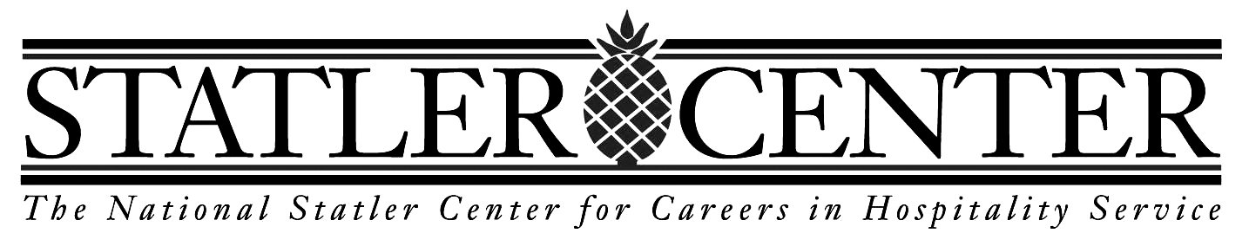

Contact Center and
Customer Service Curriculum
PLUS medical and financial office, transportation, communications

7 week program
Monday – Friday 9:00 AM – 4:00 PM

Statler has developed S.T.E.C., a Customer Service and Contact Center training program, providing students with transferrable skills for any service-oriented company. The customer service industry hinges on people.

The National Statler Center is a proven concept in Customer Service and Contact Center employment training. The first and only program of its kind, Statler provides blind, visually impaired, or disabled individuals with the right tools for successful careers in this rapidly growing industry. Graduates of our comprehensive program are computer-literate and job-ready, equipped with a thorough knowledge of industry standards.

In the United States, Customer Service and Contact Centers rank in the top 10 of America’s largest employers. The industry includes a number of interrelated businesses – anywhere that customer service is critical. The industry pays untold billions in related wages and salaries and employs millions of people across a broad spectrum of industries.

Statler trains people to be capable, motivated, and highly desired job candidates. We provide in-depth skills training and job-preparation services to working-age adults who are sight-impaired or physically disabled and interested in pursuing permanent employment in the customer service and contact center fields.

New Opportunities for the Blind, Visually Impaired and Physically Disabled Community
As recently as two decades ago, competitive job options for blind, visually impaired and physically disabled were nearly non-existent. Modern technology has opened a world of possibilities never before dreamed.

The Statler Center offers blind, visually impaired, and physically disabled adults an exciting opportunity for job training and placement in Customer Service and Contact Centers, one of the largest industries worldwide. The Statler Center features:

A comprehensive curriculum specially adapted for persons with disabilities,
Qualified, professional staff trained in working with the visually impaired,
Access to state-of-the-art computers and industry-specific software,
A modernized, well-equipped facility,
Hands-on work experience in the student’s field of choice,
Follow-up advisement after a student has secured employment in the field to help ensure his or her long-term success.

Statler has developed this training program focusing on Customer Service, and Contact Centers providing students with transferrable skills for any service-oriented company
- We train students, who have a visual or physical disability.
- The curriculum is based in Customer Service and Contact Centers. We have developed a training program that offers exactly what a company considers to be most important.
- Included in the Computer and Technology course are Microsoft Word and Excel and Outlook.
- Statler is licensed by the New York State Department of Education and is certified by New York State as a proprietary business school.
- When you have completed the training program, you will have the knowledge that companies look for in a candidate. Our Job Coaches and Job Placement Specialists will help you find opportunities, help prepare your resume and cover letter, and hone interview techniques
- This training is transferable to companies which rely on Customer Service and Contact Center excellence.

Courses include Microsoft Word and Excel, levels 1 and 2, Outlook, e-mail communications and database software. Fundamentals of customer service, telephone courtesy, grammar essentials, effective business writing, managing conflict, telephone call simulation, and the softer skills of interviewing, dressing for success, resumes and cover letters, and job searching. Job Seeking Workshop speakers include professionals from call centers and a number of other businesses to share their insights from an employer’s perspective.
The Statler Center has a 12-year history of successfully training people with visual and/or physical disabilities in hospitality and customer service. More than 82% of our graduates are working in a variety of industries.
Our students travel to Buffalo, NY, for training, from more than 30 states in the U.S., and abroad. Our training has also been held in Orlando, Las Vegas, and Albany, NY proving the value we bring to employment opportunities. We help develop job opportunities in the student’s home area upon graduation.
For more information about this exciting training program, please call Patrick Keyes at 716-888-4526 or pkeyes@StatlerCenter.org.

Contact Center and
Customer Service Curriculum
PLUS medical and financial office, transportation, communications

Training Topics:

Business Math:
Whole numbers, fractions, decimals, percents, interest, discounts, credit information, markups, payroll and taxes, banking – checks, drafts, endorsements, deposits, reconciliations, credit cards, interest
Communications:
a. Oral: anxiety; communication theory in workplace settings; appropriate topic for a specific audience; suitable presentation aids; deliver a manuscript speech; grammar essentials
b. Written: the basics (reader-centered writing, stages of the writing process, common mistakes of writing); formats of business documents (memorandums, letters, reports/proposals); employment documents; practice
c. Telephone: techniques, behavior, etiquette, personality, key industry terms, listening and speaking skills
Computers and Technology:
Computer basics; working with applications and websites; task bars; MS Windows; opening/saving documents; files and folders; shortcuts; settings; storage media; Outlook (basics, e-mails, calendars, contacts); Word (basics, documents, tables, templates); Excel (basics, editing and formatting, data, formulas). Included in the Computer and Technology course are Microsoft Word, Excel and Outlook. Statler is licensed by the New York State Department of Education and is certified by New York State as a proprietary business school.

Industry Expert Presenters:
Their mission statement, procedures, employer expectations, field trips, guest speakers from Human Resources or line level employees from the company to meet and greet the students
Job Readiness Workshop Days:
Fridays are “workshop days,” when students receive personal guidance in a variety of job-readiness topics such as resume writing, public speaking, and dressing for success.

For class schedules, go to our web site or call.

For more information about this exciting training program, please contact Patrick Keyes at 716-888-4526 or pkeyes@StatlerCenter.org.

Contact Center and
Customer Service Curriculum
PLUS medical and financial office, transportation, communications

STEC Student Traits

If you have some of the following qualifications, please consider applying:
Dependable, Punctual, High level of motivation
Open minded towards ideas and view of others
Good social skills, pleasant and friendly, self confident
High school Diploma, GED or Transcript showing date of Graduation
Some background in customer service
Telephone experience
Good computer skills using assistive technology
Good skills in basic Microsoft applications; internet knowledge
Data entry skills
Ability to type 20 wpm
Organizational and time management skills
Customer service skills

For more information about this exciting training program, please contact Patrick Keyes at 716-888-4526 or pkeyes@StatlerCenter.org.

