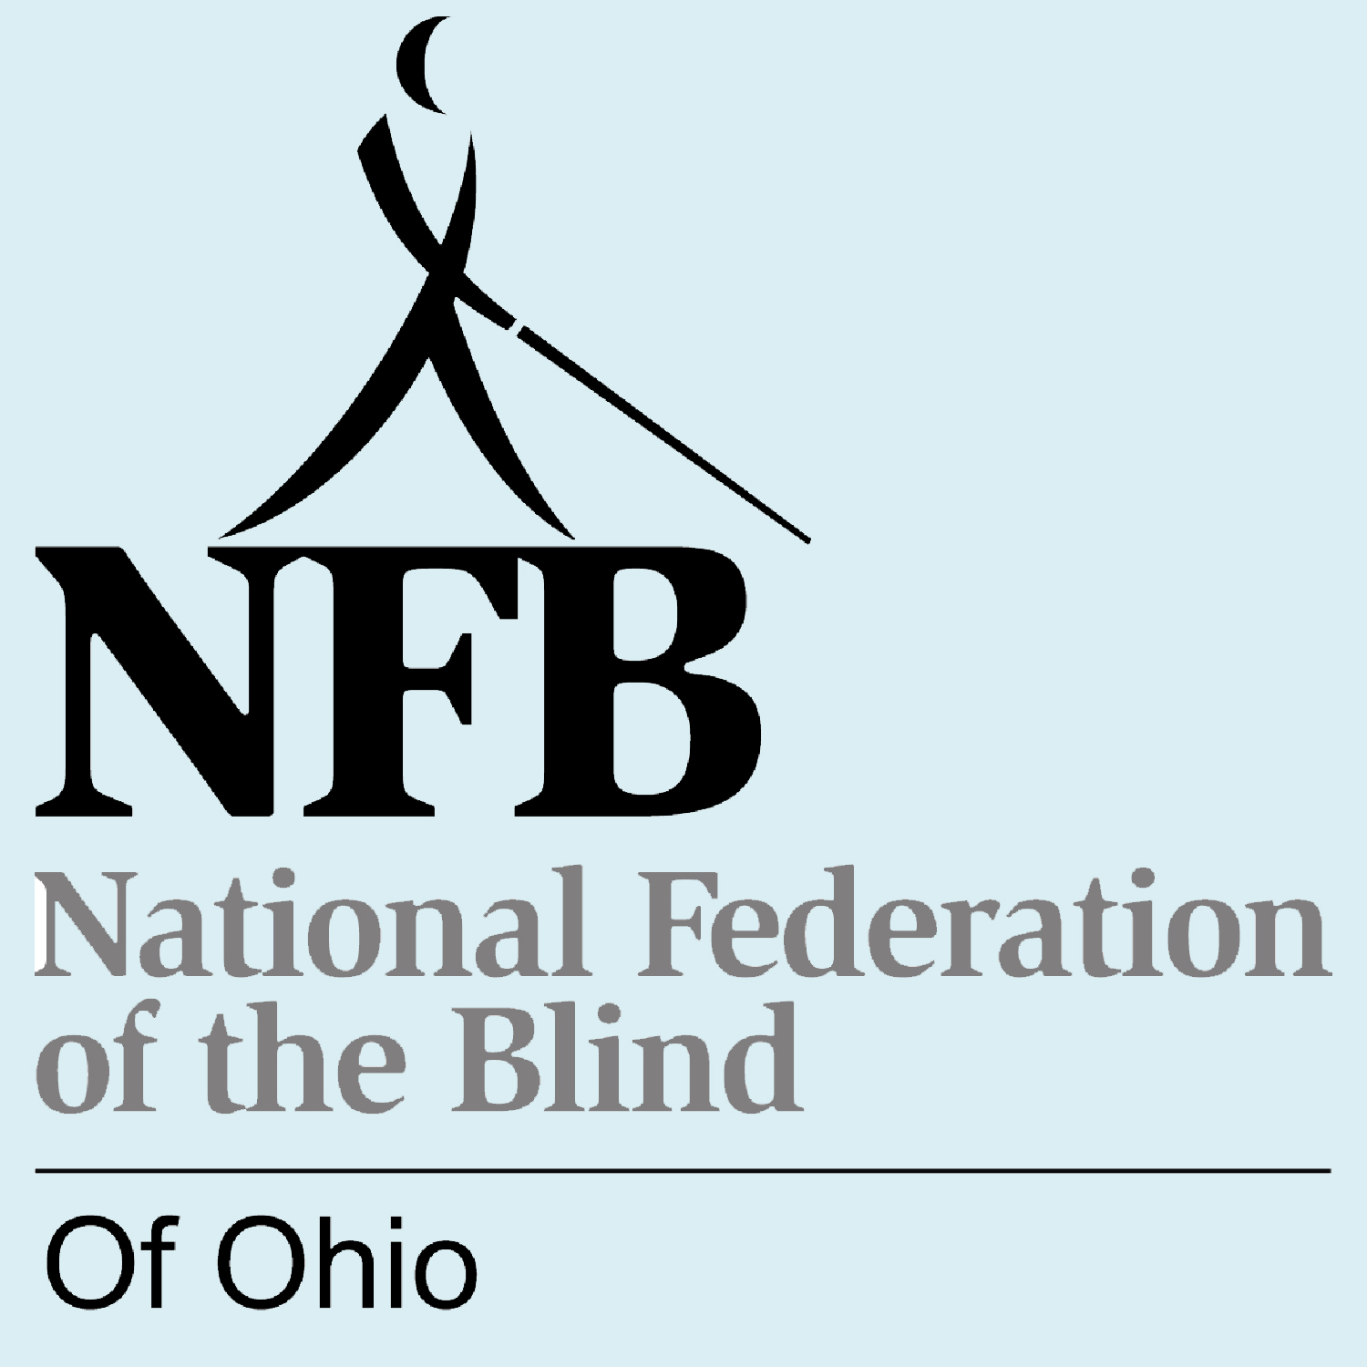
NATIONAL FEDERATION OF THE BLIND OF OHIO

2014 SCHOLARSHIP PROGRAM

The National Federation of the Blind of Ohio is a membership organization changing what it means to be blind. We are committed to promoting equality, opportunity, independence, and dignity for all blind Ohioans, and are committed to doing what we can to secure education and career equality for all blind people.

The NFB Ohio will award three scholarships this year to legally blind students who are planning to pursue post-secondary education in the 2014-2015 school year.

CRITERIA

All applicants for these awards must be legally blind and pursuing (or planning to pursue) a full-time post-secondary course of study during the 2014-2015 academic year. The scholarships are awarded on the basis of academic excellence, service to the community, and financial need. Attendance and participation in the 2014 state convention in Worthington, Ohio is mandatory. Scholarships will be awarded at the banquet on Saturday evening, November 1st.

SCHOLARSHIPS

$1500  Jennica Ferguson Memorial Scholarship | The Jennica Ferguson Memorial Scholarship is named for a young woman whose intelligence and leadership embodied the spirit of the Federation. Jennica was blind and died at the age  of 18.
$1000  Robert Eschbach Scholarship | Robert Eschbach served as NFB-Ohio president for 11 years, and devoted his life of 80 years to changing what it means to be blind.
$1000  NFB-O  Scholarship | This additional $1000 scholarship has been made possible by generous NFB supporters.

MEMBERSHIP

The National Federation of the Blind of Ohio is an organization dedicated to creating opportunity for all blind people. Recipients of Federation scholarships need not be members of the National Federation of the Blind.

APPLICATIONS

To apply for the National Federation of the Blind of Ohio scholarships, complete and return the attached form. Applications must be received by May 15, 2014. After completing the application, attach all additional documents. Arrange to have recommendation letters sent directly to the scholarship chair. (Address included on application form).

NOTIFICATION

The Scholarship Committee reviews all applications and selects the scholarship winners who will be notified of their selection by July 15th and will be brought to the state convention (October 31 – November 2) at Federation expense. This trip is in addition to the scholarship grant.

STATE CONVENTION

The National Federation of the Blind of Ohio convention will be the largest gathering of blind people to occur anywhere in the state this year. You will have the opportunity to meet with other blind students and exchange information and ideas, as well as an opportunity to meet blind individuals who are successfully working in their chosen professions or occupations. State officials, legislators, and businesses on the technology frontier attend Federation conventions. Above all, a broad cross-section of the most active segment of the blind population of Ohio will be present to discuss common problems and plan concerted action.

2014 NFB Ohio State Convention:

October 31 – November 2
Holiday Inn Worthington
7007 N. High Street
Worthington, OH 43085

NATIONAL FEDERATION OF THE BLIND OF OHIO

2014 SCHOLARSHIP PROGRAM

APPLICATIONS MUST INCLUDE

Personal Bio | Send us a letter: we want to get to know you! What information on your application needs or deserves further explanation? How have you dealt with your blindness? What are your hopes and dreams?
Recommendations | Have two letters of recommendation sent directly to us. (Address on Application Form)
Transcripts | Provide transcripts through December 2013 from current and all past post-secondary institutions attended. If you have not yet attended a post-secondary institution, send your high school transcript.
NFB Ohio Interview | Speak with an officer or chapter president of the National Federation of the Blind of Ohio about your post-secondary goals and ask him/her to submit a letter on your behalf. Our state president, Eric Duffy (614) 377-9877, will provide you with contact information for one of these titled individuals upon request.

NATIONAL FEDERATION OF THE BLIND OF OHIO

2014 SCHOLARSHIP PROGRAM

APPLICATION FORM

Read the cover sheet for instructions and explanation. This form may be photocopied, but only if the cover sheet is also copied.

Complete this application form and mail completed application and attachments to:

Deborah Kendrick, Chair  National Federation of the Blind of Ohio  Scholarship Committee  2848 Ridgewood Avenue  Cincinnati, Ohio 45213 | Phone | 513.321.2228  Email | dkkendrick@earthlink.net
***Applications must be received by May 15, 2014***

Name (please include any names by which you have been known):

Date of birth:

Spring '14 school address:

Personal phone number while at school:

Home (summer) address:

Home phone number:

Cell phone number: ___________________ Email address:

Institution being attended in spring semester, 2014, with class standing (freshman, senior, etc.):

Cumulative grade point at this institution:

Institution to be attended in fall of 2014, with class standing:

List all post-secondary institutions attended with highest class standing attained and cumulative grade point averages:

High school attended and cumulative grade point:

Vocational goal:

State your major or proposed major:

Awards and honors (attach list if necessary):

Community service (attach list if necessary):

Name of state officer or chapter president who has interviewed you and promised to send a letter:

How did you learn about this scholarship program?

