Worthington Duchess Convenience Store
7141 N. High Street
Worthington, OH

Menu

Duchess Made Deli Subs
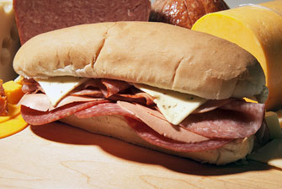
- $3.99Duke Sub
- $3.19Duchess Sub
- $3.59Roast Beef & Cheese
- $2.89Turkey & Cheese
- $2.29Cooked Ham & Cheese
- $2.09Chopped Ham & Cheese
- $2.59Trail Bologna & Cheese
- $2.69Full O’ Bologna & Cheese
- $2.89Dutch Loaf & Cheese
- $3.59The Club
- $3.69Italian Sub
- $3.99Caesar Chicken Wrap
- $3.39Meatball Sub
- $5.5913" Meatball Sub
- $2.39Pizza Sub
- $3.99Deluxe Pizza Sub
- $3.19Steak Hoagie
- $2.69Pizza Steak
- $2.99Meat Loaf Sandwich
- $2.99BBQ Pork Patty

Duchess Made Deli Sandwiches
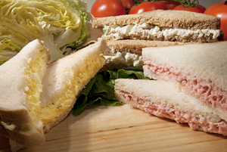
- $1.89Chopped Ham & Cheese
- 99¢Peanut Butter & Jelly
- $2.79Tuna Salad
- $2.49Chicken Salad
- $1.99Ham Salad
- $2.49Egg Salad
- $1.79Pimento Cheese Spread
- $1.89Bologna & Cheese

Duchess Made Hot Sandwiches
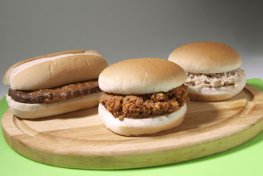
- $1.99BBQ Shredded Pork
- $1.99BBQ Shredded Beef
- $1.99BBQ Shredded Chicken
- $1.99Shredded Chicken
- $1.99Sloppy Joe
- $2.69Salisbury Steak

Roller Grill
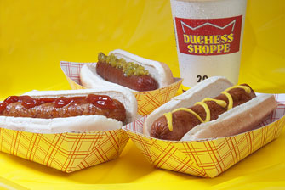
- $1.59Roller Cheeseburger
- 99¢Hot Dog
- $1.39Hillshire Farm Jalapeno Sausage
- $1.39Hillshire Farm Cheddarwurst
- $1.39Hillshire Farm Polish Sausage
- $1.39Breakfast Smoked Sausage
- $1.19Don Miguel Spicy Beef & Bean Taquito
- $1.19Don Miguel Pepperoni Pizza Taquito
- $1.19Don Miguel Cheesy Pepper Jack Taquito
- $1.19Don Miguel Steak Ranchero Taquito
- $1.19Don Miguel Buffalo Chicken Taquito
- $1.19Don Miguel Egg & Sausage Taquito

Pizza
- Day 'N Night Bite Pizza
- $1.99Hunk
- $7.49Whole
- Flavors: Breakfast, Cheese, Pepperoni, Italian Sausage, and Combination.
- Hunt Bros Pizza (Only at Alum Creek and Ft. Amanda)
- $2.99Single (5-6 Piece)
- $5.49Double (10 piece)
- $12.99Party (25 piece)
- $2.69Hunk
- $4.992 Hunks
- $9.49Whole
- $8.492nd Whole
- $1.59Extra Cheese (add)
- $4.99Hunk and Single (5 wings)
- $13.99Whole and Double (10 wings)

Sides
- $3.99Baked Beans /lb.
- $3.09Amish Potao Salad /lb.
- $3.39Amish Macaroni Salad /lb.
- $4.39Pasta Italian Rotini Salad /lb.
- $3.19Cole Slaw /lb.

Crown Café Coffee
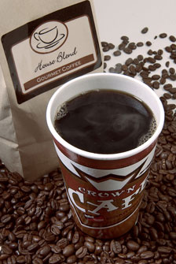
HOUSE BLEND: Smooth coffee with mellow flavor and excellent aroma
DARK ROAST: Highly flavorful coffee with a distinct aroma and rich, smooth taste
ROYAL ROBUST: Bold coffee with rich aroma, rich flavor and full body
FRENCH ROAST: A bold full body roast with a mellow dark chocolate flavor and a caramel finish.
DECAF: Decaffeinated coffee with mellow flavor and low acidity
Various Cappuccino Flavors available, as well.
- 99¢12oz.
- $1.1916oz.
- $1.3920oz.
- $1.5924oz.

Duchess Made Breakfast Sandwiches
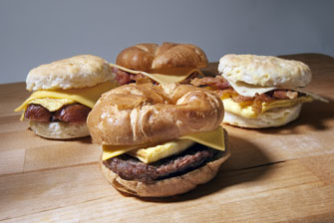
(FIT FOR A KING. Available at select locations)
- $2.59Ham, Egg, & Cheese Croissant
- $2.59Ham, Egg, & Cheese Biscuit
- $2.59Split Link Sausage, Egg, & Cheese Croissant
- $2.59Split Link Sausage, Egg & Cheese Biscuit
- $2.59Sausage Patty, Egg & Cheese Croissant
- $2.59Sausage Patty, Egg & Cheese Biscuit
- $2.59Bacon, Egg & Cheese Croissant
- $2.59Bacon, Egg & Cheese Biscuit
- $1.59Egg & Cheese Croissant

Breakfast
- Breakfast Pizza
- $1.99Hunk
- $7.49Whole
- Jimmy Dean Breakfast Sandwiches
- $2.59Sausage, Egg, & Pancake
- $2.59Sausage, Egg, & Cheese Croissant
- $2.59Bacon, Egg, & Cheese Biscuit
- $2.59French Toast & Sausage
- $2.59Ham, Egg, & Cheese Biscuit
- $2.59Sausage, Egg, & Cheese Biscuit
- $2.59Sausage, Egg, & Cheese Muffin
- $2.59Canadian Bacon Muffin Delight
- $2.59Turkey Sausage on Bagel Delight

Milkshakes
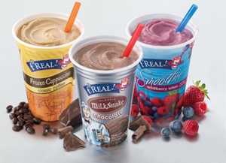
- $2.59F'real Milkshakes
- Flavors: Chocolate, Chocolate Malt, Strawberry, Vanilla, Reese Peanut Butter, Mint Chip, Cookies & Cream.
- $2.59F’real Frozen Cappuccinos
- Flavors: Coffee & Mocha.
- $2.89F’real Smoothies
- Flavors: Blueberry Raspberry Pomegranate, Mango, and Strawberry Banana.

Cold Beverages
- Fountain Pop & Majestic Brewed Iced Tea
- 99¢20oz.
- $1.1932oz.
- $1.2944oz.
- Pepsi and Mountain Dew Freeze
- $1.2920oz.
- $1.6932oz.
- $1.9944oz.
- Slush Puppy
- 89¢12oz.
- $1.0916oz.
- $1.2921oz.

Duchess Deli Menu Disclaimer*
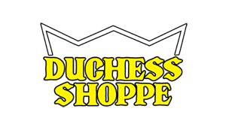
*Availability of food items varies by location. Prices subject to change without notice.

