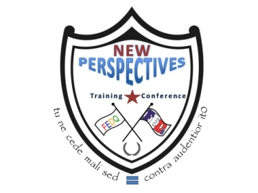
Hilton Garden Inn
1225 First Street Northeast Washington, DC 20002
Phone: (202) 408-4870

New Perspectives Training Conference
Attendees Registration Form

April 27-29, 2015

E-mail/Mail completed form and payment to:
FEDs and FEDQ – New Perspectives
P.O. Box 2185
Montgomery Village, MD. 20886
Email: 2015NTP@fedq.org
Web Site: www.fedsfirst.com / www.fedq.org

Registrants Information
Name: (Last) (First) (MI)
Mailing Address City: State: Zip:

Phone No: Member of: FEDs FEDQ Neither
Job/Position/Title:
Agency/Company/Organization:
E-mail Address:
Please state any accommodations needed:

Billing Information
Credit Card No.: Expiration Date: Security Card Code:

Visa Master Card
Cardholder’s name as it appears on the card:

Billing Address: City: State: Zip:

Registration Category – Please Check Appropriate Box
 | Member | Non Member
NTP Registration | $400 | $425
Late/On-site Registration (After March 20, 2015) | $525 | $550
Special group discount: 5+ registrations (each) | $400
Special group discount: 10+ registrations (each) | $350
Special group discount: 15+ registrations (each) | $300

CANCELLATION POLICY: Cancellation requests for registration and tickets must be received by March 15, 2015; no refunds will be accepted after this date. All registration cancellations are subject to a US $50.00 service fee. All cancellation requests must be submitted in writing to 2015NTP@fedq.org with “cancellation” in subject heading. Phone cancellations will not be accepted. FEDs will refund registration and ticket fees if the 2015 National Training Program is cancelled but takes no responsibility for travel or other related costs incurred by members and guest. Registration and tickets are transferable.

CONFERENCE USE ONLY
Payment by: (Check One) | Date Received: | Amount
Certified Check or Money Order No: | PO/Auth. No: | Invoice No:
Receipt No.: | Items Received: Event Ticket Name Tag Registration Packet

FEDs and FEDQ are 501(c)(3) non-profit organization
www.fedsfirst.com / www.fedq.org

