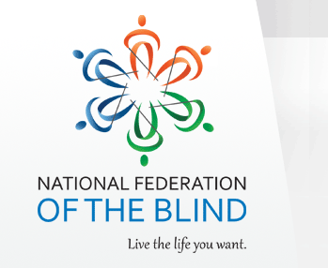
Cleveland Chapter of
The National Federation of the Blind of Ohio
hosts
A Trip to the Amish Country: Saturday April 9, 2016

Itinerary: The Hartville Market and Kitchen and Maize Winery located in Hartville, OH

Departure Time: 7:00 am
Departure Location: Cleveland Sight Center - 1909 E. 101st Street, Cleveland OH 44106

Cost is $50.00 per person.
This includes transportation by Lake Front Lines and lunch at the Hartville Kitchen.
A $20.00 non-refundable deposit is required per person.
Balance due by March 31, 2016.

Return Time: 6:00pm
Return Location: Cleveland Sight Center - 1909 E. 101st Street, Cleveland OH 44106

Note: The bus will make a breakfast stop prior to arriving at the Hartville Market.
This is not included in the cost of the trip.
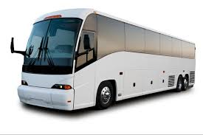
For additional information, please contact any member of the Cleveland Chapter
William Turner, President
330.328.9860

