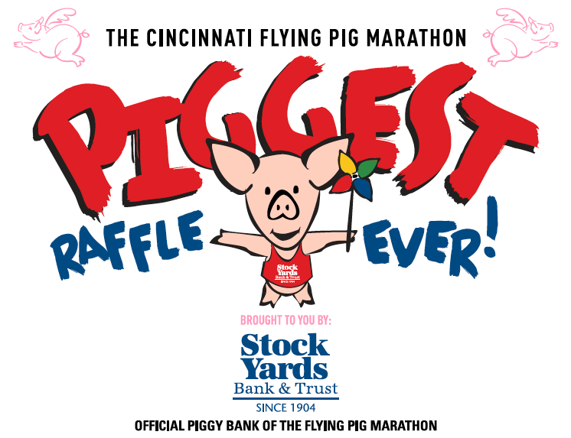
Drawing to be held Friday, April 29, 2016 in Downtown Cincinnati
For more information and contest rules, visit: www.piggestraffle.com
GRAND PRIZE: $10,000 CASH ($5,000 TO winning ticket holder & $5,000 to charity selling the ticket)
2ND PRIZE: 2-YEAR LEASE OF TOYOTA PRIUS
3RD PRIZE: CINCINNATI GET AWAY EXPERIENCE-(over $1,500 value)
Winner need not be present to win.

Adopt your piggies: $5 for a single pig, $25 for 6 pigs, $50 for 12 pigs

100% of your donation to adopt piggies goes to the NFB of Ohio Charity.
You can also attend a weekend of fun for the 18th annual Flying Pig Marathon and festivities April 29, May 1 and 2nd. Great family fun weekend.
www.flyingpigmarathon.com

