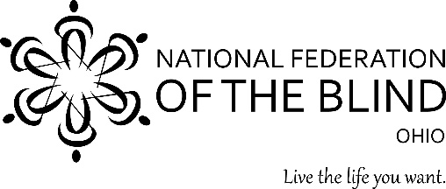
71st Annual Convention
The Dream Convention – Transforming Dreams into Reality
October 27 – October 29, 2017
DoubleTree by Hilton Columbus/Worthington
175 Hutchinson Ave., Columbus, OH 43235

Registration Form
Please complete the form below for each attendee then email it to rchpay7@gmail.com. Payment must be paid in full to be considered complete. Mail a check made payable to NFB of Ohio, to 6922 Murray Ridge Rd, Elyria, OH 44035. Be sure to place “Convention Registration” on the memo line. To register online and pay by credit card visit http://nfbohio.org/new/registration. Pre-registration rates are valid until Oct. 6th. Boxed Lunch and Ohio Association to Promote the Use of Braille Breakfast tickets will not be sold at convention.
Attendee Information
Full Name
Address
City, State Zip
Home Phone
Cell Phone
Email
Is this your first NFB Ohio convention? (Yes or No)
Would you prefer a Braille agenda? (Yes or No)
Event Tickets
2017 Convention Registration: $15 ($20 after Oct. 6) |  |  | $
2017 Banquet – Oct. 28: $40 ($45 after Oct. 6) |  |  | $
Please select your Banquet meal preference |  | Vegetarian | Meat
Ohio Association to Promote the Use of Braille Breakfast –  Oct. 28: $18 (Not sold after Oct 6) |  |  | $
Boxed Lunch – Oct. 28: $18 (Not sold after Oct. 6) |  |  | $
I wish to make an additional contribution. (Donations are greatly appreciated) |  |  | $
Total |  |  | $

