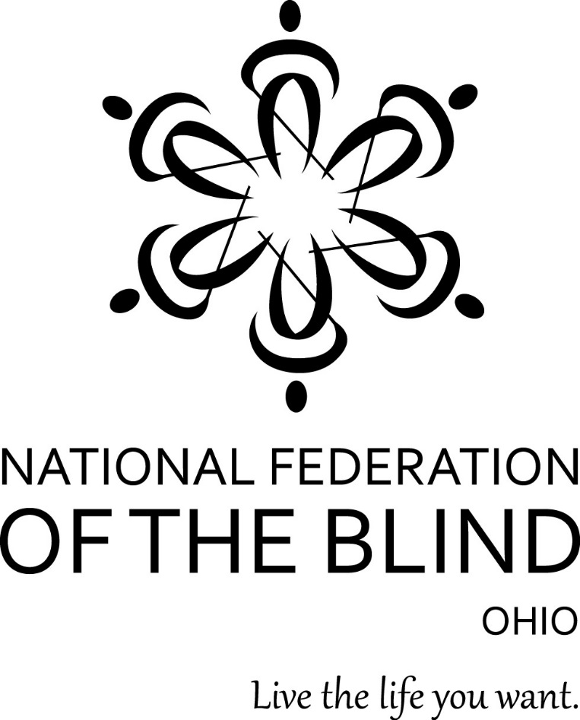

National Federation of the Blind of Ohio 71st Annual Convention

The Dream Convention: Transforming Dreams into Reality
Friday, Oct. 27–Sunday, 29, 2017

DoubleTree by Hilton Columbus/Worthington
175 Hutchinson Ave.
Columbus, OH 43235
614-885-3334

The National Federation of the Blind of Ohio invites you to join us for our 71st annual convention to be held at the DoubleTree by Hilton Hotel in Columbus, Ohio. We are Ohio’s oldest organization of blind people working together to change what it means to be blind. Our convention will inspire, empower, and celebrate our accomplishments. Join us to learn more about issues confronting blind people today and walk away ready to advocate for change and to live the life you want.
Richard Payne, President

Sheri Albers, Vice President

Host: Capitol Chapter, Shelbi Hindel, President

About the NFB-O
The National Federation of the Blind of Ohio is a 501 (c)3 non-profit organization and a founding affiliate of the National Federation of the Blind. We are proud to be an integral part of the oldest and largest blindness organization in the United States. We are a diverse group of people dedicated to changing what it means to be blind. Our members work tirelessly to break down the legal, social, and personal barriers to living the lives we want.

The National Federation of the Blind knows that blindness is not the characteristic that defines you or your future. Every day we raise the expectations of blind people, because low expectations create obstacles between blind people and our dreams. You can live the life you want; blindness is not what holds you back.

NFB Pledge
I pledge to participate actively in the effort of the National Federation of the Blind to achieve equality, opportunity, and security for the blind; to support the policies and programs of the Federation; and to abide by its constitution.

Mastering the DoubleTree
by Barbara Pierce

By this point in your reading of the newsletter you know that we will be at the DoubleTree by Hilton in Worthington for our convention. We have not been to this facility before, so here is your word map of the ground floor. To check in, you will enter from the north side of the building. There are two entrances about thirty feet apart. The check-in desk is about fifteen feet to the south of these doors. As you step into the hotel, angle toward the other door as you walk forward to the desk, and mind the three pillars that run from east to west half way across the space between the doors and the desk.
After you finish checking in, you probably want to find your room and drop your suitcase. Turn left (east) at the desk and start along a hall that leads to the sleeping rooms. Just after the check-in desk is a right turn to the hall that leads to our meeting rooms, but ignore this for the moment. Keep traveling east past the work-out room, the pool, and the outdoor courtyard on your right. There are large windows, so, if it is sunny, you may feel a rise in the temperature. On your left will be a door leading out to a dog relief area. A trash receptacle will be right outside the door. Exit the door and follow the sidewalk to the left, and you will immediately find a grassy area for your dog. After the courtyard you will hit carpet. Hallways to the first-floor sleeping rooms branch to the left and right. About ten feet after the carpet begins, are the elevators, two on the right (south) side of the hall and one on the left (north). There are six floors of sleeping rooms, including the ground floor. The rooms all have Braille and raised print signs.
Returning to the front door and facing south, you can turn to the right (west) almost immediately. Walk west until you deadend into a wall. This hall leads you to the restrooms as well as the Franklin and Fairfield Rooms, which is where hospitality will be held. Once you hit carpet, turn right (north); the restrooms are to your left (west). To get to the hospitality rooms, turn left (south) and begin looking for an opening on the right into an east/west hall. The entrance to the Franklin Room is just across a hall coming into this hall from the right (north). The entrance to the Fairfield Room is at the north end of this hallway.
Returning to the front door and facing south, if you continue traveling south past the west end of the check-in desk, you will find the Crosswood Bar and Grill on your right. This is the restaurant. It is on the west side of this hallway. The Upper Terrace is on the left (east) side of the hall and up four steps. This is a large seating area that is often used for casual seating or meals, but we will not be using the space. So it is safe to say that you can ignore any short flights of steps that you discover in the lobby area. Past the Upper Terrace you can make a left turn (east) and travel past the two large ballrooms on the south (right) side of the hall. The Alder Room is our general session meeting room. `It is the eastern-most of these two rooms. One you have reached carpet, that is where registration will be set up.
You can reach the Alder Room another way. Returning to the front door and facing south, if you continue traveling south past the east end of the check-in desk, you will find a set of restrooms on your left (east) side of the hall. To your right is the Upper Terrace, which was mentioned earlier. Continue walking south along the Upper Terrace, and you will walk directly into the Alder Room. If you turn left (east) just before the Alder Room, you will find the Polaris 1 and 2 Rooms on your left. When you reach the carpet, you have found the registration area. At the east end of this hall on the left is a door out to the courtyard. The break-out rooms that we will be using are all in this area. You can turn right (south) in this carpeted area. You will be walking south toward the end of the hall. On your left in this hall are the German Village, the Arena District, and the Short North Rooms. On the right are the Oak 1, 2, and 3 Rooms. At the south end of this hall is the exit leading to the dog relief area. A trash receptacle will be located outside this door. Exit the building into a parking lot with parking along the building. Cross the driveway and another line of parking places to get to a grassy island suitable for the dogs. Please use this area and clean up after your dog.
There you have it. The usual advice applies to reading this article. Do not expect to grasp the layout of the hotel after one reading. Study the article several times, pausing after each sentence to be sure that you have the instructions in mind. See you at the DoubleTree.

Convention Arrangements
If you have any questions about convention arrangements, contact Convention Co-chairs Sheri Albers (513-886-8697) or Rachel Kuntz (937-245-0547).

Announcements
NFB-O is one of the sites that have been chosen to feature LowViz Guide, an indoor navigation system that allows iPhone users to find the locations of meeting rooms, restrooms, dog relief areas, and other important locations in unfamiliar venues. Jerrod Witt will provide orientation to this new technology during scheduled sessions and will be available to answer questions at the registration table throughout the convention.

Annual Not So Silent Auction
Our chapters and divisions have submitted numerous items including electronics, gift certificates, food baskets, and more to raise money for the affiliate. The auction will take place throughout General Sessions on Friday afternoon and Saturday morning and at the Banquet. You may view auction items at the auction tables in the back of the Alder Room during General Sessions and again at the Banquet. The highest bid registered at the auction table will be the opening bid when items are auctioned off. Please call Annette Lutz, chair of Fundraising, at 614-288-4323, to make arrangements to get your items to the tables when you arrive.

Registration and Literature
Pre-Registration packet pick-up and convention registration will take place to the east of the Alder Room on the carpet. Those who have completed their registration prior to convention will form a line at the Pre-Registration Table for a speedy process. Visit the Registration Table to register for convention or to purchase additional tickets to events. Both tables will be open for two shifts on Friday, October 27, from 9:00 AM to 10:45 AM and 12:15 PM to 1:45 PM and then again on Saturday, October 28, from 8:00 AM to 8:45 AM. The Capitol Chapter has volunteered to staff both tables at convention. Please contact Shelbi Hindel (614-558-8059) with any questions or concerns. NFB literature will be available throughout the convention in the registration area. Feel free to take as much as you like and share it with your friends and family.

Door Prizes
Door prizes should be labeled clearly in print and Braille with the donor's name and the amount of cash or type of gift. They may be brought directly to Annette Lutz or left at Convention Registration with instructions.

Guide Dogs
There are two relief areas for your convenience, one outside the convention room hall, and one near the sleeping room hall. Please read the hotel description for details. For assistance with any guide dog issues, please contact Deanna Lewis, President of the Ohio Guide Dog Users Division at 513-328-7976.

Exhibit Hall
Whether you are an information-seeker or a new-gadget shopper, you will find everything that you need to help you live the life you want at this year’s exhibit hall. Visit the exhibit hall in the Cedar Room on Saturday, October 28, from noon to 5:00 PM to explore the latest technology and to get answers to the questions that race through your mind about employment, healthcare, services for the blind, and much more. All visitors’ names will be entered to win a door prize.

Convention Agenda

Friday, October 27, 2017
9:00 AM to 10:45 AM--Pre-Registration Packet Pick-Up and Convention Registration
To the east of the Alder Room on the carpet

11:00 AM to Noon--Board of Directors Meeting
Alder Room

12:15 PM to 1:45 PM: Pre-Registration Packet Pick-up and Convention Registration
to the east of the Alder room on the carpet

12:15 PM to 1:15 PM--Meet and Greet with light refreshments
Fairfield Room

12:30 PM to 1:15 PM--The Art of Structured Discovery: Cane Travel the Federation Way
Led by Shawn Martin, President, Cuyahoga chapter
Participants should meet in the main lobby near the front desk to take a walking tour of the hotel.

12:30 PM to 1:30 PM--Rookie Round-Up
Led by Carolyn Peters and other NFB-O leaders
Alder Room

General Session

2:00 PM--Call to Order by Richard Payne, President, NFB-O
Alder Room

2:02 PM--Invocation
Paul Jordan

2:10 PM--Welcome to Columbus
Shelbi Hindel, Secretary NFB-O and President of the Capitol Chapter

2:20 PM--Convention Arrangements
Sheri Albers and Rachel Kuntz, Convention Co-Chairs

2:25 PM--National Report
Shawn M. Callaway, National Representative, President of the NFB of the District of Columbia, member of the NFB Board of Directors, and Chair of the 2017 NFB Convention Host Committee

2:45 PM--Daring to Dream
Rachel Kuntz, President, NFB of Butler County

3:00 PM--The Current State of OOD and Updates on the Services We Receive from BSVI, with time for questions
Kevin Miller, Director, Opportunities for Ohioans with Disabilities, and Melinda Duncan, Deputy Director

3:35 PM--Training at BLIND, Inc.
Dick Davis, Project Specialist, BLIND, Inc., Minneapolis, MN

3:55 PM--March on Columbus: Advocacy Is Alive and Well in Ohio
Report on Our May 9, 2017, Columbus Seminar, and Update on the Three Bills We Are Moving through the Ohio Legislature
Scott Lipps (R District 62)
Brigid Kelly (D District 31)
Sheri Albers, NFB-O Vice President and Chair of the NFB-O Legislative Committee

4:35 PM--Report from the Talking Book Library
Tracy Grimm, Head of Circulation and Special Services, State Library of Ohio

5:00 PM--Recess

5:30 PM to 6:30 PM--Ohio Association of Blind Merchants Meeting
Annette Lutz, President
Arena District Room

5:30 PM to 8:30 PM--Hospitality and Game Night with Cash Bar
Franklin and Fairfield Rooms

7:00 PM to 8:00 PM--At-Large Chapter Meeting
Colleen Roth, President
Short North Room

8:00 PM to 8:30 PM--Resolutions Committee Meeting
Mike Leiterman, Committee Chair
Arena District Room

8:30 PM--Nominating Committee Meeting
This is a closed meeting.
Short North Room

9:00 PM to 9:45 PM--OAPUB play
"Baby Snooks"
Alder Room

Saturday, October 28, 2017

7:00 AM to 8:45 AM--Ohio Association to Promote the Use of Braille (OAPUB) Breakfast Meeting
Marianne Denning, President
Oaks 1 and 2 Rooms

7:00 AM to 8:45 AM--Ohio Diabetes Action Network (DAN) Breakfast Meeting
Paul Jordan, President
Members will have breakfast in the Crosswoods Bar and Grill and proceed to the Oaks 3 Room to conduct their meeting.

7:00 to 8:45 AM--Scholarship Breakfast
Crosswoods Bar and Grill

8:00 AM to 8:50 AM--Pre-Registration Packet Pick-up and Convention Registration
East of the Alder Room on the carpet

General Session
9:00 AM--Call to Order
Richard Payne, NFB-O President
Alder Room

9:05 AM--Roll Call of Chapters
Shelbi Hindel, NFB-O Secretary and President of the Capitol Chapter
9:10 AM--Why I Am a Federationist
Lillie Pennington, Cincinnati, OH

9:25 AM--Update
Tiffany Wild, Ph.D., Department of Teaching and Learning, Program in Visual Impairments

9:45 AM--A Discussion: The Benefits of Hiring the Blind
Suzanne Turner, Member, Cleveland chapter, and Nancy Martin, Vice President, Medical Mutual of Ohio

10:10 AM--The Evolution of Technology
Robert Spangler, Secretary, NFB of the Miami Valley

10:30 AM--AIRA Presents New Technology to Revolutionize Access for the Blind
Jessica Jakeway, AIRA Agent Analyst

11:00 AM--BELL Rings Again in Ohio
Heather Leiterman, Vice President, Capitol Chapter, and 2017 BELL Coordinator.

11:30 AM--Update on Disability Rights Ohio and How it Can Help Blind Consumers
Michael Kirkman, Executive Director, Disability Rights Ohio

Noon–Recess

Noon-Boxed Lunch Pick-Up (tickets required)
Fairfield Room

Noon to 5:00 PM--Exhibit Hall
Cedar Room

12:15 PM to 1:45 PM--Ohio Parents of Blind Children Meeting
Interested in revitalizing this division, come join this discussion
Heather Leiterman, Vice President, Capitol Chapter
Short North Room
12:15 PM to 1:45 PM--Ohio Organization of the Senior Blind Meeting
Barbara Pierce, President
Arena District Room

12:15 PM to 1:45 PM--Ohio Association of Guide Dog Users (OAGDU) Meeting
Deanna Lewis, President
Oaks 1 and 2 Rooms

12:15 PM to 1:45 PM--Ohio Association of Blind Students (OABS) Meeting
Oaks 3 Room

1:00 PM to 3:00 PM—Hospitality
Franklin and Fairfield Rooms

2:00 PM to 3:30 PM--Membership Building and More
All NFB members are invited. There will be a drawing for chapter members who recruited three or more paid chapter members between
January 1, 2017, and October 28, 2017.Pick up lots of ideas about recruiting and retention of members. Door prizes and more
Carolyn Peters Ph.D., Membership Committee Chair and President of the NFB of the Miami Valley Chapter
Suzanne Turner, NFB of Cleveland member
Alder Room

3:00 PM to 5:00 PM--Technology Workshop: All Things Tech
Join a discussion about all things tech. Several topics are in store: new mobile apps, existing apps, and demonstrations of several Windows programs and features. The new iPhone app from Microsoft, Seeing AI will be demonstrated, as well as how to navigate the Gmail interface on Windows. There will be time at the end for a question and answer session.
Robert Spangler, Secretary, NFB of the Miami Valley Chapter, and Jordy Stringer, Capital Chapter member
Short North Room

3:00 PM to 4:30 PM—A Crash Course in Advocacy: What Is Informed Choice, and How to Advocate for Yourself
Topics include: a brief description of the rehab process and how it works; how to exercise your rights under informed choice; how to write your own Individualized Plan for Employment (IPE), which is your right under the law; and discussion of the appeal rights and the appeal process.
Dick Davis, Project Specialist, BLIND, Inc.
Oaks 1 and 2

3:45 PM to 5:00 PM--Coming Together Meeting
President Payne and Vice President Sheri Albers, joined by Shawn Callaway, national rep, and various other leaders from around the state
Topics of discussion include leadership, chapter finances, fundraising, advocacy, and policy. This meeting is open to all.
Alder Room

5:30 PM to 6:30 PM--Pre-Banquet Social Hour, Cash Bar
Outside of the Alder Room

6:30 PM—NFB-O Banquet. (tickets required)
Event Highlights:
- Master of Ceremonies, Richard Payne, NFB-O President
- Keynote Speaker, Shawn M. Callaway, National rep
- Awards presentations, Cheryl Fields, Awards Committee Chair and member, NFB-O Board of Directors
- Scholarship Awards, Jordy Stringer, Scholarship Committee Chair
- Not so Silent Auction, Annette Lutz, Fundraising Chair
- Money for the Movement, Sherry Ruth, NFB-O Treasurer
Alder Room
We would like to thank the Norwalk Ohio Lions for generously supporting our Scholarship Program.

9:00 PM--After Party
Stick around after the banquet to fellowship and party with your NFB-O family. Enjoy live music and a cash bar.
Alder Room

Sunday, October 28, 2017

General Session

9:00 AM--Call to Order
Richard Payne, NFB-O President
Alder Room

9:05 AM--Remembering the Federation Members No Longer with Us
Macy McClain will sing a song.

9:10 AM--Living the Life You Want
JW Smith, Ph.D., Past President, NFB of Ohio, and Associate Professor, School of Communication Studies, Scripps College of Communication

9:30 AM--Nominating Committee Report

9:35 AM--Affiliate Elections

10:00 AM--The Dream Report
Richard Payne, President, NFB-O

10:20 AM--Financial Report
Sherry Ruth, NFB-O Treasurer and President, NFB of Lorain County

10:40 AM--Resolutions
Mike Leiterman, Resolutions Committee Chair

11:05 AM--NFB Ice Breaker and Straight Talk
Richard Payne, NFB-O President,

11:45 AM--Closing Remarks and Final Words from Our National Rep
Shawn Callaway.

Noon--Adjournment

National Federation of the Blind of Ohio
2017 Board of Directors

President, Richard Payne, 937-396-5573 (c)
rchpay7@gmail.com
PO Box 20544, Dayton, OH 45420

Vice President, Sheri Albers, 513-886-8697 (c)
sheri.albers87@gmail.com
3052 Lischer Avenue, Cincinnati, OH 45211

Secretary, Shelbi Hindel, 614-558-8059 (c)
shelbiah1@gmail.com
185 Crestview Road, Columbus, OH 43202

Treasurer, Sherry Ruth 440-324-4218 (h), 440-281-6959 (c)
Babyruth2@windstream.net
6922 Murray Ridge Road, Elyria, OH 44035

At-Large Board Members 2015-2017
Barbara Pierce, 440-774-8077 (h)
barbara.pierce9366@gmail.com
198 Kendal Drive, Oberlin, OH 44074

Cheryl Fields, 216-566-4317 (c)
cherylelaine1957@gmail.com
PO Box 202091, Cleveland, OH 44120

Rachel Kuntz, 937-245-0547 (c)
rachelrkuntz@gmail.com
7281 Birchwood Dr., West Chester, OH 45069

Deanna Lewis, 513-328-7976 (c)
deannakay03@gmail.com
2526 Meyerhill Drive, Cincinnati, OH 45211

Dr. Carolyn Peters, 937-657-5134
drcarolyn-peters@att.net
411 Elmhurst Rd., Dayton, OH 45417

William Turner, 330-328-9860 (c)
william.h.turner@ssa.gov
1064 East 167th Street, Cleveland, OH 44110

At-Large Board Member 2016-2018
Macy McClain, 937-935-2610 (c)
macymcclain0990@gmail.com
701 Stonehollow Place, Bellefontaine, OH 43311

Honor Roll
Special Sponsor
Medical Mutual of Ohio
“Our humanity makes us human.”
Medical Mutual is proud to support the National Federation of the Blind of Ohio.

Silver Sponsors
Cincinnati Association for the Blind and Visually Impaired, Cincinnati, Ohio
Offering blind and visually impaired people the opportunity to seek independence
Disability Rights Ohio, Columbus, Ohio
Disability Rights Ohio is a non-profit corporation with a mission to advocate for the human, civil, and legal rights of people with disabilities in Ohio.

