The National Federation of the Blind of Ohio 2019 Convention Assistance Form

The National Federation of the Blind National Convention is the largest gathering of blind people in the world.
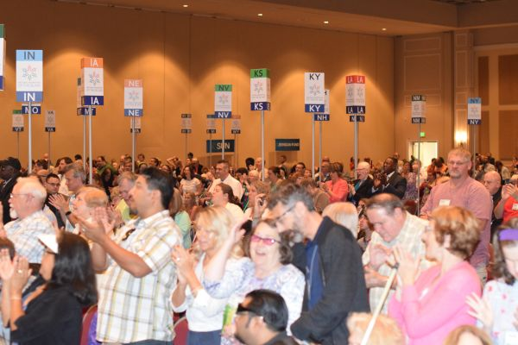It is the premier event for training, support, and information for the blind community. It also serves as a governing body, democratically electing our leadership and establishing each year's organizational priorities.
Although the convention is open to all, our constitution states that only members of the NFB have the right to participate in decision making when it comes to organizational policy. If you are not already a member, you can join the NFB today.

2019 Dates
Sunday, July 7 through Friday, July 12, 2019

2019 Location
Mandalay Bay Resort and Casino3950 South Las Vegas BoulevardLas Vegas, NV 89119
For the first time in seven years, the convention will be held west of the Mississippi at Mandalay Bay Resort and Casino.

Due to limited affiliate resources, we are only able
to offer partial assistance to those who qualify, and we are working on a budget, so it would serve you best to get your request in before the allotted funds are gone.
Assistance requests must be submitted to President Richard Payne before May 15, 2019. Any application forms received after that date will not be considered. If you have any questions about the form or the process, contact president Payne by email at rchpay7@gmail.com or call (937)829-3368.
NOTE: For anyone receiving convention assistance, you will be expected to attend all general sessions, meetings and workshops. While attending the convention if you do not follow those instructions that will way heavy on your applications for assistance in the future. There will also be various volunteer positions available that you will be expected to get involved in.
How to apply for Convention Assistance please answer all the questions in detail one question may decide the difference in the amount or even if you receive assistance:
- Submit a personal request letter. Please tell us why you wish to attend the convention and what you hope to accomplish as a result. Since financial need is the basis for this request, briefly describe the extenuating circumstances that are preventing you from attending convention. This is a major consideration in the decision-making process.

- Contact your chapter or division president and ask him/her to send a letter of support for your application directly to President Richard Payne. This letter must also state what assistance, if any, you will be receiving from that chapter or division. NOTE: If you are not yet a member of the National Federation of the Blind of Ohio, please call President Payne for an interview by phone at (937)829-3368.

- Describe in detail how you have been involved in state fundraising.

- What part do you take in keeping your local chapter engaged in the national federation of the Blind?

- What arrangements have you made to assist in getting you to the national convention?

- How long have you been a member of this affiliate?

- Complete the convention assistance form below.

NFB 2018 CONVENTION ASSISTANCE FORM

Name:
Street Address:
City, State, Zip:
Phone:
Email:

Number of adults planning to attend:
Number of children planning to attend:

Date of arrival:
Date of departure:

WHAT TYPE OF ASSISTANCE DO YOU NEED?

- Hotel Room: Yes or No. If No, skip this section.
This applies to a single adult, are you willing to share a room with one to three other adults? Yes or No. If Yes, are there any habits or health problems that your roommate should know about? Please explain.
Do you have a guide dog? Yes or No.
Have you made a room reservation? Yes or No? If Yes, what name is the reservation listed under?

- Food stipend: Yes or No.
Food allowance is $40 a day per adult and $20 a day per child.

- Transportation: Yes or No.
If you are driving, NFBO will reimburse 48 cents per mile. Remember that you may only receive partial assistance. What is the mileage from your home to the location of the convention?

If you have already made transportation arrangements, please explain what they entail.

- Convention Fees: Yes or No.
registration is now available online at nfb.org and by mail. We urge everyone to save money by pre-registering.

If you are requesting cash assistance in advance, you will have to sign an expense reimbursement form, which you will receive from President Richard Payne. Without a signed blank form that we will fill out with the amount of cash granted, we cannot advance any funds to you.

Please return this completed form and your personal letter of request by email to rchpay7@gmail.com or mail to the following address. No faxes will be accepted.
NFB of Ohio
Po box 20544
Kettering, OH 45420

