Dear Member of the Federation Family:

I want to welcome you to the family of the National Federation of the Blind and congratulate you on your decision to join us. As one of our newest members, you have taken a step that will make a great difference in your life. You are now plugged into a nationwide network that you can call upon to help you with any question you have about blindness. You also have the power to combine your efforts with others in order to improve opportunities for the blind and to strengthen the protection of our rights.

Enclosed in your new member packet is an official National Federation of the Blind membership coin. The only people who have them are members of our organization. On one side you will find a group of six overlapping icons. Visually, these icons appear to be abstract figures using white canes. Collectively, this circle of icons creates a symbol that appears in our logo, evoking feelings of unity and love while depicting the diversity of our core membership and its ability to come together and support one another. Put yourself in the empty space in the center and you are now surrounded by your sisters and brothers in the Federation. When you recite the Federation pledge you are making a commitment to support those around you as you enjoy the security of the circle of friends you have joined. On the other side of the coin, the words “NATIONAL FEDERATION OF THE BLIND” appear around the edge of the coin. In the center is the word “MEMBER.” Above this word are the three Braille characters for t, g, and r. These letters in Braille form the contraction for the word “together.” As a member, you now take hold of a bond of faith that we share in our efforts in this great movement. It is a faith that our first President, Jacobus tenBroek, described as a faith that “could move mountains and mount movements.”

Carry this coin with you to remind you of the support that surrounds you and the commitment you have made to help advance our collective equality, opportunity, and security. Carry this coin to remind you that active membership is important to us. We have been a growing organization since 1940 because our members participate actively in building our future. Carry this coin to show others and discuss the value that this organization brings to you in your life.
Our organization has a rich history and our literature contains thousands of pearls of wisdom from other members. We have also included in this package a few pieces of our literature to get you started on your path of learning about our organization. As you study the history and develop an understanding of the depth of our movement, I hope you will begin to contribute your own perspectives.

As the elected President of the National Federation of the Blind, I know that the most important resource we have in our organization is our membership. Our members drive our policies, carry out our projects, expand our public outreach, and fuel the spirit of the movement. I first made the commitment to membership back in 1996, and I renew that commitment every time I recite the pledge at a chapter meeting or convention. The reason I stay energized to continue this journey is the hope, love, and determination that comes from meeting new members like you. I hope you will take the opportunity to introduce yourself when our paths cross at a Federation meeting.

As a father of three beautiful children and a husband to an amazing woman (all of whom are members of our organization), I know how important family is and how impactful the Federation family will be in your life. I am also well aware that your contributions to the work of our organization will make a difference to my family as much as it will in your own life. Thank you in advance for your service, and I anticipate the opportunity to get to know you personally. Together with love, hope, and determination, we will transform dreams into reality.

Warmest regards,
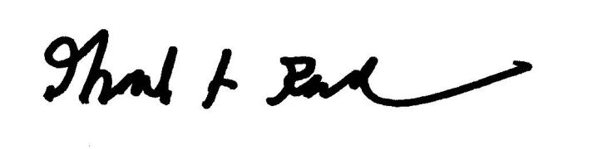
Mark A. Riccobono, President
National Federation of the Blind

