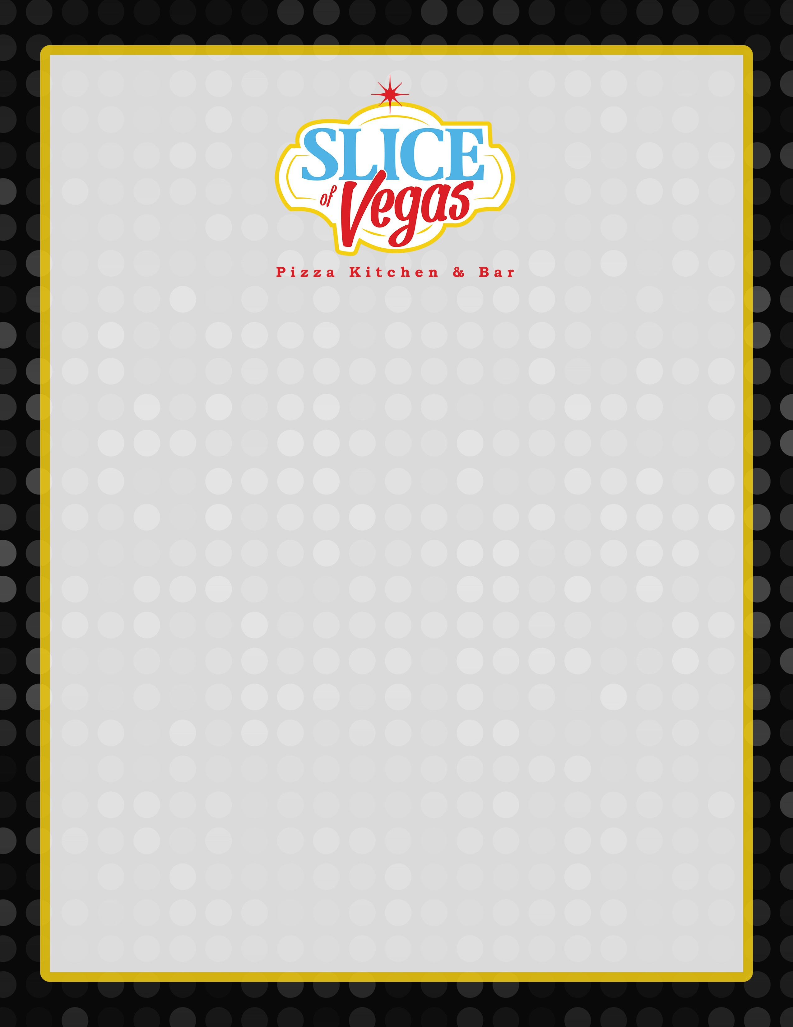

**MENU #1**

*\* $32 per person plus 8.25% tax and 21%gratuity*

***(***

***Served family style or buffet, comes with our delicious garlic bread.***

***)***

**APPETIZERS**

*(*

*Choose 1 of the following*

*):*

**•**

**Bruschetta**

**•**

**Meatballs**

**•**

**Chicken Wings**

**•**

**Fried Ravioli**

**SALADS**

*(*

*Choose 1 of the following*

*):*

**•**

**Caesar Salad**

**•**

**Garden Salad**

**PIZZA**

*(*

*Choose four different pizzas. Choose up to two toppings,*

*(1) 18*

*”per every 4 guests*

*):*

**•**

**Pepperoni**

**•**

**Pineapple**

**•**

**Mushrooms**

**•**

**Sausage**

**•**

**Green Peppers**

**•**

**Roma Tomatoes**

**•**

**Garlic**

**•**

**Jalapeños**

**•**

**Meatballs**

**•**

**Basil**

**•**

**Arugula Mangino**

**•**

**Chicken**

**•**

**Red Onion**

**•**

**Fontina Cheese**

**•**

**Sun Dried Tomatoes**

**•**

**Artichoke**

**•**

**Bacon**

**•**

**Ricotta**

**•**

**Prosciutto**

**•**

**Shrimp**

**•**

**Ham**

**•**

**Yellow Onion**

**•**

**Anchovies**

**•**

**Black Olives**

**•**

**Spaghetti Marinara**

**•**

**Fettuccini Alfredo**

**•**

**Orecchiette w/ Bolognese**

**•**

**Penne Arrabbiata**

**PASTAS**

*(*

*Choose 1 of the following*

*):*

**DESSERT**

*(*

*Choose 1 of the following*

*):*

**•**

**Cannoli**

**•**

**Chocolate Cake**