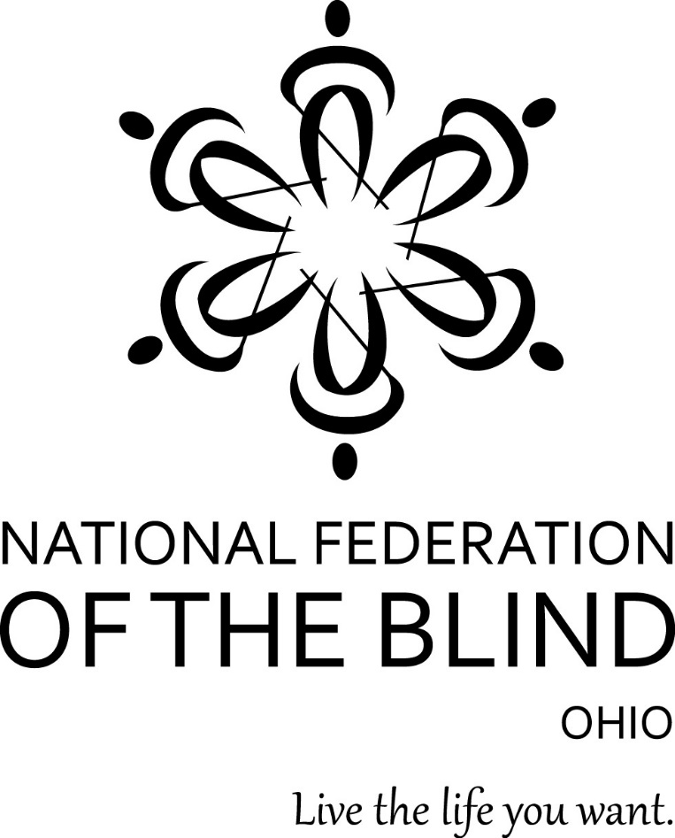
The 73rd Annual Convention of the National Federation of the Blind of Ohio will be the largest gathering of blind people in the state. It will be held at the
DoubleTree by Hilton Hotel Columbus/Worthington
175 Hutchinson Avenue
Columbus, OH 43235
Phone: 614-885-3334

“Obstacles are Opportunities”: The NFB is an Instrument of Change.

The NFB was founded on the guiding principles that blind people have an inalienable right to independence, that blind people have equal capacity, and that only blind people themselves can legitimately speak for the blind community. These principles have continually permeated the membership and structure of our ever-growing organization.

The National Federation of the Blind knows that blindness is not the characteristic that defines you or your future. Every day we raise the expectations of blind people, because low expectations create obstacles between blind people and our dreams. You can live the life you want; blindness is not what holds you back

Our 73rd Annual Convention entitled “Obstacles are Opportunities” will showcase inspirational stories, history and philosophy of the work of our movement. With proper training and technology, the blind can live the life they want. It is through love, hope and determination, that the NFB helps to transform dreams into reality.

This Convention will be an opportunity for attendees to learn about living with blindness, by attending many educational seminars, and seeing the latest accessible technology at our Tech Fair and Exhibit Hall.

As Ohio’s oldest organization comprised of blind people, the National Federation of the Blind of Ohio, works together to change what it means to be blind. Our 73rd annual convention promises to inspire, empower and celebrate our accomplishments. We provide encouragement, training and support to families with blind children, blind veterans and people who are losing vision later in life.

Here are a few convention highlights:
• Network with blind people from all parts of the state.
• Encourage blind persons to expand their knowledge of resources.
• Attend Workshops designed to promote leadership, membership building, and successful attitudes towards employment strategies.
• Attend the banquet that provides scholarships for blind college students.
• Visit Exhibit Hall to explore the latest technology and low-vision products. Exhibitors will be open to shoppers and information gatherers on Saturday. November 2,2019 from noon to 4:30 PM.
(Space is limited and all exhibitors are subject to approval. Please reserve your table by contacting Suzanne Turner at 216-990-6199 or by email at smturner.234@gmail.com)

You can start reserving your room now and the cost is $89.00 plus 16.5 percent tax, this includes FREE breakfast buffet for two and $5 for any additional persons in the room. The deadline for reservations is Thursday, October 11, 2019.

For more information on the convention and our organization, please contact: Sheri Albers at (513)886-8697 or sheri.albers87@gmail.com .

You may also contact our Ohio Affiliate President: Richard Payne at (937) 396-5573 or rchpay7@gmail.com

