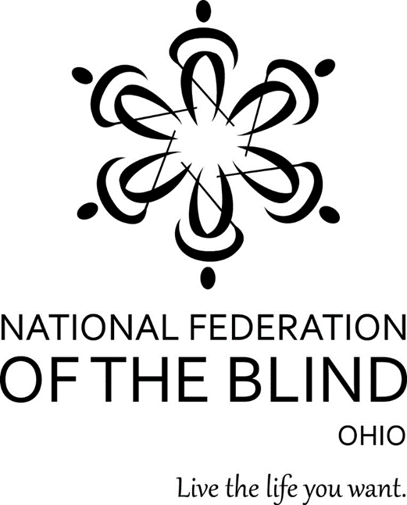

The 73rd National Federation of the Blind of Ohio Annual Convention
“Obstacles are Opportunities”: The NFB is an Instrument of Change.

The NFB was founded on the guiding principles that blind people have an inalienable right to independence, that blind people have equal capacity, and that only blind people themselves can legitimately speak for the blind community. These principles have continually permeated the membership and structure of our ever-growing organization.

How to Register
- Complete one form for each attendee and email to Sheri Albers at sheri.albers87@gmail.com, or mail to: Sheri Albers 3052 Lischer Ave Cincinnati, OH 45211. All forms must be received by October 24, 2019 to take advantage of pre-registration prices. Mail your check made payable to NFB of Ohio, to Sherry Ruth: 6922 Murray Ridge Road Elyria, OH 44035. Be sure to write “Convention Registration” on the memo line. Payment must be paid in full to be considered complete.
- Pre-register online by October 24, 2019, and pay by credit card, visit www.nfbohio.org
- You will be able to register at convention, however, fees will be higher and we will only take cash transactions.

PRE-REGISTRATION FORM
Attendee Information
Full Name:
Address:

City, State, Zip:
Home Phone:
Cell Phone:
Email:
Is this your first NFB of Ohio convention? (Yes or No)
Would you prefer a Braille agenda? (Yes or No)

Event Tickets
2019 Convention Registration: $15 ($20 after Oct. 24) $
2019 Banquet – Nov 2: $40 ($45 after Oct. 24) $
Please select your Banquet Meal preference: Vegetarian or Meat
Ohio Association to Promote the Use of Braille (OPUB) Breakfast -
Nov 2: $20 (Not sold after Oct 24) $
Boxed Lunch – Nov 2: $25 (Not sold after Oct 24) $
Please select your preference: Turkey, Ham or Veggie
1Touch Self Defense Class: $20 $
I wish to make an additional contribution. (Donations are greatly appreciated) $
Total Payment Due by Oct 24, 2019 $

