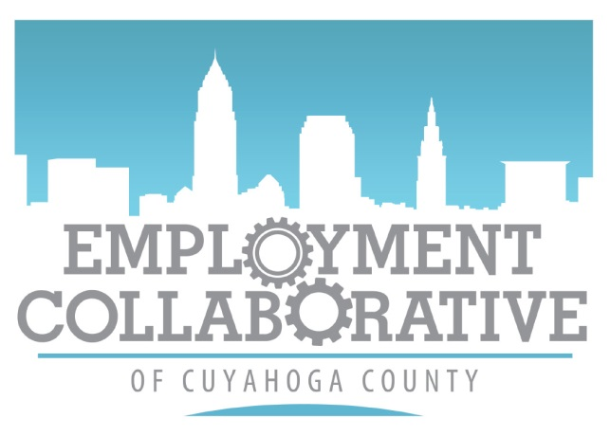
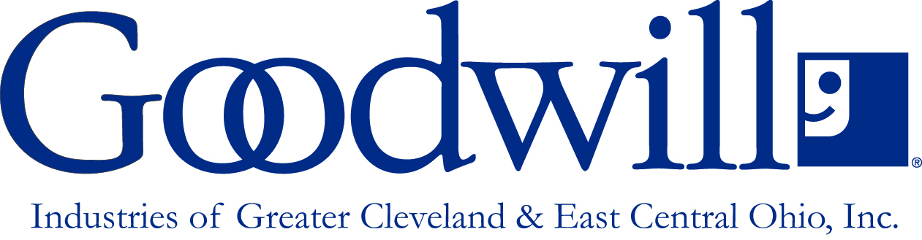

Interview Clothing Program

Goodwill Industries of Greater Cleveland & East Central Ohio, Inc. and the Employment Collaborative of Cuyahoga County have partnered to assist individuals with getting professional clothing for ECCC hiring events.

$20 Voucher to any Goodwill in Cuyahoga County to purchase interview clothing in 3 easy steps!
- Complete voucher form - https://goo.gl/forms/wX3v2vT5M9KfBpkh1
- Get Voucher (Receive contact scheduling pick up day and time)
  - 3 Pick Up locations
    - East Side – 17903 St. Clair, Cleveland Ohio, 44110 (Door #3)
    - Downtown – 1275 Lakeside Ave East, Cleveland, Ohio 44114
    - West Side – 6880 Pearl Rd, Cleveland, Ohio 44130
  - Receive in mail (Please allow for up to 10 business days to arrive)
- Shop at any local Goodwill store to get interview clothes

*This program is to be utilized exclusively for ECCC events and leads.
It will not be available to job seekers needing interview clothes for general job development and job seeking purposes.

