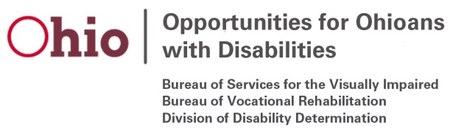

Bureau of Vocational Rehabilitation
OOD Council Briefing- November, 2019

Program Performance: The following table summarizes Federal Fiscal Year 2019 year-end performance for the Vocational Rehabilitation (VR) program.

Metric | September 30, 2018 | September 30, 2019 | Percent Change
Eligibility Decisions | 17,870 | 18,396 | 3%
Plans Written | 13,164 | 13,934 | 6%
Eligible + Served | 35,964 | 38,525 | 7%
Rehabilitations | 5,755 | 5,726 | -0.5%
Average Wage | $11.46 | $11.83 | 3%
Average Hours | 26.5 | 26.3 | -0.7%

Programmatic Updates:

- Ohio College2Careers: Memorandum of Understanding (MOUs) are complete and OOD has immersed Vocational Rehabilitation Counselors in the Disability Services Offices at 15 Ohio colleges and universities. Counselors will work with eligible students to provide internship and other work experiences, access to technology, and job placement services. Counselors have been conducting outreach to students and to date there are 158 students on the caseload. 1500 students with disabilities will be served by the project.

- OOD Jobs for Recovery: OOD met with the judges in five of the six new counties and MOUs are in process so that staff can be deployed for the project. This program replicates a successful model of services established in Butler County. OOD will immerse a Vocational Rehabilitation Counselor, Caseload Assistant and a Job Developer in each of the identified drug courts to support the recovery of participants through job placement, on the job supports and other services needed for successful employment.

- Ohio Transition Support Partnership (OTSP): The three additional counselors (Columbus, Cleveland and Cincinnati City Schools) are in place. This brings the total number of counselors funded through this partnership with the Ohio Department of Education to 54. The partnership will increase by another four counselors for the 2020-21 school year.

- OOD has immersed counselors at both the Ohio State School for the Blind and the Ohio School for the Deaf this fall.

- OOD’s updated Vocational Rehabilitation Fee Schedule went into effect on October 1, 2019. This fee schedule includes an across the board increase of 6.5% and an 8% increase for job development, including supported employment job development services. Other enhancements include adjustments to group rates for summer youth services, and additional placement fees when individuals receive job offers based upon their participation in other VR services.

