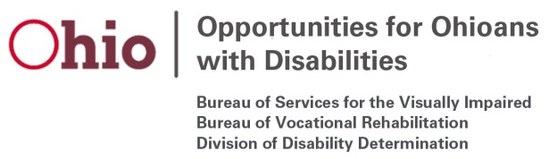

Vocational Rehabilitation (VR) Participant Focus Groups
Federal Fiscal Year (FFY) 2020

Planned topics to be covered at the VR Participant Focus Groups in FFY 2020 will be as follows:

Month | Focus Area | Notes
October | Job Seekers | Focus Groups to be held in conjunction with prep sessions for OOD’s job fairs.
January | High School Students | Focus Groups to be held in collaboration with school partners.
April | Individuals who are blind or visually impaired
April | College Students | Central office will conduct an online statewide focus group.
July | General

