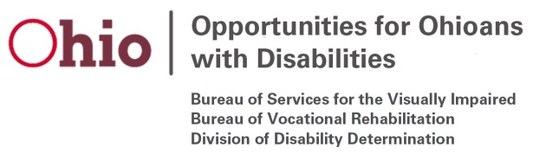

Bureau of Services for the Visually Impaired
OOD Council Briefing- November, 2019

Program Performance:

- Applications: 3.8% increase in applications from previous year as of 9/30/19
- 359 total successful closures for FFY19
- 2,497 total served for FFY19

Programmatic Updates:

BlindSquare Partnership with Capital Square Review and Advisory Board:

- OOD is partnering with CSRAB to install BlindSquare technology through the Capital Building. Contract has been executed, final installation targeted by end of year.

Outreach/Multi-point plan updates:

- BSVI and OSILC visited The Ability Center of Greater Toledo, having now visited all 12 Center’s for Independent Living around Ohio.
- The BSVI team has attended NFB events and chapter meetings around the state, including the Cincinnati Vision Expo, NFB Cleveland Chapter event in Lake County, Akron Chapter meeting, and the State Convention in Columbus.
- The Fee Schedule changes have been implemented, including changes to the provider credential requirements to allow for a higher level of quality services.
  - Initial meeting with Youngstown Goodwill to talk about the credential requirements for serving individuals with vision loss. They have expressed interest to expand their service to include this populations. Their service area is an underserved area in terms of available providers.
- Contract development underway for creative programming and outreach opportunities for the ILOB program in partnership with the Sight Centers. One example is some group based training at assisted living and senior centers.

Business Enterprise Program:

- The past federal fiscal year marked a record-breaking year for the program, with the largest number of licensees on record. A total of 11 new licensees were granted, and seven of these licensees are now active operators. These 11 individuals were all served by BSVI.

