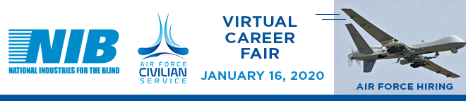
Virtual Event Open to Legally Blind Jobseekers who are interested in Contract Specialist jobs.
Learn about these career opportunities with upward mobility.
Event Date: January 16th, 12 pm - 2 pm Eastern
Register at CareerEco.com/Register/AFCS
Registration Instructions for Screen Readers
Learn about AFCS: CareerEco.com/Details/AFCS
For more information: 770.980.0088 | AFCS@CareerEco.com
Free Event. Attend the Fair from Anywhere.
What Other Jobseekers Have Said About Prior Virtual Career Fairs
- "Virtual fairs give people who are blind control & confidence."
- "I am optimistic about getting the job."
- "I would definitely participate in future career fairs. I enjoy the ability to participate online."
We look forward to having you join us for the event. Be sure to register as soon as possible.
Event Hosted by National Industries for the Blind

