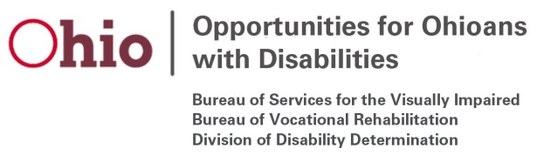

Bureau of Vocational Rehabilitation
OOD Council Briefing- May 6, 2020

Program Performance: The following table summarizes Federal Fiscal Year 2020 performance for the Vocational Rehabilitation (VR) program:

Metric | 3/31/2019 | 3/31/2020 | Percent Change
Eligibility Decisions | 9,378 | 10,229 | 9%
Plans Written | 6,639 | 7,092 | 7%
Eligible + Served | 27,847 | 29,569 | 6%
Rehabilitations | 2,720 | 2,950 | 8.5%
Average Wage | $11.37 | $11.58 | 2%
Average Hours | 26.2 | 25.8 | -1.5%

Programmatic Updates:
- All VR Field Staff have been working from home since Friday, March 13. Staff have called all program participants to let them know that we are still working and are available to assist them. Staff have indicated that individuals called have had significant basic needs to be addressed.

- OOD established a new service called REACH (Refer, Educate, and Check-In). Providers offering this service will complete check-ins with OOD participants to identify participants’ current needs, provide information to address those needs and make corresponding referrals when needed.

- OOD has implemented a number of flexibilities for OOD staff and providers to ensure that services can continue to the maximum extent possible. Examples include flexibilities in obtaining signatures, remote service delivery and modifications to the summer services for students with disabilities. OOD continues to see job placements in the current environment using the Urgent Job List and other business partnerships.

- OOD held Participant Focus Groups related to transition services in January (report included in materials). Students indicated that they would like OOD to help them to:
  - Find and keep a job after graduation
  - Choose and get ready for college or other training after high school
  - Get their driver’s license
  - Participate in longer work experiences in the summer.

- Participant Focus Groups planned in April have been postponed.

